NEE Worksheets
Vocabulary
Countries and nationalities 100
Types of houses 101
Daily routine 102
Household chores 103
School subjects | School facilities | After-school clubs 104
Physical features | Personality 106
Clothes, footwear and accessories 107
Places in a city | Shops 108
Means of transport 109
Where to stay | What to take 110
Free time activities | Beach activities 111
Grammar
Present simple 114
Adverbs of frequency 116
Connectors 117
Present continuous 118
Adjectives + prepositions 120
Modal verb should 121
Comparative 122
Superlative 123
Adverbs: adjectives + -ly 124
Past simple – verb to be 125
Past simple – verb there + to be 126
Past simple – regular verbs 127
Past simple – irregular verbs 128
Prepositions of movement 129
Want / Would like 130
Be going to 131
Reflexive pronouns 133
Answer key 134
Available in editable format at | 




Tests Available
in September
at 
1
2
3
4
5
6
7
8
9
10
11
12
13
14
15
16
17
1
2
3
4
5
6
7
8
9
10
11

A. Complete with the words from the box. (Completa com as palavras da caixa.)
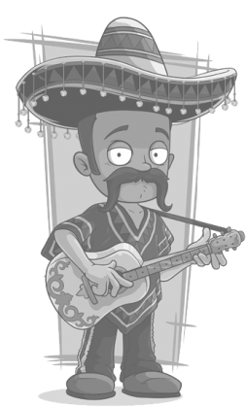
British American Mexican
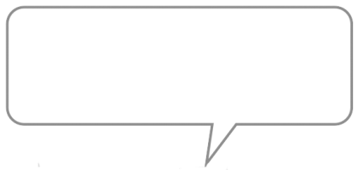

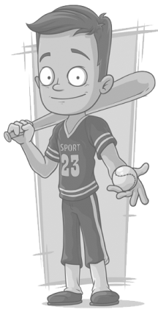
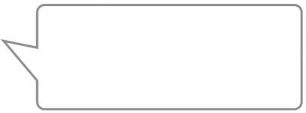
1. I’m from Mexico. 2. We’re from the UK.
I’m ..___________. We’re ..___________.

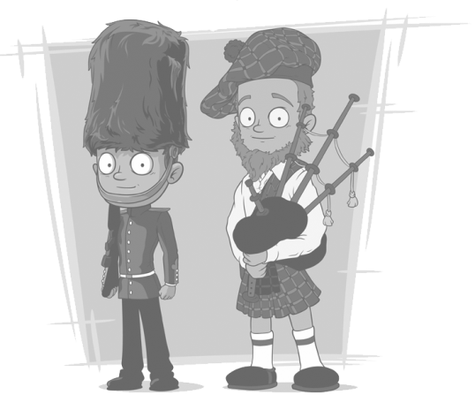

3. I’m from the USA.
I’m ..___________.

B. Complete the dialogue with the words from the boxes.
(Completa o diálogo com as palavras das caixas.)
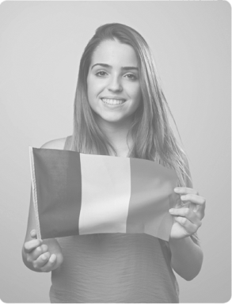
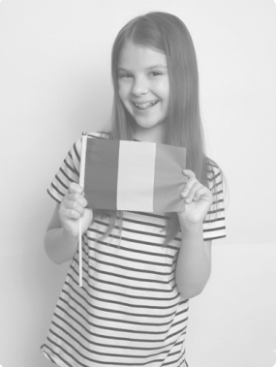

1. ..___________ are you from?

2. I’m from ..___________.

3. Where are you ..___________?
4. I’m from ..___________.
5. ..___________ nationality are you?
Irish
Ireland
nationality
from
French
France
Where
What
6. I’m ..___________.
7. What is your ..___________?
8. I’m ..___________.

C. Answer the questions about YOU. (Responde às questões sobre TI.)
1. Where are you from? ._________
2. What nationality are you? ._________

A. Tick (✔) the correct option. (Escolhe (✔) a opção correta.)
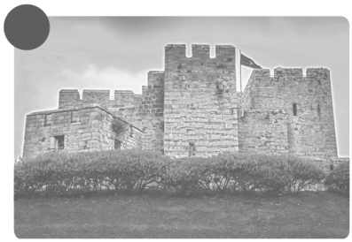
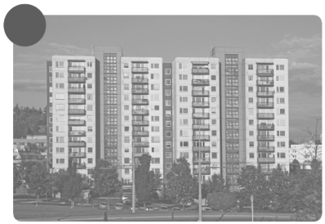
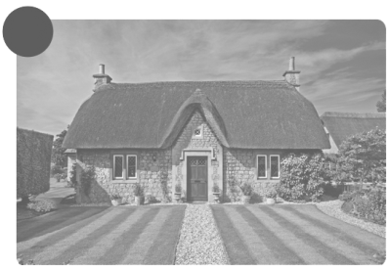
1 2 3

a) detached house  a) block of flats a) castle
b) cottage b) terraced house b) flat

B. Look at the pictures and complete the crosswords with the types of houses.
(Olha para as imagens e completa as palavras cruzadas com os tipos de casa.)
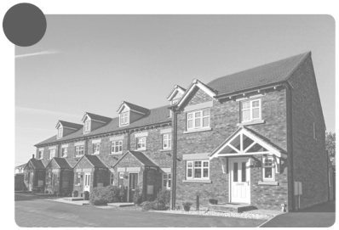
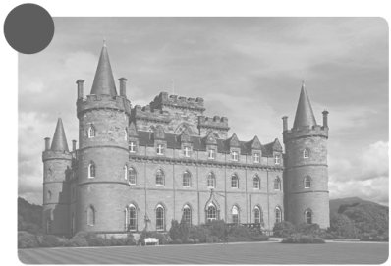
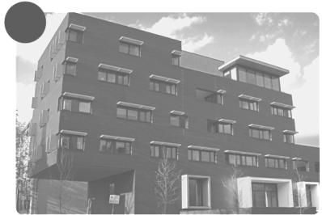
1 2 3

 | 1 |  |  |  |  |  |  |  |  |  | 4
 | B |  |  |  |  |  |  |  |  |  | D

2 | C
 |  |  |  |  |  |  |  |  |  |  |  |  |  | 5
 |  |  |  |  |  |  |  |  |  |  |  |  |  | C
 |  |  | 3 | T
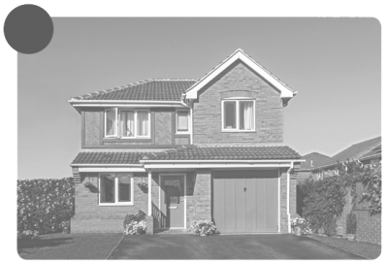
4

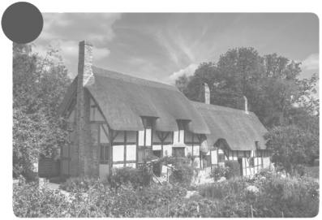
5

C. Answer this question about YOU. (Responde a esta questão sobre TI.)
1. What type of house have you got? …I have got a/an._____..
____

A. Circle the correct option to complete the expressions.
(Rodeia a opção correta para completar as expressões.)
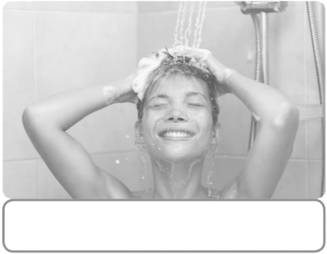
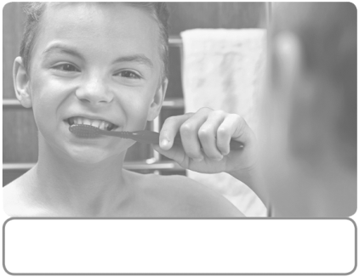
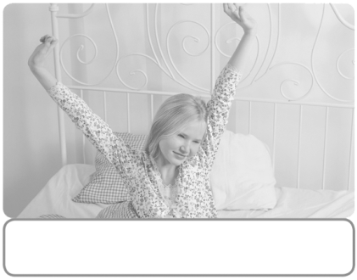

1. wake / wash up 2. brush my hair / teeth 3. have a snack / shower

4. have breakfast / lunch 5. do my hair / homework 6. go to bed / work


B. This is Camila Cabello’s daily routine. Order the sentences.
(Esta é a rotina diária de Camila Cabello. Ordena as frases.)
a) I go to bed at 10:00 p.m.
b) I have dinner in the evening.
c) Then I have breakfast.
d) I wake up at 8:00.
e) I have lunch at 12:30.
f) I always have a shower at 8:30.

C. How is YOUR daily routine? Use the expressions from the box.
(Como é a TUA rotina diária? Usa as expressões da caixa.)
wake up
have a shower
have breakfast
brush my teeth
do my homework
watch TV
have dinner
have lunch
play football
have dance classes


In the morning I (1) __________________________ and
(2) ________________________.

In the afternoon I (3) _________________________ and
(4) ________________________.

In the evening I (5) __________________________ and
(6) ________________________.

A. Unscramble the letters to label the pictures.
(Ordena as letras para legendar as imagens.)
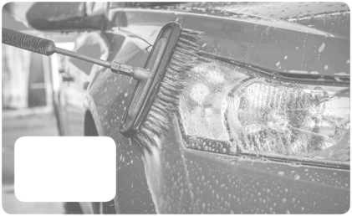
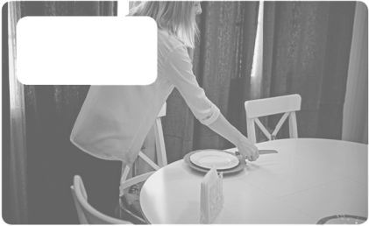
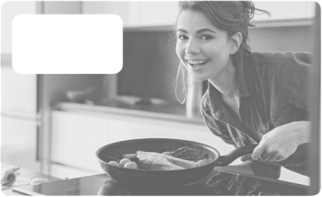
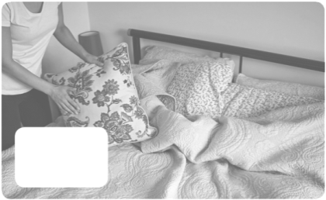
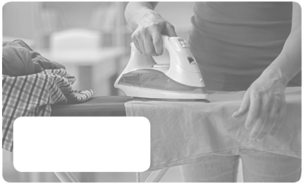

ARC
EDB
NIGRION

1. make the _____________ 2. wash the _____________ 3. do the ______________

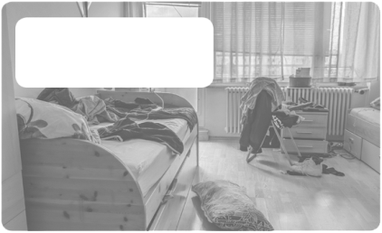
OKOC
LEBAT
BROEOMD

4. set the ______________ 5. ____________________ 6. tidy the _____________

B. Match the expressions with the pictures. Draw lines.
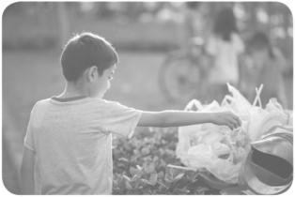
(Liga as expressões às imagens. Traça as linhas.)

clean the bathroom 1. • • a)

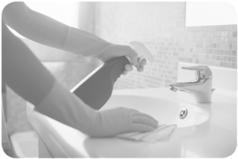

do the washing up 2. • • b)

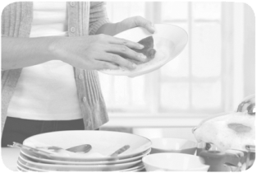

take the rubbish out 3. • • c)

C. Tick (✔) the chores you usually do. (Assinala (✔) as tarefas que fazes habitualmente.)
1. make the bed 5. do the washing up
2. wash the car 6. tidy the bedroom
3. set the table 7. cook
4. clean the bathroom 8. take the rubbish out

