A. Label the pictures with the words from the box.
(Legenda as imagens com as palavras da caixa.)
physical education art English maths
history music science geography


1. …s____________ 2. …g____________ 3. …m____________ 4. …a___________

5. …h____________ 6. …m____________ 7. …E____________ 8. …p___________

B. Complete the dialogue. Use the words from the box.
(Completa o diálogo. Usa as palavras da caixa.)
Bye-bye Hello subject favourite

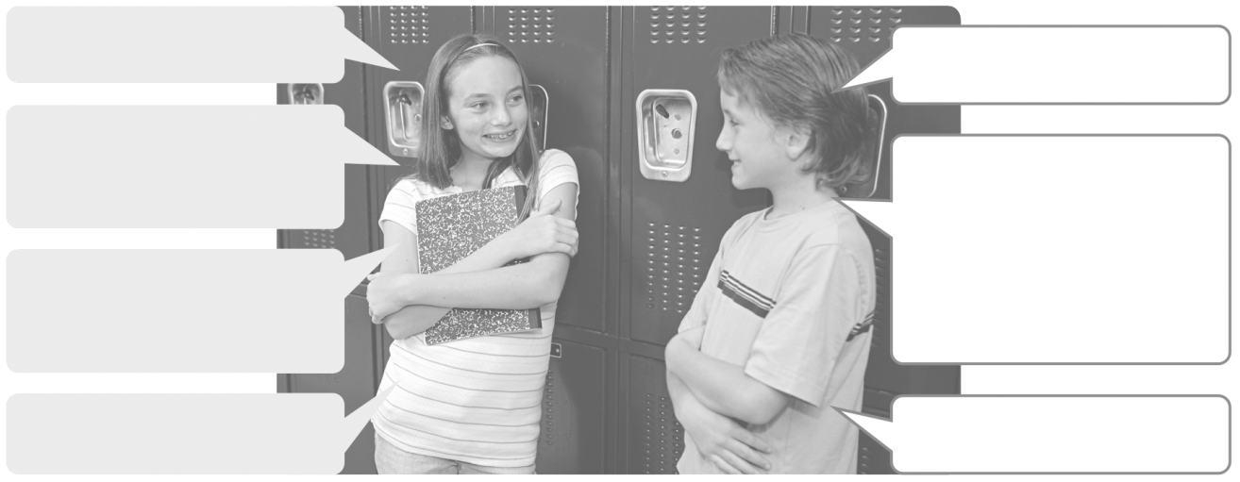
1. Good morning!
2. ______________!

3. What’s your
4. My favourite
________ is music.
What’s your
favourite subject?
favourite subject?

5. My ___________
subject is science.
6. Goodbye!
7. ______________!

C. Answer about YOU. (Responde sobre TI.)
1. What’s your favourite subject? ___

D. Label the picture with the school facilities.
(Legenda a imagem com os locais da escola.)
library lab canteen sports field classroom stationer’s
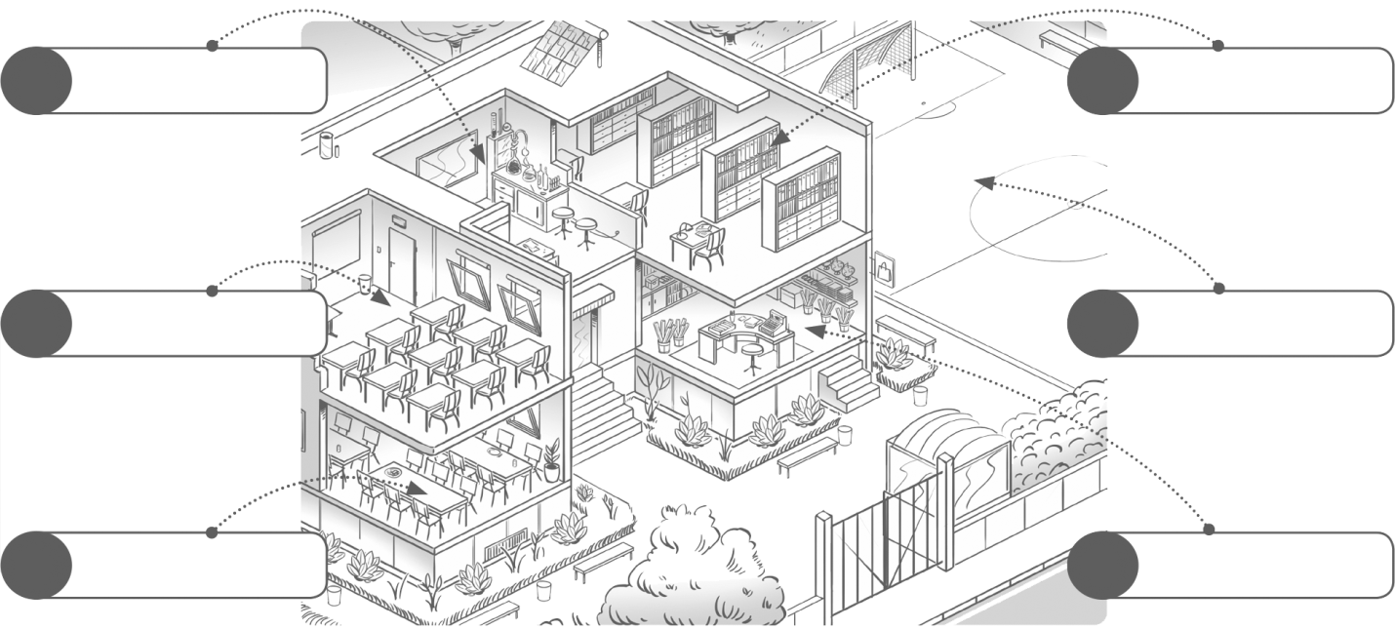

1 4

2 5

3 6

E. Match the columns and find the school facilities. Draw lines.
(Associa as colunas e descobre os locais da escola. Traça as linhas.)
art 1. • • a) field
sports 2. • • b) office
headmaster’s 3. • • c) hall
assembly 4. • • d) room

F. Which clubs are there in your school? Tick (✔) the correct options.
(Que clubes há na tua escola? Seleciona (✔) as opções corretas.)
1. Music Club 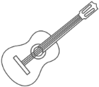  4. Science Club 
2. Drama Club  5. Maths Club 
3. Sports Club  6. Chess Club 