A. Label the pictures. Use the words from the boxes.
(Legenda as imagens. Usa as palavras das caixas.)

medium height
short
tall
1. _______________ 2. _______________ 3. _______________


slim
thin
fat
4. _______________ 5. _______________ 6. _______________


wavy hair
curly hair
straight hair
7. _______________ 8. _______________ 9. _______________

B. What does Shakira look like? Circle the correct option.
(Como é a Shakira? Rodeia a opção correta.)

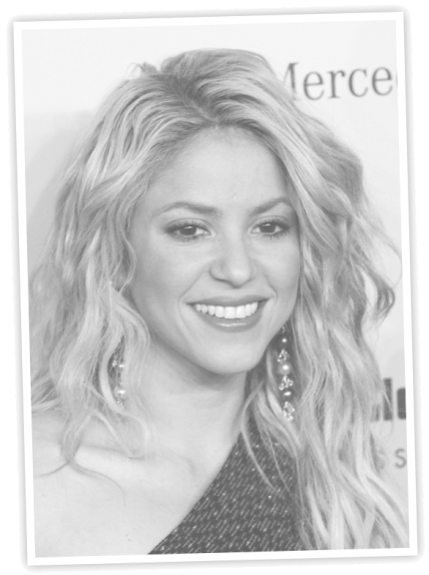
1. Shakira is fat / slim. 
2. She has got brown / blond hair.
3. She has got a big nose  / a moustache 
4. She has got wavy / straight hair.
5. Her hair is long / short.
6. She has got a big / small mouth. 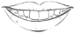
7. She is ugly / beautiful. 

C. Find out the words about personality. (Descobre as palavras sobre a personalidade.)
(divertido/a) | UNYFN | (1) ________________________________________
(teimoso/a) | BBORNSTU | (2) ________________________________________
(educado/a) | IEPOTL | (3) ________________________________________
(preguiçoso/a) | AYZL | (4) ________________________________________

A. Write the missing letters to label the pictures.
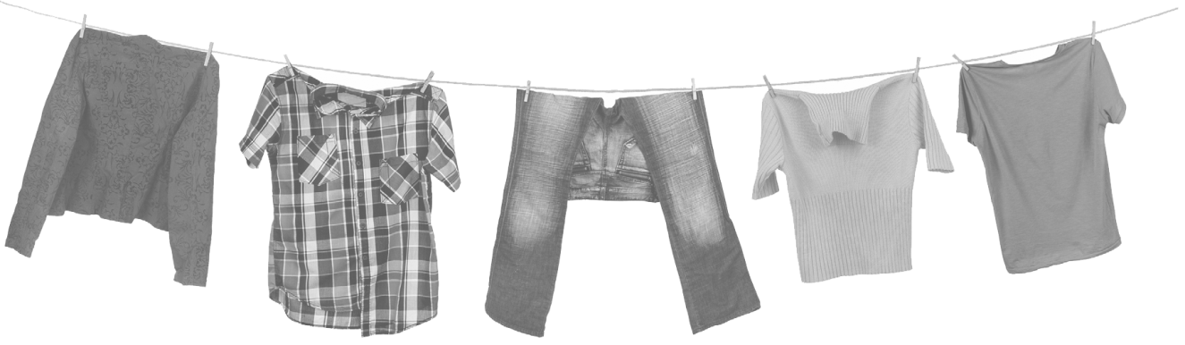
(Escreve as letras em falta para legendares as imagens.)

1. J_ _ K _ _ 2. S_ I _ T 3. J_ _ N _ 4. S_ _ A _ E _ 5. _ -S _ T _ _

B. What are Héctor, Imelda and Miguel wearing? Use the words from the box.
(O que é que o Héctor, a Imelda e o Miguel têm vestido? Usa as palavras da caixa.)
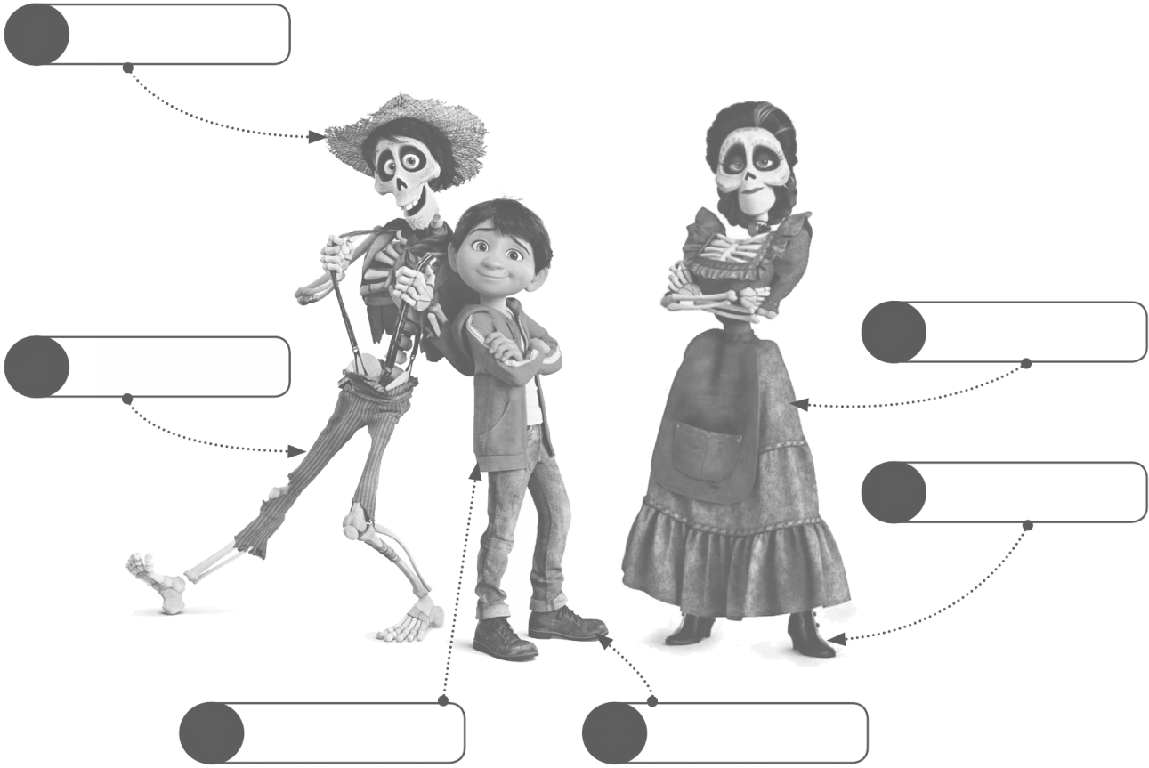
dress boots shoes
jacket hat trousers
1

6
2

5

3 4

C. And YOU? What are YOU wearing today? (E TU? O que é que tens vestido hoje?)
…I am wearing._____..
____

