A. Match the columns. Find the places in a city. Draw lines.
(Associa as colunas. Descobre os locais da cidade. Traça as linhas.)
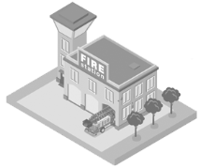
fire 1. • • a) pool
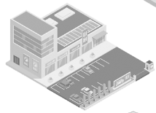
shopping 2. • • b) station
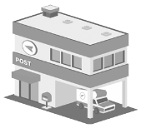
post 3. • • c) station
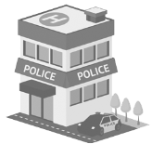
police 4. • • d) centre
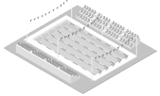
swimming 5. • • e) office

B. Circle 6 places in a city. (Rodeia 6 lugares na cidade.)
j b a n k c s s t a d i u m i p a r k b u l i b r a r y c j s m u s e u m b f h e r e s t a u r a n t k v

C. Label the pictures. (Legenda as imagens.)
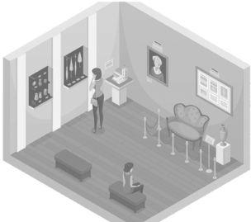
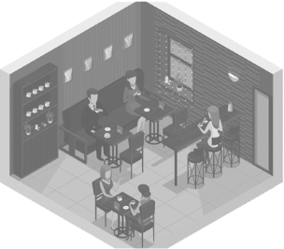
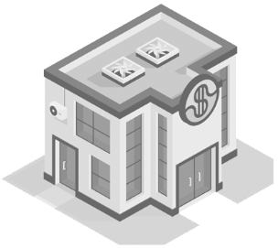

1. _B______________ 2. _R ______________ 3. _M ______________

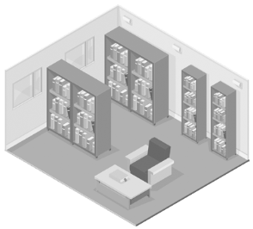
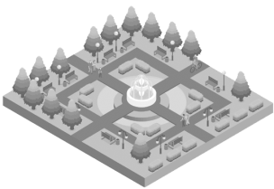
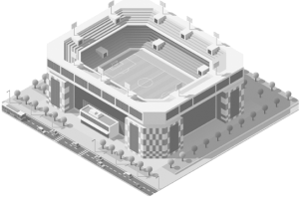

4. _S______________ 5. _L ______________ 6. _P ______________

