A. Tick (✔) the correct option. (Seleciona (✔) a opção correta.)
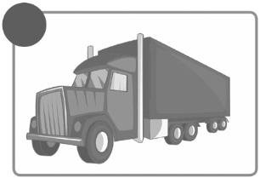
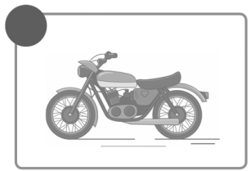
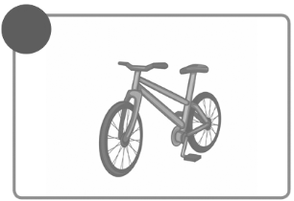
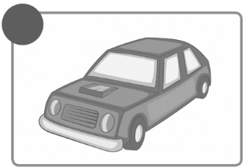
1 2 3 4

a) car  a) bus a) train a) taxi
b) underground b) bike b) underground b) lorry
c) boat c) lorry c) motorbike c) helicopter

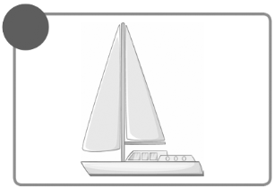
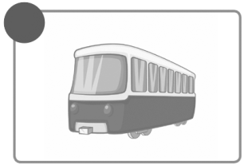
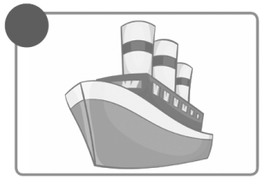
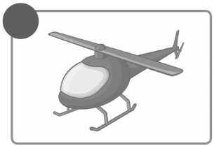
5 6 7 8

a) car a) ship a) car a) bike
b) plane b) motorbike b) underground b) helicopter
c) helicopter c) train c) bike c) boat

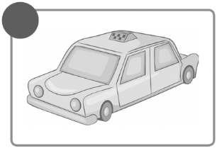
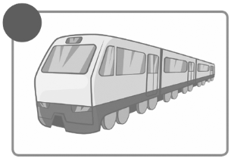
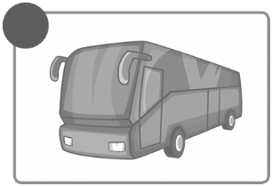
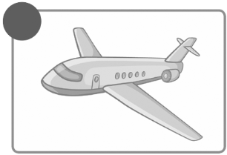
9 10 11 12

a) plane a) bus a) car a) bus
b) underground b) lorry b) train b) underground
c) motorbike c) helicopter c) boat c) taxi




B. Put the words in the correct column. (Coloca as palavras na coluna correta.)
bus car
boat train
helicopter
underground
plane bike
lorry taxi
motorbike
ship
I like  travelling by… |  | I don’t like travelling by… |  | I don’t  know…
______________ |  | ______________ |  | ______________
______________ |  | ______________ |  | ______________
______________ |  | ______________ |  | ______________
______________ |  | ______________ |  | ______________
______________ |  | ______________ |  | ______________
______________ |  | ______________ |  | ______________

A. Complete the dialogue with the words from the box.
(Completa o diálogo com as palavras da caixa.)
beach resort camera caravan ticket camping
cities beach tent suitcase

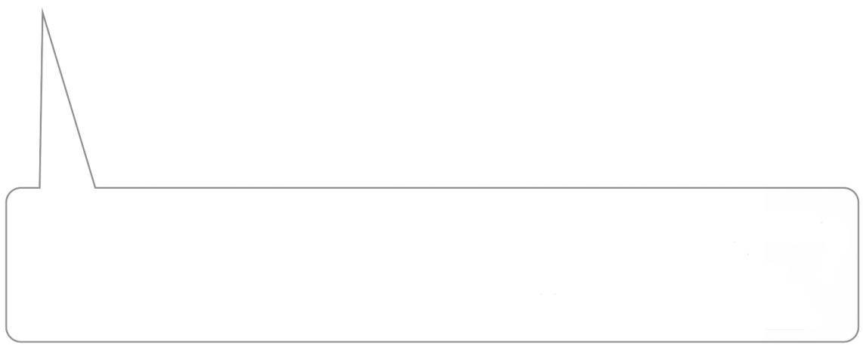
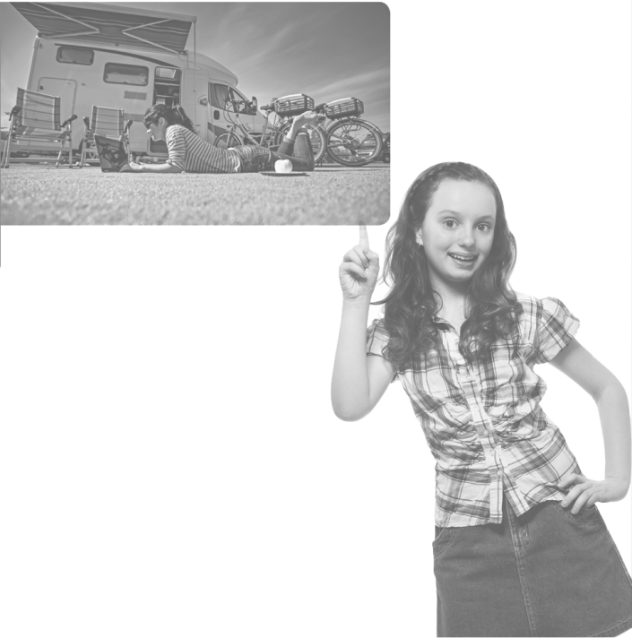

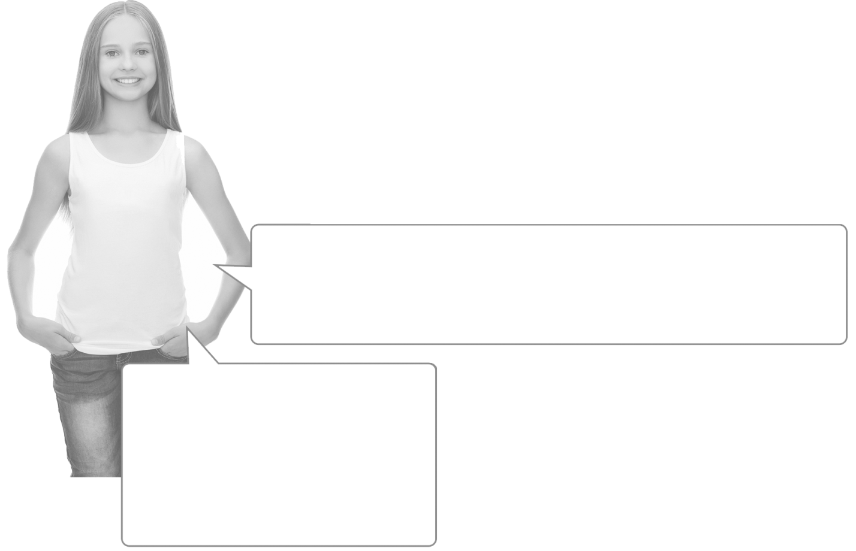
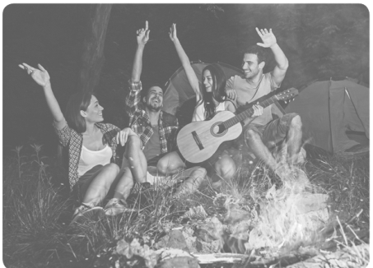


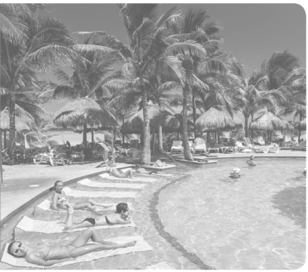
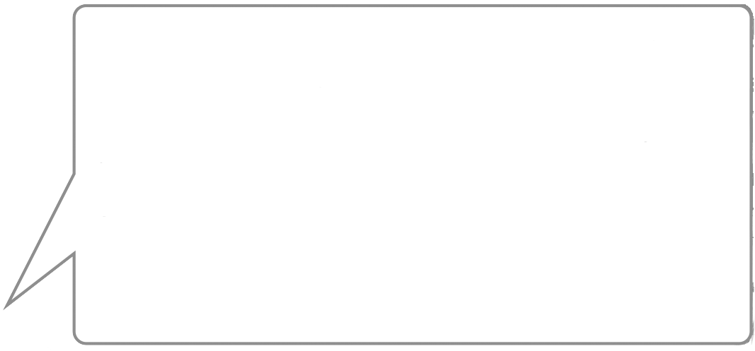
This was last summer. I travelled
with my grandparents, we visited
lots of (5) ______________ 
because they have got
a (6) __________________  .
I always take my (7) _______________  with some clothes and footwear.
When I travel by plane, I always take the (8) __________________ .
I love taking photos, so I always travel with my (9) __________________ .
What do you usually
take when you travel?
This is from last year.
I went (3) _______________________  with my friends.
We stayed in a (4) ______________________ 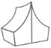.
And this one?
Look at my photo album, I have great photos!
The first was this spring.
I went to Mexico with my parents. We stayed
at a (1) ________ ________  . It was
great because I love the (2) _____________
!

