A. Put the pieces in the correct order to make free time activities.
(Coloca as peças na ordem correta e escreve as atividades de tempo livre.)




surfing net the
hanging friends out with




sports
doing
cinema going to the





sending
text messages to the going
beach

 1. ____________________________...  4. ____________________________...
 2. ____________________________...  5. ____________________________...
 3. ____________________________...  6. ____________________________...

B. Label the pictures. Use the words from the box.
(Legenda as imagens. Usa as palavras da caixa.)
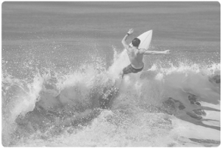
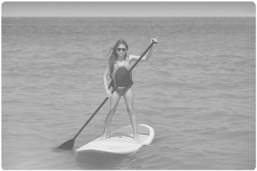
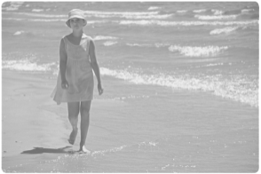
surfing
sunbathing
canoeing
paddling
walking
swimming

1. ______________... 2. ______________... 3. ______________...

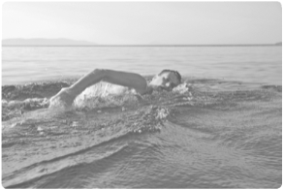
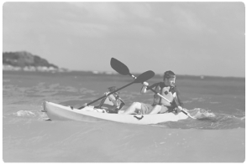
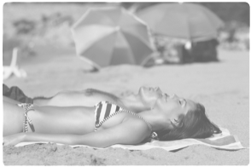

4. ______________... 5. ______________... 6. ______________...

