Review
Worksheets Grammar
Personal pronouns 42
Present simple: verb to be 43
Question words 44
Articles (an, a, the, omission of the) 45
Possessive determiners 46
Present simple: verb have got 47
To be vs have got 48
Possessive case and whose…? 49
Possessive pronouns 50
Verb there + to be 51
Present simple 1 52
Present simple 2 53
Verb + -ing 54
Adverbs of frequency 55
Present continuous 1 56
Present continuous 2 57
Personal pronouns (object) 58
Imperative 59
Available in editable format at | 


1
2
3
4
5
6
7
8
9
10
11
12
13
14
15
16
17
18

A. Look at the words in the box. Circle the personal pronouns. There is one example.
(Observa as palavras da caixa. Rodeia os personal pronouns. Segue o exemplo.)
he name not she they my Oliver we
have it English you got are am I

B. Complete the table. Write the English pronoun next to the Portuguese equivalent.
(Completa a tabela. Escreve o pronome em inglês depois do equivalente em português.)
Singular |  | Plural
Portuguese | English | Portuguese | English
eu | (1) … ...____ | nós | (5) … ...____
tu | (2) … ...____ | vós | (6) … ...____
ele | (3) … ...____./ it | eles | (7) … ...____
ela | (4) … ...____./ it | elas | (8) … ...____

C. Complete the sentences with a personal pronoun from the table.
(Completa as frases com um personal pronoun da tabela.)
1. Listen to this music – … ... is fantastic!
2. It’s by my favourite band, Coldplay.
Do … ... like it?
3. There are four people in the band.
… ... are all from the UK.
4. Chris Martin is the singer.
… ... has got a great voice!
5. My mum is a fan too – … ... loves their music.
6. Mum and I are really happy. … ... have got two tickets for their

concert next month!
7. … ... think my favourite album
is Viva la Vida.
8. … ... is their fourth album and
their best.
9. The songs are great.
… ... are all about love and life.
10. Do … ... want to listen to more? Coldplay
A. Complete the sentences with the words from the box. There is one example.
(Completa as frases com as palavras da caixa. Segue o exemplo.)
Yes are not aren’t is am Is isn’t I No I’m Are
1. …I’m_ Portuguese. You ___________ American. She ___________ from Australia.
2. I ___________ not hungry. They ___________ (not) tired. He ___________ (not) thirsty.
3. Am ___________ beautiful? ___________, I am! No, I’m ___________!
4. ___________ they tall? Yes, they are.
5. ___________ she lazy? ___________, she isn’t.
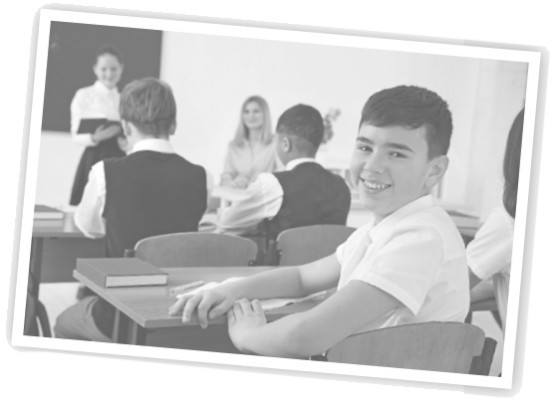
B. Circle the correct verb in each sentence.
(Rodeia o verbo correto em cada frase.)
1. Jake is / are happy. He loves English class.
2. Quick! We am / are late for school!
3. Are / Is they English or American?
4. You isn’t / aren’t a teacher. You ’re / ’nt a student.
5. Am / Are I in the football team this week?
6. They isn’t / aren’t a very big family.

C. Complete the sentences with the verb to be: affirmative (✔), negative (x) or interrogative (?).
(Completa as frases com o verbo to be: afirmativa (✔), negativa (x) ou interrogativa (?).)

1. My dad ___________ (✔) a firefighter. He ___________ (✔) my hero!
2. My test marks ___________ (✔) all good this year!
3. I ___________ (x) very good at sport.
4. ___________ you (?) in the drama club? Yes, I ___________ (✔).
5. I ___________ (✔) tall but I ___________ (x) very strong.
6. ___________ this exercise (?) difficult? No, it ___________ (x).
It ___________ (✔) easy!

D. Now complete these sentences about YOU. Use the verb to be.
(Agora completa as frases sobre TI. Usa o verbo to be.)
My name (1) ______ (2) ________________. I (3) ______ (4) ________________ years old.
My favourite sport (5) ________ (6) ________________. My favourite singers (7) _________
(8) ___________________ and (9) __________________ At school, I (10) __________ (✔)
good at (11) __________________________, but I (12) ________________ (x) very good at
(13) ______________________


A. Match the questions and answers about Jennifer Lawrence.
(Liga as questões e as respostas sobre Jennifer Lawrence.)
What’s her job? 1. • • a) It’s on 15th August.
Where is she from? 2. • • b) She lives in Los Angeles.
How old is she? 3. • • c) She drives a fast car!
When is her birthday? 4. • • d) Her favourite group is Paramore.
Where does she live? 5. • • e) She’s an actress.
Who is her favourite group? 6. • • f) She’s 28 years old.
How does she go to work? 7. • • g) She’s from the USA.

B. Read the answer and choose a question word from the box to complete the question.
(Lê a resposta e escolhe uma question word da caixa para completar a questão.)
Who Where (2x) When How How old What

1. ________________ is his name?
His name’s Robert Pattinson.
2. ________________ is he? He’s 32 years old.
3. ________________ is he today? He’s fine!
4. ________________ is his family from?
They are from London.
5. ________________ is his favourite singer?
His favourite singer is Van Morrison.
6. ________________ was he in a Harry Potter film?
In 2005 – he was in The Goblet of Fire.
7. ________________ does he go on holiday?
He likes to go to France.

C. Imagine you can meet Jennifer Lawrence or Robert Pattinson. What do you want to ask them? Write questions. Use the question words in exercises A and B.
(Imagina que podias conhecer a Jennifer Lawrence ou o Robert Pattinson. O que lhes perguntarias?
Escreve as questões. Usa as question words dos exercícios A e B.)
Questions for __________________________________.
1. ________________
2. ________________
3. ________________
4. ________________
5. ________________

A. Look at the example sentences. Then circle the correct option to complete the sentences.
(Observa as frases-exemplo. Depois rodeia a opção correta para completar as frases.)

• Cara Delevingne is an actress. She is in the film Paper Towns.
• She’s from England, but she lives in the USA.
She’s got a sister called Chloe. She likes swimming.
1. Hi, I’m – / the Dane DeHaan. I’m a / an actor.
2. I’m in the / an film Valerian and the City of 1000 Planets
with a / – Cara Delevingne.
3. I’m from an / the USA. I live in a / – Brooklyn.
4. I’ve got a / an sister called Meghan.
5. I’m married to – / the Anna Woods. We like playing – / a tennis.

B. Complete these sentences. Use a, an, the or –.
(Completa as frases. Usa a, an, the ou –.)
1. Manchester United is a football team from … UK.
2. I always eat … banana and drink … milk for breakfast.
3. Neymar is from … Brazil. He is … fantastic football player.
4. I’ve got … sister and … brother. They are … students.
5. I play … basketball every week in physical education.
6. … Christmas holidays start tomorrow. Yes!

C. Complete these dialogues with a, an, the or –.
(Completa os diálogos com a, an, the ou –.)

1. a) I think the best football player is … Messi.
b) Really? I prefer … Cristiano Ronaldo.
2. a) Katy Perry is … great singer.
b) Oh, I agree. … song ‘Roar’ is my favourite.
3. a) My uncle works in … kitchen of … big restaurant.
b) Wow! Is he … good cook?
4. a) A lot of tulips come from … Netherlands.
b) I know. … weather is perfect for … flowers there.
5. a) Have you got … big family?
b) Yes, I’ve got … sister, two brothers and … lot of cousins!
6. a) Have we got … test today?
b) Yes, we’ve got one in … afternoon.
A. Look at the pictures. Complete the sentences with the correct possessive determiner from the box. There is one example.
(Observa as imagens. Completa as frases com o possessive determiner correto da caixa. Segue o exemplo.)

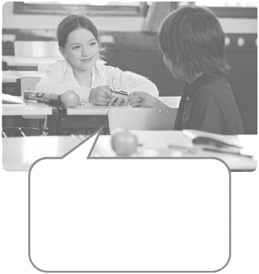

your our
his your
my their
her

1. Is this ______
Pencil?
Yes, thanks.

2. This is Jake.
I like ________
hat.

• This is my
book.



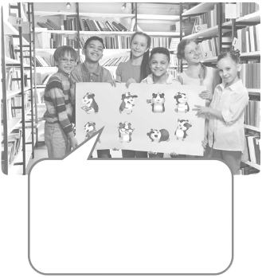


6. I like rabbits.
I think _______
ears are cool!
5. Open _______
books on
page 32.

4. These are
________
pictures.

3. Oh, it’s Rihanna.
I love _______
music!

B. Circle the correct possessive determiner.
(Rodeia o possessive determiner correto.)
1. Hello. I’m your new teacher. My / our name’s Richard Kelly.
2. Cristiano Ronaldo is a good football player, but I don’t like your / his hair!
3. We are good students. Our / Their class is the best in the school.
4. Please stop and put your / my pens on the desk.
5. She lives in New York. His / Her house is fantastic!
6. My favourite band is D.A.M.A. Their / Her music is great.

C. Complete the text with possessive determiners.
(Completa o texto com os possessive determiners.)
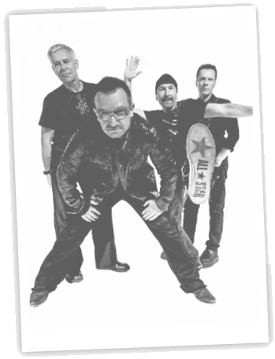
U2 is a famous band from Ireland. The singer is very famous – (1) ______ name is Bono. There are three other people in the band. (2) _______ names are Adam Clayton, Larry Mullen Jr and The Edge. Millions and millions of people have got (3) ______ albums. I like them, but they are not (4) ______ favourite band. My sister has got three albums and (5) ______ favourite is Zooropa. Bono is very interested in ecology. He says “We are all important. It is (6) ______ responsibility to save the planet!” What’s (7) ______ opinion?

A. Put the words in order to make sentences: affirmative (✔), negative (x) or interrogative (?).
(Ordena as palavras para formares frases: afirmativas (✔), negativas (x) ou interrogativas (?).)
1. new schoolbag / got / a / have / I (✔)
____
2. today / hasn’t / Lucy / a test / got (x)
____
3. big car / got / have / your parents / a (?)
____
4. thirty / has / classroom / chairs / got / our (✔)
____
5. your / haven’t / homework / got / you (x)
____ !

B. Use the words to make complete sentences: affirmative (✔), negative (x) or interrogative (?). There is one example. (Usa as palavras para construíres frases: afirmativas (✔), negativas (x) ou interrogativas (?). Segue o exemplo.)
• we / got / sport / today (✔)
_We have got sport today___
1. your mum / got / long hair (?)
____
2. our teacher / got / long hair (x)
____
3. my sisters / got / one bedroom (✔)
____
4. you / got / a new video game (?)
____
5. I / got / TV / in my bedroom / a (x)
____

C. Answer the questions about YOU. Use have got in your answers.
(Responde às questões sobre TI. Usa have got nas tuas respostas.)
1. Have you got any brothers or sisters? ___ _
2. Has your house got a garden? __ _
3. How many books have you got today? ___ _
4. Have you got a pet? ____
5. Have you got school tomorrow? ____
A. Read the sentences and write the numbers in the table. There is one example.
(Lê as frases e escreve os números na tabela. Segue o exemplo.)

1. My name’s Jilly.
Sentences with…
to be | have got
1
2. I’ve got a big family.
3. I’m twelve years old.
4. I’ve got brown hair.
5. My hair isn’t very long.
6. Is your house big?
7. We’ve got a garden, but we haven’t got a swimming pool!

B. Circle the correct option.
(Rodeia a opção correta.)
1. My brother has got / is tall and he has got / is blue eyes.
2. My school bag isn’t / hasn’t got big. I have got / am twenty books in it!
3. My friends are / have got good at English. We are / have got a good teacher!
4. Are you / Have you got in the football team?
5. How old are you / have you got? I am / have got 13 years old. Today is / has got my birthday!
6. I am / have got hungry! Have we got / Are we any biscuits, Mum?

C. Complete the text with the correct form of have got or to be.
(Completa o texto com a forma correta de have got ou to be.)
This (1) _______ my classroom. It (2) _______ really big! It (3) _______________ a big whiteboard and a projector. I (4) _______________ twenty-five classmates. We (5) _________all good friends! Some of my friends (6) ______________ eleven years old and some of them (7) ____________ twelve. I (8) ______________ (not) very tall, but one girl in my class is 1 metre 60 tall! She (9) ______________ long legs, but she (10) _______________ (not) long hair. She (11) ________________ very pretty. She (12) __________ my best friend!

D. Write complete sentences about the informationon this ID card. There is one example.

(Escreve frases completas sobre a informação
deste bilhete de identidade. Segue o exemplo.)
• …His name is Peter Shaw....
1. ..
Name: Peter Shaw
Age: 12 years old. (1)
Family: one brother (2)
Height: 1 m 52 (3)
Hair: dark (4)
Eyes: brown (5)

2. ..
3. ..
4. ..
5. ..
School
ID Card
A. Look at the pictures. Complete the sentences with ’s or ’.
(Observa as imagens. Completa as frases com ‘s ou ’.)


This is Kate and her
brothers, Harry and Billy –
they are twins.

1. Kate_____ brothers are short and thin.
2. The twins_____ hair is short and brown but their sister_____ hair is blond.
3. The boys_____ clothes aren’t exactly the same.
4. The twins_____ favourite sport is swimming.
5. Their sister_____ favourite sport is football.

B. Look at the pictures in exercise A again. Complete the sentences with the names and ’s or ’.
(Observa novamente para as imagens do exercício A. Completa as frases com os nomes e ‘s ou ’.)
1. ______________ shirt is white.
2. ______________ brothers are handsome.
3. ______________ sister is pretty.
4. ______________ pet is a rabbit. The ______________ name is Nibbles.
5. ______________ pet is a dog. The ______________ name is Dash.

C. Look at the pictures of their possessions. Write questions and answers about possession. There is one example. (Observa as imagens dos objetos. Escreve as questões e as respostas sobre posse. Segue o exemplo.)



2

3
1

4

THE TWINS
KATE

• …Whose CD is this.. .? …It’s Kate’s CD.. .
1. . ? . .
2. . ? . .
3. . ? . .
4. . ? . .

A. Circle the possessive pronouns from the box. There is one example.
(Rodeia os possessive pronouns da caixa. Segue o exemplo.)
theirs how us mine me ours
there hers this yours his you

B. Complete the table with the possessive pronouns from the box.
(Completa a tabela com os possessive pronouns da caixa.)
Possessive determiners | Possessive pronouns
This is my schoolbag. | It’s (1) ______________.
Is that your phone? | Is that (2) ______________?
I think those are his shoes. | They’re (3) ______________.
This is her homework. | It’s (4) ______________.
This is our car. | It’s (5) ______________.
Are these your books? | Are they (6) ______________?
Where is their classroom? | Where is (7) ______________?

C. Circle the correct option to complete the sentences.
(Rodeia a opção correta para completar as frases.)
1. I haven’t got my / mine homework. Have you got your / yours?
2. It says “Mike” on this coat. I think it’s he’s / his.
3. You sing your / yours part and we sing our / ours.
4. Chris has got his / their test but Rachel hasn’t got her / hers.
5. You haven’t got your / yours book? You can look at my / mine.
6. Lynn and Freddie can’t come to my / mine house, so I’m going to their / theirs.

D. Complete the sentences with a possessive pronoun.
(Completa as frases com um possessive pronoun.)
1. Excuse me, Mr Jackson? This test hasn’t got my name on it. It isn’t ___________.
2. Ellen’s painting is good, but I prefer ___________, Anna – it’s excellent!
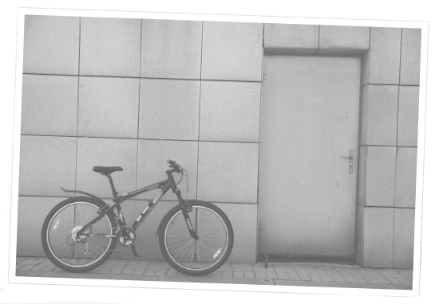
3. The twins have got a really good camera. Why don’t we use ___________?
4. There are two parties on Saturday. Maggie’s my best friend,
so I want to go to ___________.
5. Our class has a great art project – I hope
the judges choose ___________!
6. Where is Paul’s bike? I can see mine
but I can’t see ___________.

A. Read the sentences and write the numbers in the table. There is one example.
(Lê as frases e escreve os números na tabela. Segue o exemplo.)
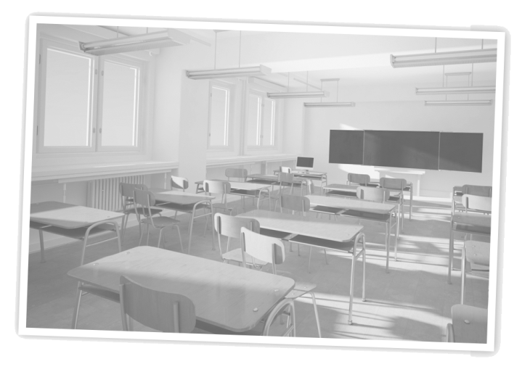
1. There aren’t any students in the classroom.
2. Is there a gymnasium in your school?
Yes, there is.
3. There’s a good film at the cinema.
4. Are there many TVs in your house?
No, there aren’t.
5. There isn’t a holiday this week.
6. There are three parks in my town.

Singular |  |  |  | Plural
✔ | x | ? |  | ✔ | x | ?
 |  |  |  |  | 1

B. Look at the picture. Complete the sentences with the verb there + to be.
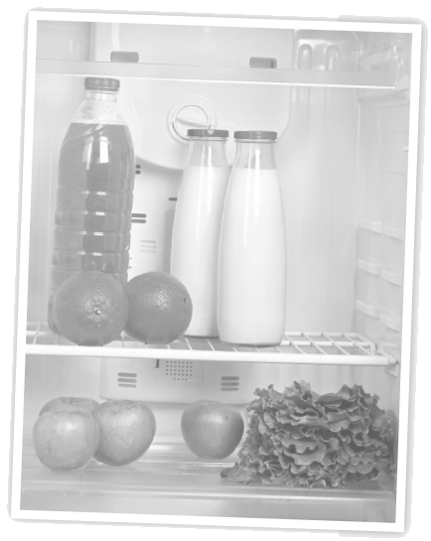
(Observa a imagem. Completa as frases com o verbo there + to be.)
1. ______________ any juice in the fridge?
Yes, ______________.
2. ______________ any eggs for breakfast.
3. ______________ a lettuce next to the apples.
4. ______________ two bottles of milk.
5. ______________ any carrots?
No, ______________.
6. I want chocolate milk but ______________ any!

C. Answer the questions about YOU.
(Responde às questões sobre TI.)
1. How many TVs are there in your house?
…There..
2. Is there a computer in your bedroom?

3. How many bedrooms are there in your house?

4. Is there a swimming pool at your school?

5. What is there in your schoolbag now?

A. Complete the sentences with the words from the box. There is one example.
(Completa as frases com as palavras da caixa. Segue o exemplo.)
do go doesn’t Do Does goes don’t doesn’t

1. I …go.. to school at 8:30. He ______________ to school by bus.
2. We ______________ (not) watch TV in the morning. She ______________ (not) have a shower
in the evening.
3. ______________ you have dinner at home? Yes, we ______________.
4. ______________ she like chocolate? No, she ______________.

B. Match the beginning to the end of the sentences. There is one example.
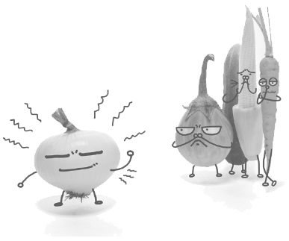
(Liga o início e o final das frases. Segue o exemplo.)
We don’t 1. • • a) goes to the cinema.
Does he go 2. • • b) on Sundays.
On Saturdays she 3. • • c) like onions.
What time do you 4. • • d) to school by bus?
They watch 5. • • e) TV in the evening.
My dad doesn’t work 6. • • f) go to bed?

C. Make these sentences negative. There is one example.
(Transforma as frases para a negativa. Segue o exemplo.)
• We have breakfast in the kitchen.
We don´t have breakfast in the kitchen...
1. Phil brushes his teeth after lunch.

2. It rains a lot in Lisbon.

3. You do your homework in the morning.

4. I go to bed at midnight.

D. Read the answers and write questions. There is one example.
(Lê as respostas e escreve as questões. Segue o exemplo.)
• …Do you like English classes________..? Yes, I do. I love English classes!
1. …______________________morning..? No, I don’t. I have a shower in the evening.
2. …_______________________Moana..? Yes, I do. It’s my favourite film.
3. …______________________at home..? No, she doesn’t. She has lunch in the canteen.
4. …What time____________________..? I start school at 8:30.
A. Circle the correct verb to complete the sentences.

(Rodeia o verbo correto para completares as frases.)
1. I study / studies English every day.
2. My sister play / plays basketball for the school team.
3. Kids don’t / doesn’t go to school on Saturdays.
4. Do / Does you play video games every day?
5. Does school finish / finishes at five o’clock?
6. We don’t / aren’t have breakfast at school.

B. Put the words in order to make sentences: affirmative (✔), negative (x) or interrogative (?).
(Ordena as palavras para formares frases: afirmativas (✔), negativas (x) ou interrogativas (?).)
1. your homework / do / do / when / you (?)

2. I / the bus / after school / catch / don’t (x)

3. at midnight / goes / brother / to bed / my (✔)

4. in / they / do / the canteen / lunch / have (?)

5. get up / the morning / she / in / does / what time (?)

6. your / you / brush / at school / teeth / don’t (x)

C. Complete the text with the correct form of the verb in brackets.
(Completa o texto com a forma correta do verbo entre parêntesis.)
My dog (1) ________________ (have ✔) a great life. He (2) ________________ (get up x) early, we (3) _________________ (make ✔) his breakfast for him and he (4) __________________ (go x) to school. I (5) _______________ (take ✔) him for a walk every day and he (6) _______________ (run ✔) in the park. What (7) ________________ (he / do ?) the rest of the day? He (8) ________________ (sleep ✔)! I (9) ___________________ (want x) to be a kid… (10) ___________________ (you want ?) to be a dog with me?!?

D. Answer about YOU. (Responde sobre TI.)
1. What time do you get up in the morning? ______________
2. What sports do you play? ______________
3. When do you watch TV? ______________
4. What food do you like? ______________

A. Do you agree? Put a tick (✔) for Yes, I agree and a cross (x) for No, I don’t agree.
(Concordas? Coloca um ✔ para Yes, I agree e um x para No, I don’t agree.)
1. I like going to the beach.  5. I like eating pizza.
2. I love doing homework. 6. I don’t like singing.
3. I like playing video games. 7. I don’t like playing games on my phone.
4. I hate watching football. 8. I prefer watching films.

B. Write the -ing form of the verbs. There is one example.
(Escreve a -ing form dos verbos. Segue o exemplo.)

• do …doing...
1. listen ...
2. write ...
3. sit ...
4. watch ...
5. sleep ...
6. run ...
7. fly...

C. Find and circle the mistakes in the sentences. Write them correctly. There is one example.
(Encontra e rodeia os erros nas frases. Escreve-as corretamente. Segue o exemplo.)
• I like go to school on my bike. …I like going to school on my bike....
1. Jill doesn’t like to drinking cold milk. …...
2. You hating watching cartoons. …...
3. My mum loves it making cakes. …...
4. I prefer to cooking lasagne. …...

D. Write sentences about YOU. Use I love…, I like…, I don’t like… or I hate… and choose expressions from the box.
(Escreve frases sobre TI. Usa I love..., I like..., I don’t like... ou I hate... e escolhe expressões da caixa.)

eat pizza play volleyball brush my teeth study English
go to the supermarket cook go to bed late go to the cinema

1. …...
2. …...
3. …...
4. …...
5. …...

A. Look at the examples. Pay attention to the position of the adverbs.
(Observa os exemplos. Presta atenção à posição dos adverbs.)
• I sometimes go to the cinema on Saturday. I never go to the theatre.
• Jackie is always on time for school. She’s never late!
Find the adverb that is not in the correct position in each sentence. There is one example.
(Encontra o adverb que não está na posição correta em cada frase. Segue o exemplo.)
• Always I always have a shower in the morning.
1. We usually have breakfast usually in the kitchen.
2. I sometimes go sometimes to my grandparents’ house at the weekend.
3. Never my friend Ana is never unkind to other people.
4. I sometimes take my phone sometimes to school.

B. Look at the information and write sentences with an adverb of frequency. Use the words in brackets. There is one example. (Observa a informação e escreve frases com um adverb of frequency. Usa as palavras entre parêntesis. Segue o exemplo.)
Monday-  Thursday ✔ | 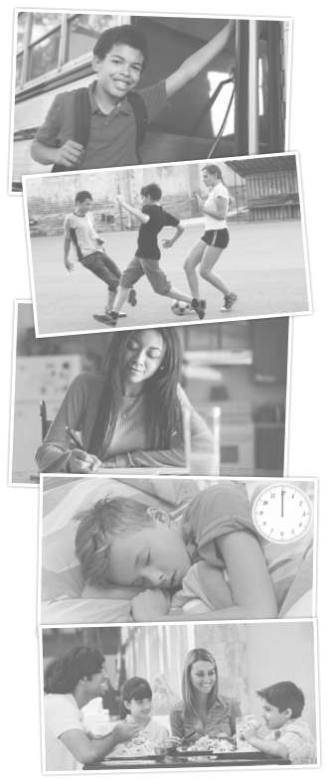 | • (Dean / go to school by bus).  Dean usually goes to school by bus.
Monday-  Friday ✔ |  | 1. (they / play football after school)  ..
Monday ✔  Tuesday-  Friday x |  | 2. (Daisy / do her homework in the morning)  ..
Monday-  Sunday  x |  | 3. (I / go to bed at midnight)  ..
Sunday  ✔ |  | 4. (We / have lunch in a restaurant on Sunday)  ..

C. Write sentences about YOU. Use the pictures and verbs from exercise B.
(Escreve frases sobre TI. Usa as imagens e os verbos do exercício B.)
1. .. 3. ..
2 .. 4. ..

A. Complete the tables.
(Completa as tabelas.)
Affirmative |  |  | Negative
I | ’m sleeping. |  | I | ’m (4) _____ reading.
You | ’re (1) _________. |  | You | aren’t reading.
He / She / It | (2) _______ sleeping. |  | He / She / It | (5) _______ reading.
We | ’re sleeping. |  | We | aren’t reading.
You | ’re sleeping. |  | You | aren’t reading.
They | (3) _______ sleeping. |  | (6) _______ | aren’t reading.

Interrogative
Am | I | working?
(7) _______ | you | working?
Is | he / she /it | working?
Are | we | working?
Are | you | working?
(8) _______ | they | working?
Short answers
Affirmative |  |  | Negative
Yes, | I | am. | No, | I ’m | (10) _______.
Yes, | You | are. | No, | you | (11) _______.
Yes, | he / she /it | is. | No, | he / she /it | isn’t.
Yes, | we | are. | No, | we | aren’t.
Yes, | you | (9) _______. | No, | you | aren’t.
Yes, | they | are. | No, | They | aren’t.

B. Complete the sentences with the present continuous of the verbs in brackets.
(Completa as frases com os verbos entre parêntesis no present continuous.)
1. My sister Sofia ______________ (cook) dinner.
2. Michael and John ______________ (run) the marathon.
3. I ______________ (do) my homework.
4. That bird ______________ (fly) over the house.

C. Put the words in order to make sentences.
(Ordena as palavras para formar frases.)
1. are / new desk / Dad and I / a / making / . ______________
2. you / for lunch / are / making / what / ? ______________
3. feeling / is / the teacher / very well / not / . ______________
4. are / strange / the models / wearing / clothes / ! ______________
5. team / today / not / playing / are / very well / the Portuguese / . ______________
______________
6. you / buying / the theatre / are / for / tickets / ? ______________

A. Match the beginning and ending of these sentences. There is one example.
(Associa o início e o final destas frases. Segue o exemplo.)
Chloe and Jay 1. • • a) a marathon!
Why are you 2. • • b) having fun at the party.
I’m not listening 3. • • c) to music at the moment.
They aren’t 4. • • d) are going to the cinema.
My uncle is running 5. • • e) wearing a tracksuit?

B. Find the mistakes in these sentences. Write the correct sentence. There is one example.
(Encontra os erros nestas frases. Escreve a frase corretamente. Segue o exemplo.)
• What film you are watching? …What film are you watching?
1. Our school bus are arriving at the museum. ..
2. Mum and Dad planning our next holiday. ..
3. Are you use your phone in class? ..
4. Is Sandy riding her bike to school? No, she doesn’t. ..
5. We not having lunch now. ..

C. Look at the pictures. Write sentences about the activities. Use the words in brackets and the present continuous. There is one example.
(Observa as imagens. Escreve frases sobre as atividades. Usa as palavras entre parêntesis e o present continuous. Segue o exemplo.)
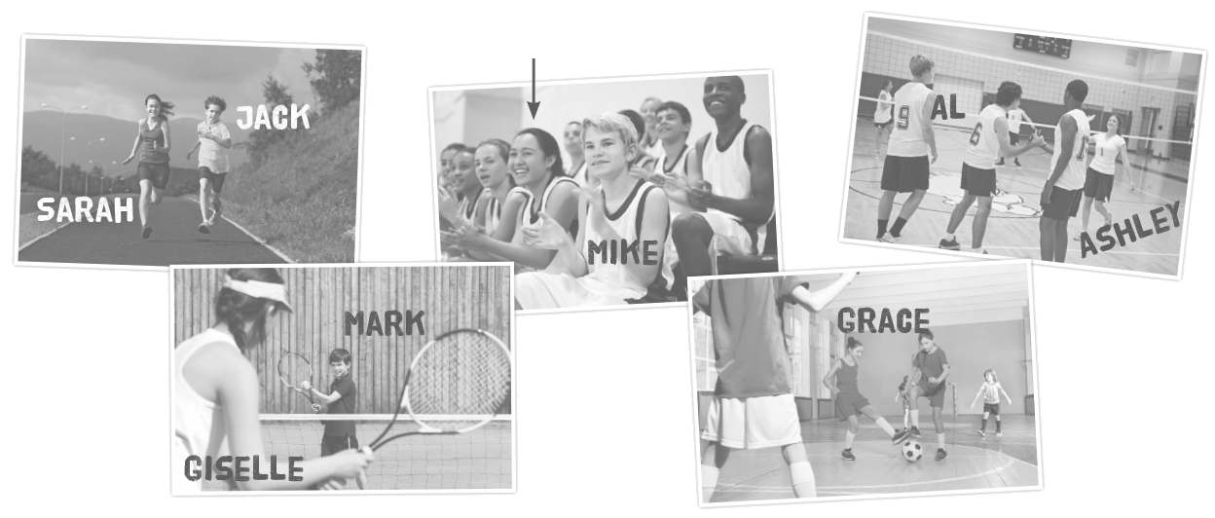
This is me!

• (Mike and I / watch basketball) …Mike and I are watching basketball..____________________...
1. (Grace / play basketball / ?) .. ? No, .. .. .. .. .. .. .. ...
2. (Jack and Sarah / run) ..
3. (Ashley and Al / swim) ..
4. (Giselle and Mark / play tennis / ?) .. ?
Yes, .. .. .. .. .. .. .. ...
A. Find and circle the object pronouns in this word snake. There is one example.
(Encontra e rodeia os object pronouns nesta word snake. Segue o exemplo.)
w h a t m e t h e y o u h a v eh i m p l a y h e r s c h o o l i t ca n u s g o t y o u l u n c h t h e m d a d
B. Match the object pronouns to the subjects. There is one example.
(Associa os object pronouns aos sujeitos. Segue o exemplo.)
Subject | Object
I | me
you | (1).. .. .. ..
he | (2).. .. .. ..
she | (3).. .. .. ..
it | (4).. .. .. ..
Subject | Object
we | (5) .. .. .. ..
you | (6) .. .. .. ..
they | (7) .. .. .. ..

C. Circle the correct option to complete the sentences.

(Rodeia a opção correta para completares as frases.)
1. Stop talking, everyone, and listen to I / me!
2. Do you want some strawberries? No, thanks.
I don’t like they / them.
3. We / Us love our dog and it loves we / us!
4. Don’t turn off the TV – I’m watching it / her.
5. Serena Williams is a fantastic tennis player.
I love watching she / her.
6. Where are you? I can’t see you / your!

D. Complete the sentences. Use subject pronouns or object pronouns.
(Completa as frases. Usa subject pronouns ou object pronouns.)
1. Do .. .. .. .. like your ice cream? They make .. .. .. .. fresh every day.
2. Let’s go to the zoo and see the animals. .. .. .. .. can see .. .. .. .. all in a day.
3. Jay and Kelly are fantastic students. .. .. .. .. are intelligent and the teachers love .. .. .. ..!
4. I don’t understand the homework. Can you help .. .. .. .., please?
5. We have got a Christmas tree in our living room. .. .. .. .. is beautiful and there are lots of presents under .. .. .. ..!
6. At our end-of-year party, the teachers always do a show for .. .. .. ..!

A. Complete these notices. Use the words from the box.
(Completa estes avisos. Usa as palavras da caixa.)

not please don’t be



1. Please, do .. .. .. .. 2. Please, .. .. .. .___. 3. .. .. ..____ .., visit 4. .. .. .. .. __ forget
feed the animals. quiet in the our gift shop! your things!
reptile room.

B. Complete these instructions with imperatives – positive or negative. Use the verbs from the box. (Completa estas instruções com o imperativo – positivo ou negativo. Usa os verbos da caixa.)
1. Please .. .. .._______ . down at the desk with your student number.
forget
give
talk
sit
write
2. .. .. .._______ . in the exam room.
3. .. .. .._______ . your answer with a pen.
4. Please .. .. .._______ . your paper to the teacher at the end.
5. .. .. .._______ . to write your name!

C. Circle the correct verbs in the notices from Crazy School.
(Rodeia os verbos corretos nestes avisos da Crazy School (Escola Louca).)
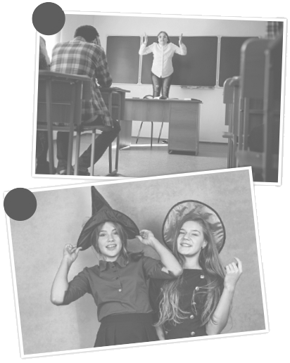
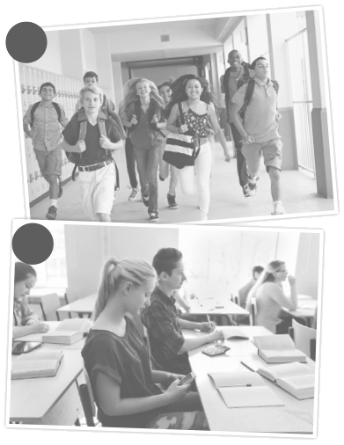
1. Please run / talk in the
2
1
corridors.
2. Don’t listen / Don’t talk to
your teacher!
3. Don’t use / Use your phone
4
3
in the classroom.
4. Don’t wear / Wear
appropriate clothes.

D. Invent two new rules for Crazy School.
(Inventa duas novas regras para a Crazy School (Escola Louca).)
1. .. .. .._______ .
2. .. .. .._______ .

