Review
Worksheets
Vocabulary
School objects 30
Means of transport 31
Personal information 32
Family 33
Jobs and occupations 34
Physical description 35
Clothes, footwear and accessories 36
Food and drinks 37
Daily routine 38
Free time activities 39
Sports 40
Grammar
Personal pronouns 42
Present simple: verb to be 43
Question words 44
Articles (an, a, the, omission of the) 45
Possessive determiners 46
Present simple: verb have got 47
To be vs have got 48
Possessive case and whose…? 49
Possessive pronouns 50
Verb there + to be 51
Present simple 1 52
Present simple 2 53
Verb + -ing 54
Adverbs of frequency 55
Present continuous 1 56
Present continuous 2 57
Personal pronouns (object) 58
Imperative 59
Answer key 60
Available in editable format at | 


1
2
3
4
5
6
7
8
9
10
11
1
2
3
4
5
6
7
8
9
10
11
12
13
14
15
16
17
18

A. Label the school objects. (Legenda os objetos escolares.)
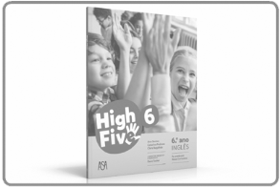
1. … ... 2. … ... 3. … ... 4. … ...

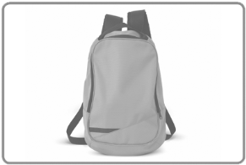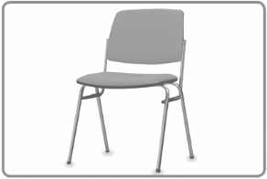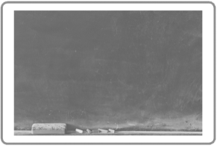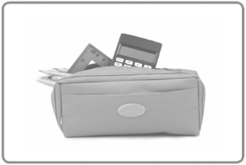
5. … ... 6. … ... 7. … ... 8. … ...

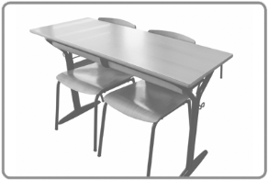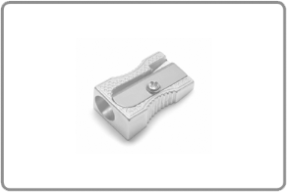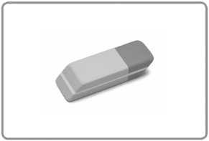
9. … ... 10. … ... 11. … ... 12. … ...

B. What goes with you and what stays in the classroom? Write the school objects from exercise A in the correct place. (O que levas contigo e o que deixas na sala de aula? Escreve o nome dos objetos escolares do exercício A no local correto.)

a) You take it with you b) It stays in the classroom

C. Answer the questions about YOU. Write the school objects.
(Responde às questões sobre TI. Escreve o nome dos objetos escolares.)
1. What do you use in your English class? … ..., … ..., … ...
2. What do you usually use in your art class? … ..., … ..., … ...
3. What does the teacher usually use? … ..., … ..., … ...

A. Unscramble the letters to make the names of the means of transport.
(Ordena as letras para formares os nomes dos meios de transporte.)
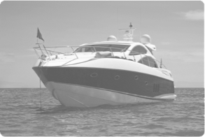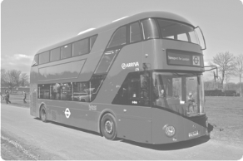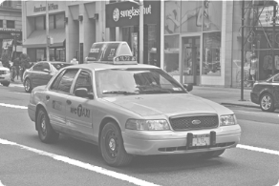
1. boomkirte 2. atob 3. sub 4. ixta
… ... … ... … ... … ...

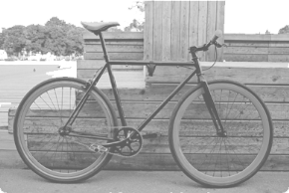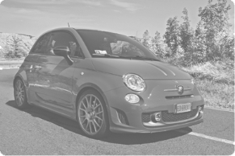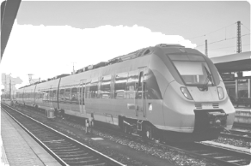
5. kibe 6. lapen 7. arc 8. ranit
… ... … ... … ... … ...

B. What’s your experience with these means of transport? Write the means of transport in the diagram. Compare it with a friend.
(Qual é a tua experiência com estes meios de transporte? Completa o diagrama. Compara com um colega.)

This week This year In my life Never

A. Complete the information on Dwayne Johnson’s ID card. Use the words and numbers from the box. (Completa a informação do cartão de identificação do Dwayne Johnson. Usa as palavras e os números da caixa.)
2nd actor Johnson 1.96 m Nationality Name


HOLLYWOOD ID CARD

(1) … ...: Dwayne
Surname: (2) … ...
Birthday: (3) … ... May
(4) … ...: American
Hometown: Hayward, California, USA
Height: (5) … ... tall
Job: (6) … ...

B. Match the questions to the answers. There is one example.
(Liga as questões às respostas. Segue o exemplo.)
What’s his name? 1. • • a) His surname’s Johnson.
What’s his surname? 2. • • b) He’s American.
When is his birthday? 3. • • c) He’s from California, USA.
What nationality is he? 4. • • d) His name’s Dwayne.
How tall is he? 5. • • e) He’s an actor.
What’s his job? 6. • • f) His birthday is on 2nd May.
Where is he from? 7. • • g) He’s 1.96 m tall.

C. Complete the questions. Then answer about YOU.
(Completa as questões. Depois, responde sobre TI.)
1. … ... your name?
2. What’s … ... surname?
3. Where are … ... from?
4. … ... tall are you?
5. What nationality … ... you?
6. How … ... are you?
7. … ... your occupation?

D. Now ask and answer the questions with a friend.
(Agora, questiona e responde com um colega.)

A. Write the missing vowels in the family words. There is one example.
(Escreve as vogais nas palavras sobre a família. Segue o exemplo.)
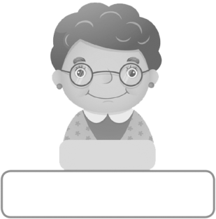
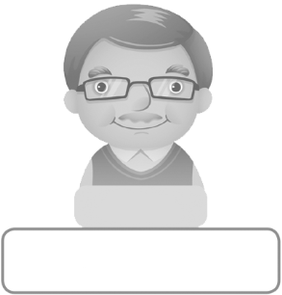

Ian Alice
• gr a ndf a th e r 1. gr ndm th r






Colin Jess Eddie Carol
2. f th r 3. m th r 4. ncl 5. nt

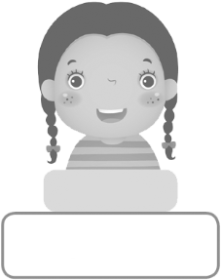




Jack Annie Lee Lisa
6. s st r 7. br th r 8. c s n

B. Complete these sentences with other family words. Use the words from the box.
(Completa as frases com outras palavras sobre a família.
Usa as palavras da caixa.)
1. Lee is Jess and Colin’s … _______ ___ .... son
2. Lisa is Eddie and Carol’s … _______ ___ .... parents
3. Jess and Colin are Jack’s … _______ ___ .... husband
4. Ian is Alice’s … _______ ___ .... children
5. Carol is Eddie’s … _______ ___ .... daughter
6. Jess and Colin have got three … _______ ___ .... wife

C. Now answer the questions about YOU. Give complete answers.
(Agora, responde às questões sobre TI. Dá respostas completas.)
1. Have you got any brothers or sisters? .
2. Have you got any uncles or aunts? .
3. How many cousins have you got? .
4. Where do your grandparents live? .

A. Unscramble the letters and label the jobs or occupations.
(Ordena as letras e legenda as profissões ou ocupações.)

1. rensig 2. hatrece 3. yabbtresit 4. reuns
… ... … ... … ... … ...


5. rotcod 6. hinccame 7. coko 8. suttend
… ... … ... … ... … ...

B. Complete the diagram. Use the words from the box. There are three examples.
(Completa o diagrama. Usa as palavras da caixa. Segue os três exemplos.)
vet football player firefighter police officer teacher
doctor lawyer engineer babysitter
a) Works b) Works inside c) Works
inside and/or outside outside


teacher football player

vet

C. Answer the questions about YOU.
(Responde às questões sobre TI.)
1. What’s your favourite job?
2. Which are difficult jobs, in your opinion?
3. What job do you never want to do?

A. Match the opposites. Write numbers. There is one example.
(Associa os opostos. Escreve os números. Segue o exemplo.)
1. small eyes 2. curly hair 3. thin 4. short 5. young 6. short hair

a) long 6 b) tall c) straight d) fat e) big eyes f) old
hair hair

B. Label the pictures. Use the words/expressions from exercise A.
(Legenda as imagens. Usa as palavras/expressões do exercício A.)
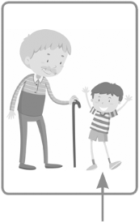
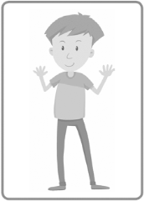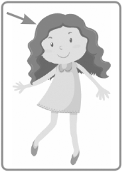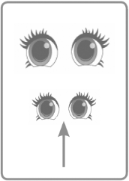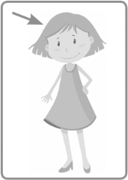
1. … ... 2. … .. 3. … .. 4. … ... 5. … ... 6. … ...
… ... … ... … ... … ... … ... … ...

C. Put the words in order to make sentences.
(Ordena as palavras para formar frases.)
1. hair / he / short curly / got / has
2. long dark / got / she / hair / has
3. dad / and thin / is / tall / my
4. old / my / and short / is / grandma
5. he / eyes / big brown / got / has

D. Look at the pictures. Complete the texts.
(Observa as imagens. Completa os textos.)

This is Sadness from the film Inside Out. She is (1) sh and fat.
She has got straight blue (2) ha and she wears big (3) gl .
Her legs are (4) s and her (5) no is small.
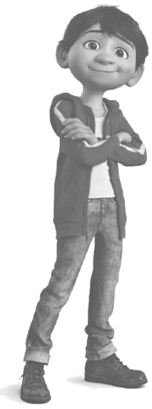
This is Miguel from the film Coco. He is (6) t
and (7) th . He’s got (8) sh
(9) da hair and his (10) ey
are (11) br .

A. Match the beginnings and the ends to make the names of clothes. Then use the words to label the pictures. There is one example.
(Liga o início ao final das palavras para formares os nomes de peças de roupa. Depois, usa as palavras para legendar as imagens. Segue o exemplo.)

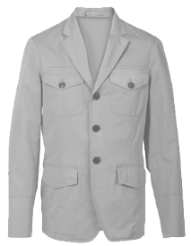
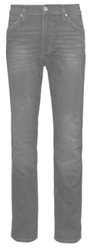
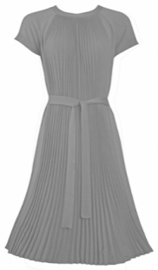

dre 1. • • a) ket
je 2. • • b) ss
jac 3. • • c) ans

• dress A. ____ B. ____


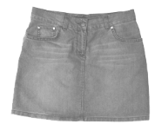

so 4. • • d) rf
sca 5. • • e) irt
sk 6. • • f) cks
C. ____ D. ____ E. ____

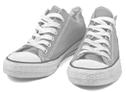

trai 7. • • g) es
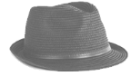
sho 8. • • h) ners
h 9. • • i) at
F. ____ G. ____ H. ____

B. Answer the questions about YOU.
(Responde às questões sobre TI.)
1. What clothes do you usually wear to school:
a) in the summer? ____________________, ____________________, ___________________
b) in the winter? ____________________, ____________________, ____________________
2. What clothes do you wear to play sports? ______________, ______________, ______________
3. What clothes do you wear to a party? _______________, _______________, _______________

C. Write about your favourite clothes: colour and size. There is one example.
(Escreve sobre a tua roupa favorita: cor e tamanho. Segue o exemplo.)
• _My favorite hat is grey and brown and it’s small.____________________________________
1. My favourite trainers are ___________________ .
2. My favourite is / are ___________________ .

A. Complete the names of the food with a, e, i, o or u. There is one example.
(Completa os nomes dos alimentos com a, e, i, o ou u. Segue o exemplo.)

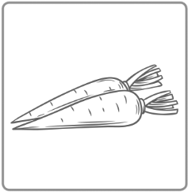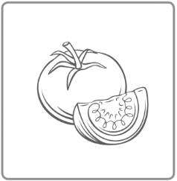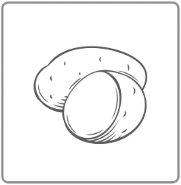
• c a rr o ts 1. __n__ __ns 2. t__m__t__ __s 3. p__t__t__ __s 4. m__lk

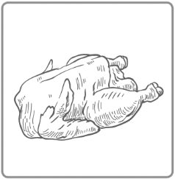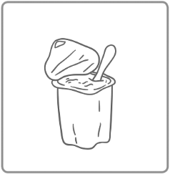
5. str__wb__rr__ 6. _c_ cr_ _m 7. m__ __t 8. ch__ck__n 9. y__gh__rt

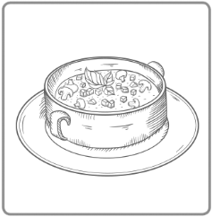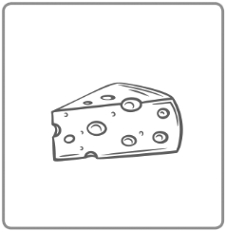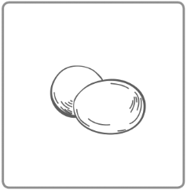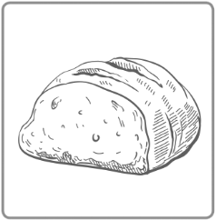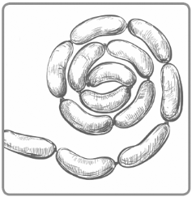
10. s__ __p 11. ch__ __s__ 12. __ggs 13. br__ __d 14. s__ __s__g__s

B. Complete the sentences with the words in exercise A.
(Completa as frases com as palavras do exercício A.)
1. I sometimes eat ___________________ for breakfast.
2. I sometimes eat ___________________ for dinner.
3. I sometimes eat ___________________ for dessert.
4. I never eat ___________________ for __________________________.

C. Answer the questions about YOU.
(Responde às questões sobre TI.)
1. What’s your favourite food?
___________________
2. What food don’t you like?
___________________
3. What food do you like cooking?
___________________

A. Complete the activities with the words from the box. There is one example.
(Completa os nomes das atividades com as palavras da caixa. Segue o exemplo.)
have up catch lunch to teeth
bed watch do have shower get
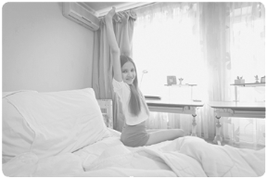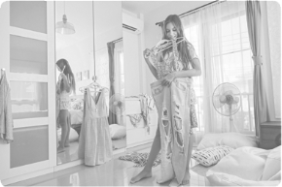
• get up 1. have a 2. 3. _____________
dressed breakfast

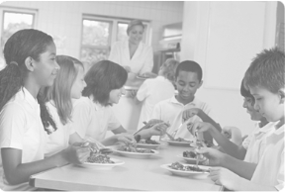
4. 5. go 6. have 7. _____________
the bus school your homework

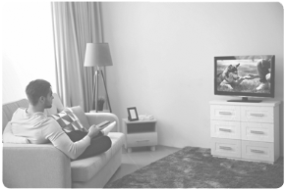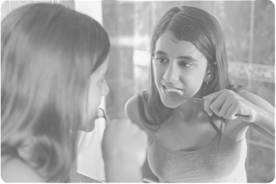
8. 9. TV 10. brush your 11. go to
dinner ______________

B. What order do you do these activities in? Write sentences. There is one example.
(Por que ordem realizas estas atividades? Escreve as frases. Segue o exemplo.)
• have breakfast / get dressed First I get dressed and then I have breakfast .
1. watch TV / do my homework
First __________________________ and then __________________________ .
2. have dinner / brush my teeth
_____________________________ and then __________________________ .
3. go to school / have lunch
____________________________ and then __________________________ .
4. catch the bus / have breakfast
__________________________ and then __________________________ .

A. Match the beginning and end to make free time activities. Then label the pictures.
There is one example.
(Liga o início e o final das expressões para formares nomes de atividades nos tempos livres.
Depois legenda as imagens. Segue o exemplo.)
  • listening to music |   A. ________________
  B. ________________ |   C. ________________
  D. ________________ |   E. ________________
  F. ________________ |   G. ________________

listening 1. • • a) cards
reading 2. • • b) the cinema
going to 3. • • c) a book
playing 4. • • d) to music
watching 5. • • e) video games
hanging out 6. • • f) with friends
surfing 7. • • g) the net
playing 8. • • h) TV

B. Do you prefer doing these activities alone or with other people? Complete the diagram with the words/expressions from exercise A. Compare with a friend.
(Preferes realizar estas atividades sozinho ou com outras pessoas? Completa o diagrama
com palavras/expressões do exercício A. Compara com um/a colega.)
a) Only me b) Sometimes alone, sometimes c) With other
with other peoplepeople people


A. Label the sports. Use the words from the box.
(Identifica os desportos. Usa as palavras da caixa.)
football ice skating snorkelling skiing cycling gymnastics
swimming baseball tennis volleyball judo basketball

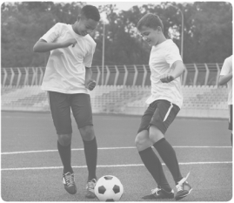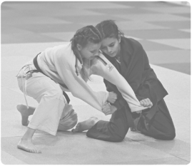
• _swimming____ 1. … ... 2. … ... 3. … ...

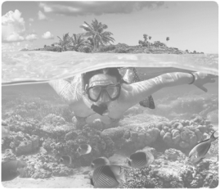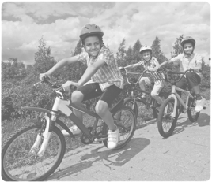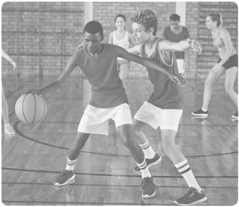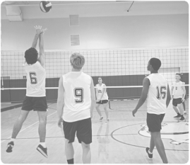
4. … ... 5. … ... 6. … ... 7. … ...

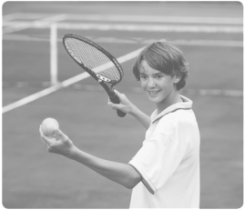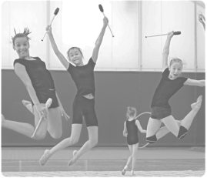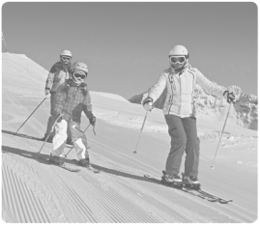
8. … ... 9. … ... 10. … ... 11. … ...

B. Which sports can be individual? Which sports need other people? Complete the table.
(Quais são os desportos individuais? E os coletivos? Completa a tabela.)
Can be individual | Need other people

C. Answer the questions about YOU. (Responde às questões sobre TI.)
1. What’s your favourite sport? …
2. What sports don’t you like? …
3. What new sport would you like to try? …

