
A. Look at the fact file and read the text.
Fact file
- Name: Charlie Puth
- Age: 27 years old
- Job: singer
- Height: tall
- Weight: slim
- Eyes: brown
- Hair: short; brown
- General appearance: handsome
- Clothes: jeans; shirts; T-shirts
This is Charlie Puth.
He is 27 years old and he is a singer. He is tall and slim.
His eyes are brown and he has got short brown hair. He is handsome.
He likes wearing jeans, shirts and
T-shirts.





B. Choose one of these fact files and describe one of the celebrities to the class. You can also choose someone different to describe and play “Who is who?” (your colleagues have to guess the celebrity you are talking about, so don’t say his/her name). Use the model from A.
Fact file
- Name: Dwayne Johnson
- Age: 46 years old
- Job: actor
- Height: tall
- Weight: slim; muscled
- Eyes: brown
- Hair: short; brown
- General appearance: strong
- Clothes: T-shirts; jeans; trainers
Fact file
- Name: Zendaya Coleman
- Age: 22 years old
- Job: actress
- Height: tall
- Weight: thin
- Eyes: brown
- Hair: straight; long; brown
- General appearance: beautiful
- Clothes: shorts; sweaters; shoes; earrings




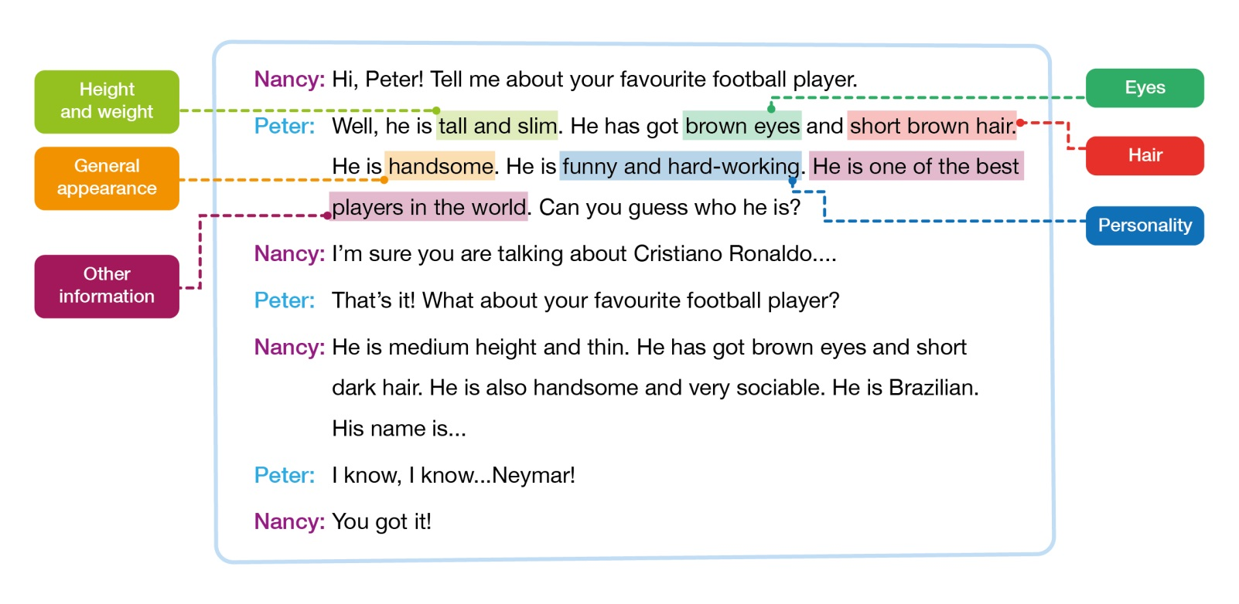
A. Nancy and Peter are talking about their favourite football players. Read their dialogue. Pay attention to the underlined information.

B. Think about your favourite football player, favourite actor/actress, favourite singer or favourite YouTuber (you can bring a photo of this person to class). Complete the table below with your partner.
 | Your favourite person | Your partner’s favourite person
Job
Height and weight
Eyes
Hair
General appearance
Personality
Other information

C. Role-play a dialogue with your partner. Use the model from A and the information from B.

