A. Match the descriptions with the pictures. Circle the correct names in the boxes.
(Liga as descrições às imagens. Rodeia os nomes corretos nas caixas.)

Lou
Susan
Miriam
Jack
Susan / Miriam
Jack / Susan
Jack / Miriam
Lou / Jack
1. She is short and fat. She has got long hair.
2. She is tall and slim. Her hair is wavy.
3. He is short and fat. He has got short straight hair.
4. He is tall and thin. His hair is short and curly.
B. Look at Moreno and Nina from the film Ferdinand and label their clothes / footwear / accessories. Use the words from the box.
(Observa as imagens de Moreno e Nina do filme Ferdinand e legenda as suas roupas / calçado / acessórios. Usa as palavras da caixa.)
trainers jacket T-shirt belt shoes jeans shorts shirt

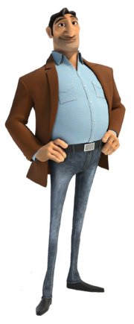
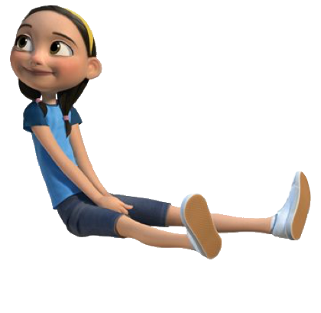
Moreno
3. __ __ __ __ __
Nina

1. __ __ __ __ __ __
6. __ - __ __ __ __ __

4. __ __ __ __
8. __ __ __ __ __ __ __ __
7. __ __ __ __ __ __
2. __ __ __ __ __
5. __ __ __ __ __

C. Circle the correct comparative form. There is one example.

(Rodeia a forma do comparativo correta. Segue o exemplo.)
- My hair is shorter / short than Mary’s.
1. Angus is funnier / funny than Ferdinand.
2. Ferdinand is strong / stronger than Valiente.
3. Lena is smart / smarter than her brother.
4. Martha is better / good at school than Peter.

D. Circle the correct superlative form. There is one example.
(Rodeia a forma do superlativo correta. Segue o exemplo.)
- I am young / the youngest student in my class.
1. Bob is the oldest / old in his family.
2. Our brother is the happiest / happy student in his class.
3. Juliet is thin / the thinnest girl at school.
4. You are the nicest / nice person I know.

E. Change the adjectives into adverbs by adding -ly. Make the necessary changes. There is one example.
(Transforma os adjetivos em advérbios juntando-lhes -ly. Faz as alterações necessárias. Segue o exemplo.)
- quick quickly______________  1. elegant ____________________  2. slow ______________________  3. terrible ____________________  4. easy ____________________ | 5. careful __________________  6. clear ____________________  7. bad _____________________  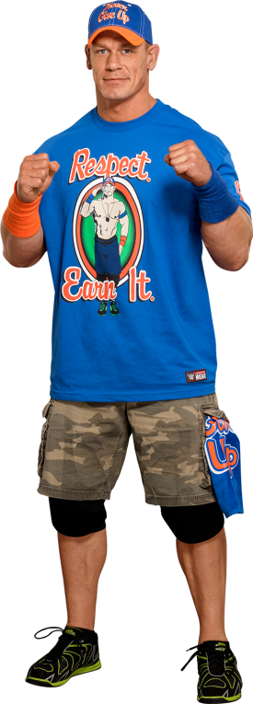  8. hard ____________________

F. John Cena is the voice of Ferdinand in the film. Look at the picture, read the text and underline the words that describe him.
(John Cena é a voz de Ferdinand no filme. Observa a imagem, lê o texto e sublinha as palavras
que o descrevem.)
John Cena is ⁽¹⁾ old / middle-aged. He is ⁽²⁾ tall / short and ⁽³⁾ fat / slim. His face is oval and he is ⁽⁴⁾ handsome / ugly.
He is ⁽⁵⁾ strong / weak.
He is wearing a ⁽⁶⁾ cap / hat, a ⁽⁷⁾ shirt / T-shirt and some ⁽⁸⁾ shorts / skirts.

Answer key
A. (4 x 3% = 12%)
1. Miriam | 2. Susan | 3. Jack | 4. Lou
B. (8 x 3% = 24%)
1. jacket | 2. jeans | 3. shirt | 4. belt | 5. shoes | 6. T-shirt | 7. shorts | 8. trainers
C. (4 x 3% = 12%)
1. funnier | 2. stronger | 3. smarter | 4. better
D. (4 x 3% = 12%)
1. the oldest | 2. the happiest | 3. the thinnest | 4. the nicest
E. (8 x 2% = 16%)
1. elegantly | 2. slowly | 3. terribly | 4. easily | 5. carefully | 6. clearly | 7. badly | 8. hardly
F. (8 x 3% = 24%)
1. middle-aged | 2. tall | 3. slim | 4. handsome | 5. strong | 6. cap | 7. T-shirt | 8. shorts

