

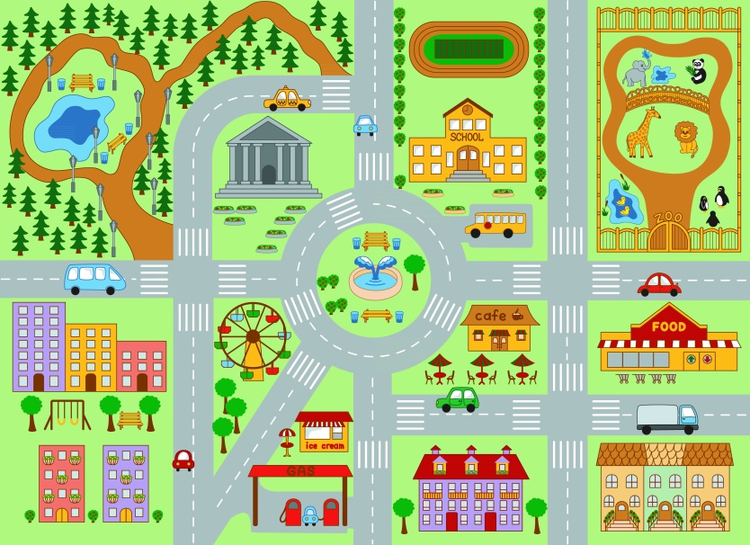
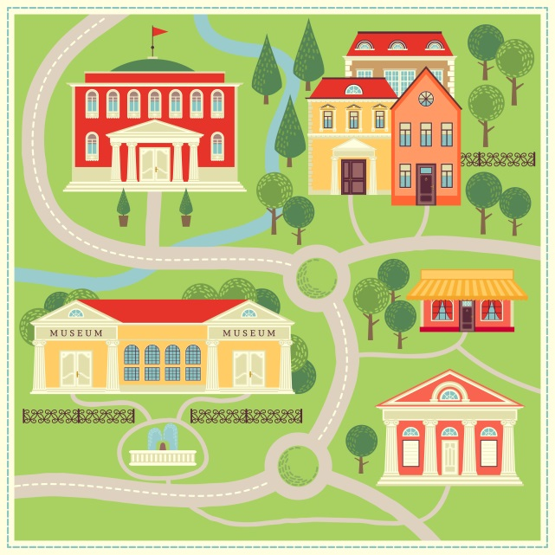
- Read the text about Skyline City!
15 years ago
The present

restaurant
Town Hall
school

Skyline City was smaller 15 years ago. There were some houses, a museum, the town hall, a small restaurant and a small school.
There wasn’t a zoo, a park or a café. There weren’t tall buildings and there weren’t so many cars in the streets.



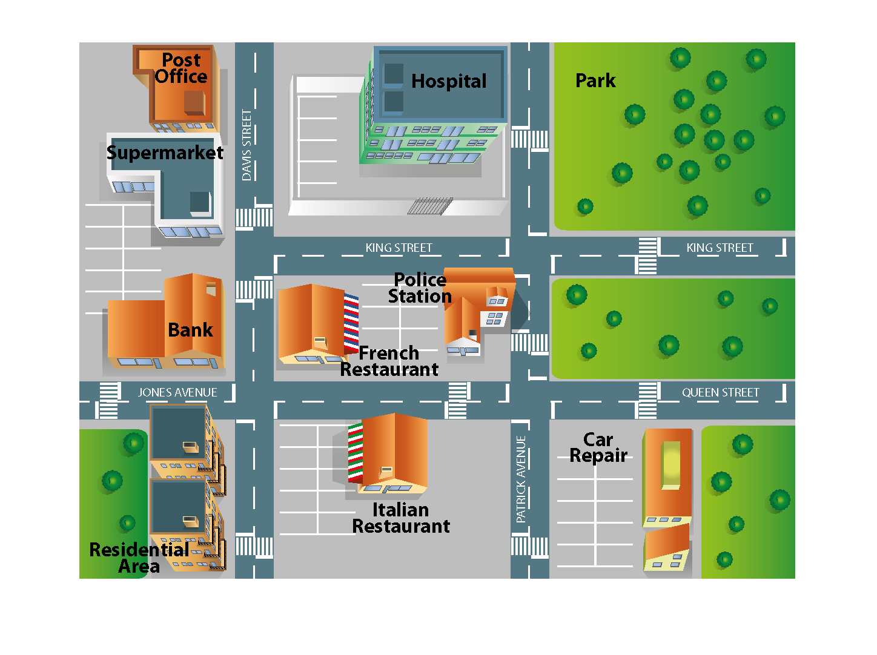
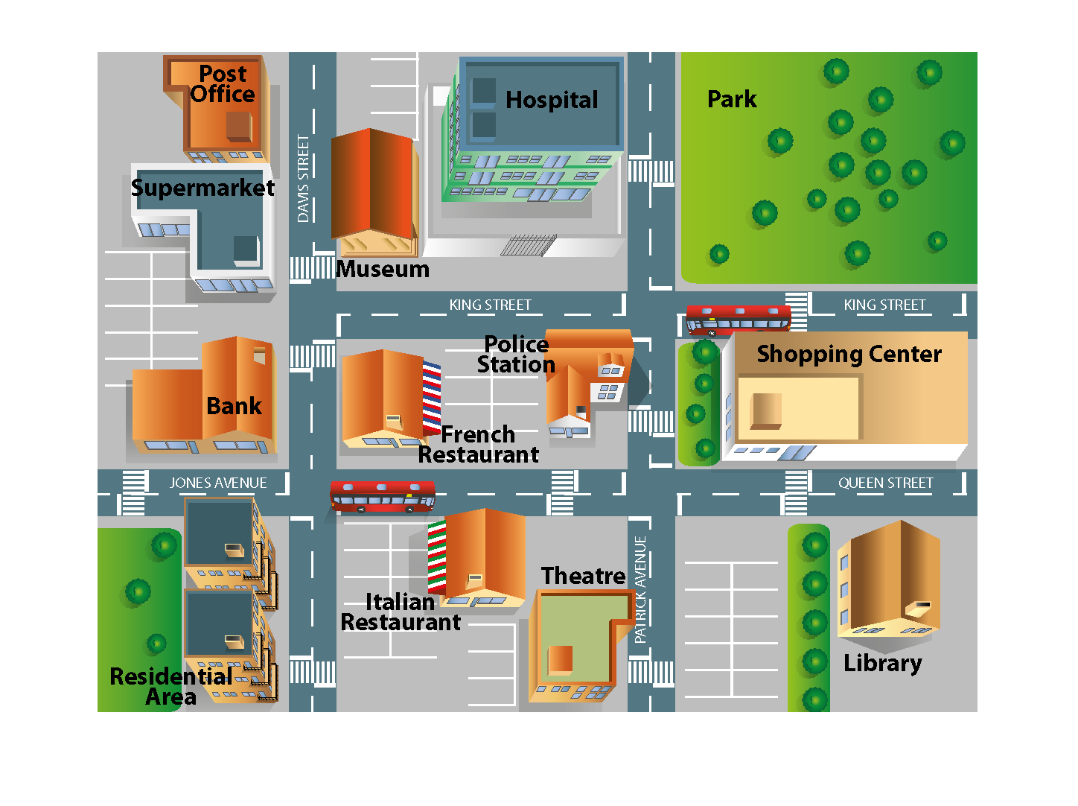
B. Look at the pictures of Vanilla City. Tell the class about what there was/wasn’t 10 years ago. Use the model from A to help you.
10 years ago
The present

A. Read the dialogue.

Jenna and Jack are talking about last weekend.


Jenna – Hi, Jenny! My last weekend was great. How was yours?
Jack – It was great too. My cousins were here and we watched the last Spider-Man film. We tried different food at the new Chinese restaurant and we walked along the streets. And you?
Jenna – Well, Martha was at my house. We walked Chase, my dog, and we visited the museum. Later we walked in the park.
Jack – We should meet next weekend and do something fun too. What do you think?
Jenna – Yes, good idea! We can go to the stadium and watch a football match!
Jack – Wow! That’s it!

- Think about your last weekend. Use the guide below and the model from A. Role-play a dialogue with your partner.

Student A Student B
Ask your partner about his/her last weekend
Answer about your weekend. Ask your partner about his/her weekend.
Ask about your partner’s weekend.is.

Answer about your weekend.

Suggest meeting next weekend.

Accept and show enthusiasm for your partner’s suggestion.
Accept your partner’s suggestion.
Suggest an activity to do.

Note: use the vocabulary from page 76 of your students’ book – Things to do in the city

