- Label the places in the city. Use the words from the box.
police station
park
bank
stadium
theatre
(Legenda os locais da cidade. Usa as palavras da caixa.)

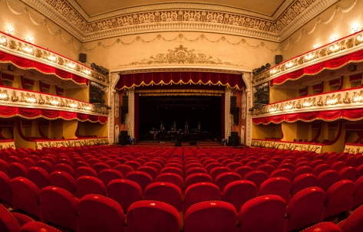
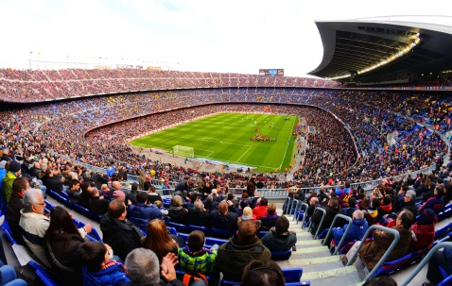
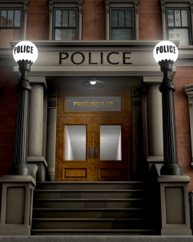

- ____________________________ 2. _______________________________
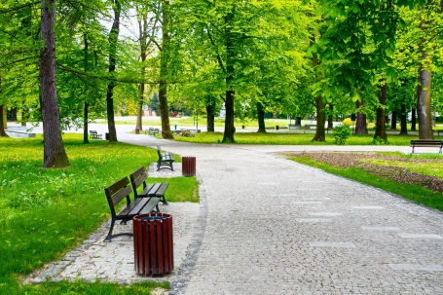

3. ______________________________ 4. _____________________________ 5. _________________________

- Match the pictures with the activities in the city. Write the correct letter next to each picture. (Liga as imagens às atividades da cidade. Escreve a letra correta ao lado de cada imagem.)
a) wash the car at the car wash b) walk the dog c) visit a museum
d) try different food e) see a play f) go to the stadium






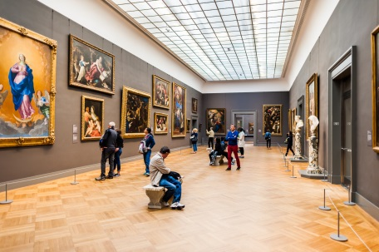

1.
2.
3.

4.
6.
5.

C. Tick () the correct form of the verb to be.
(Assinala a forma correta do verbo to be.)
- João _________ in Porto with his schoolmates last week.
a) was b) were
2. They _________ with their teacher.
a) was b) were
3. His schoolmates _________ very happy because they were in the north.
a) was b) were
4. He _________ born on 7th April.
a) was b) were

D. Circle the correct form of there + to be.
(Rodeia a forma correta de there + to be.)
1. In the past there were / there was a post office next to the bank.
2. There were / there was two hospitals in the city.
3. There were / There was a bank next to the cinema.
4. There was / There were some parks.

E. Circle the correct past simple form of the verbs.
(Rodeia a forma correta dos verbos no past simple.)

David: Hi, Mary Ann. Are you OK? I ⁽¹⁾ call / called you last night. I ⁽²⁾ wanted / want to tell you about my school day as you missed class...
Mary Ann: Sorry, David, yesterday I wasn’t very well. But you can tell me now.
David: Oh… Well, our geography teacher ⁽³⁾ organises / organised a small trip to the castle and it was great. We ⁽⁴⁾ walked / walk along the streets and ⁽⁵⁾ listened / listen to the teacher.
Mary Ann: ⁽⁶⁾ Do / Did you visit the tower?
David: No, we ⁽⁷⁾ did / didn’t. It was late, so we ⁽⁸⁾ don’t visit / didn’t visit everything.
Mary Ann: How ⁽⁹⁾ did / do you return to school?

David: We ⁽¹⁰⁾ return / returned to school by bus. What a pity you weren’t there!
Mary Ann:

F. Complete the text about a city tour. Circle the correct expressions.
(Completa o texto sobre uma visita turística. Rodeia as expressões corretas.)
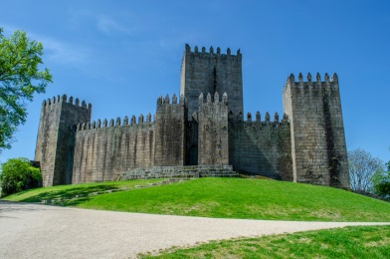
Last year, I visited Guimarães with my ⁽¹⁾ family / hotel.
We walked along the ⁽²⁾ restaurants / streets and visited many historical
⁽³⁾ monuments / police station. We also visited beautiful ⁽⁴⁾ car wash / museums and churches. We tried new food in a great ⁽⁵⁾ restaurant / stadium. We saw a play in the ⁽⁶⁾ theatre / park.
I loved that trip.

Answer key
A. (5 x 4% = 20%)
1. bank | 2. theatre | 3. police station | 4. stadium | 5. park

B. (6 x 2% = 12%)
1. d) | 2. f) | 3. b) | 4. a) | 5. e) | 6. c)

C. (4 x 3% = 12%)
1. a) was | 2. b) were | 3. b) were | 4. a) was

D. (4 x 3% = 12%)
1. there was | 2. there were | 3. there was | 4. there were

E. (10 x 2% = 20%)
1. called | 2. wanted | 3. organised | 4. walked | 5. listened | 6. Did | 7. didn’t | 8. didn’t visit | 9. did |
10. returned

F. (6 x 4% = 24%)
1. family | 2. streets | 3. monuments | 4. museums | 5. restaurant | 6. theatre

