

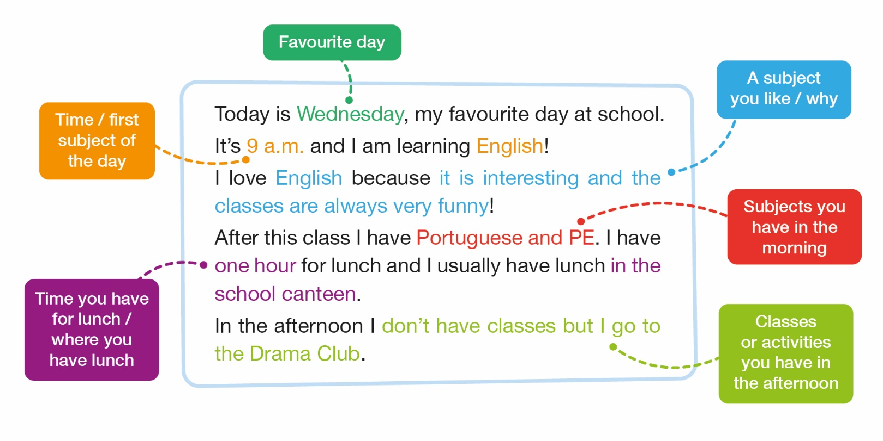
- Read the text Melissa is writing during her English lesson about her favourite day at school.


B. Look at the model from A and follow the guide below. Complete the text about your favourite day at school. Then tell the class about it.
Today is _____________ (favourite day), my favourite day at school.
It’s __________ (time) and I am learning ____________ (first subject of the day)!
I love ____________ (a subject you like) because ___________________________ (why).
After this class I have ____________________ (subjects you have in the morning).
I have ________________ (time you have for lunch) for lunch and I usually have lunch ____________________ (where you have lunch).
In the afternoon I _____________________________________________________________
___________________________________________________________________________(classes or activities you have in the afternoon).



A. Read the dialogue between Harry and Freddy about their schools.
Harry – So, Freddy, tell me about your school.
Freddy – I go to School of Rock. It’s a big school. There are 45 classrooms, a gym, a canteen and lots of music rooms. My favourite room is Music Room B because it has lots of different instruments to play. What about your school?
Harry – Well, I go to Hogwarts! It’s a different school. It’s big, but there aren’t many students. There is a playground, a big assembly hall and a library. My favourite room is the Potions Classroom. We learn how to make potions there!
Freddy – Wow! It sounds great! We can visit each other’s schools one day!

B. Complete the table with information about your school.
Name of your school
Number of rooms
Name of the rooms
Favourite room / why


C. Use the information from B and the box below. Role-play a dialogue with your partner comparing your school with Ted’s school. Use the model from A to help you. Then change roles with your partner.

Name of the school | St. Paul’s Cathedral School
Number of rooms | 50
Name of the rooms | 35 classrooms; one sports field; one gym; a stationer’s;  a canteen; a library
Favourite room / why | Science lab – do funny experiments there

