- Label the pictures with the correct school subjects. Use the words from the box.
(Legenda as imagens com as disciplinas escolares corretas. Usa as palavras da caixa.)
art science music maths geography English






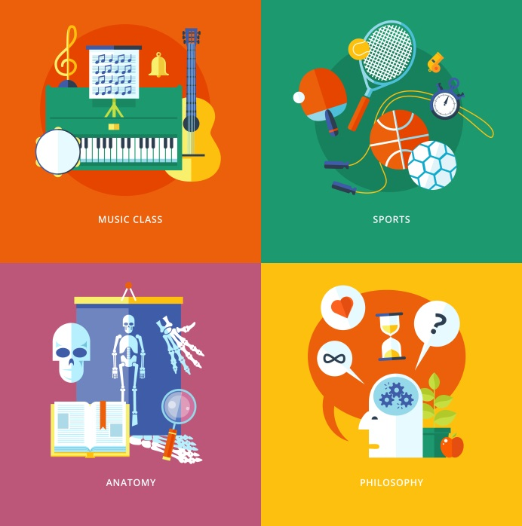
1. __ __ __ __ __ __ __ __ __
2. __ __ __
3. ____ __ __ __ __ __
6. __ __ __ __ __ __ __
4. __ __ __ __ __
5. __ __ __ __ __

B. Read the sentences and circle the correct school facilities.


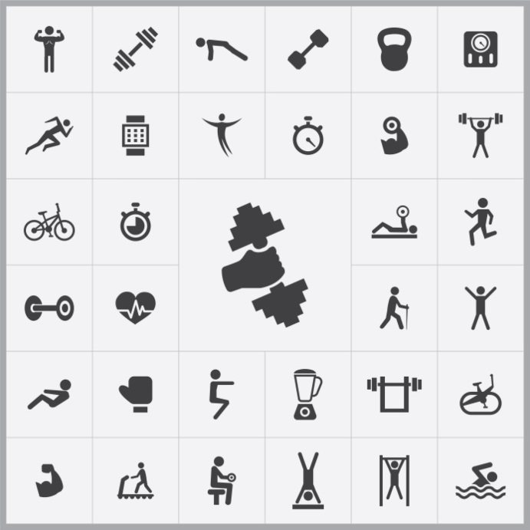

(Lê as frases e rodeia os espaços da escola corretos.)
1. My friends and I have lunch in the classroom / canteen.
2. I usually go to the library / music room to read and study for the tests.
3. We have PE lessons in the stationer’s / gym.
4. She sings and plays the guitar in the music room / computer room.
C. Complete the sentences with the after-school clubs. Use the letters given.
(Completa as frases com os clubes escolares. Usa as letras dadas.)
3. She loves running. That’s why she’s in the
S __ __ __ __ __ Club.
OTRS
1. We’re interested in technology, so we’re in the C__ __ __ __ __ __ __ Club.
MPOTERU

4. They’re in the C__ __ __ __ Club because it’s good for their concentration.
SHES
2. I’m in the A __ __ Club because I love drawing and painting.
TR

D. Circle the correct present continuous forms of the verbs. There is one example.
(Rodeia as formas corretas dos verbos no present continuous. Segue o exemplo.)
- I playing / am playing basketball in the gym.
- Mike is catching / catching the school bus.
- We playing / are playing football in the Sports Club.
- I going / am going to the Art Club.
- Susan and her classmates are studying / studying for the test.

E. Circle the correct preposition. (Rodeia a preposição correta.)
1. We’re interested in / for theatre, so we’re in the Drama Club.
2. Peter isn’t very good with / at history.
3. She’s always late for / of school.
4. Julie and Marcy love swimming with sharks because they aren’t afraid in / of them.

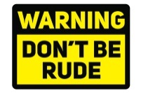
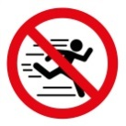

F. Tick () the correct option. (Seleciona a opção correta.)
- You __________ use your mobile phone in the library.
a) should b) shouldn’t
- You __________ be rude to your friends.
a) should b) shouldn’t
- You __________ run in the school hall.
a) should b) shouldn’t
- Maria, you __________ go to bed because it’s late.
a) should b) shouldn’t

G. Answer about you / your school. (Responde acerca de ti / da tua escola.)
- What is the name of your school? (Qual o nome da tua escola?)
The name of my school is ________________________________________________________
- What’s your favourite subject? (Qual a tua disciplina preferida?)
My favourite subject is ___________________________________________________________
- What’s your favourite school facility? (Qual o teu local preferido na escola?)
My favourite school facility is ______________________________________________________
- What after-school clubs are there in your school? (Que clubes há na tua escola?)
_____________________________________________________________________________
- Do you like your school? (Gostas da tua escola? Assinala a opção correta.)
a) Yes, I do. b) No, I don’t.

Answer key
A. (6 x 2% = 12%)
1. geography | 2. art | 3. science | 4. maths | 5. music | 6. English
B. (4 x 3% = 12%)
1. canteen | 2. library | 3. gym | 4. music room
C. (4 x 3% = 12%)
1. Computer | 2. Art | 3. Sports | 4. Chess
D. (4 x 4% = 16%)
1. is catching | 2. are playing | 3. am going | 4. are studying
E. 4 x 4% = 16%)
1. in | 2. at | 3. for | 4. of
F. (4 x 3% = 12%)
1. shouldn’t | 2. shouldn’t | 3. shouldn’t | 4. should
G. (5 x 4% = 20%)
Personal answer

