

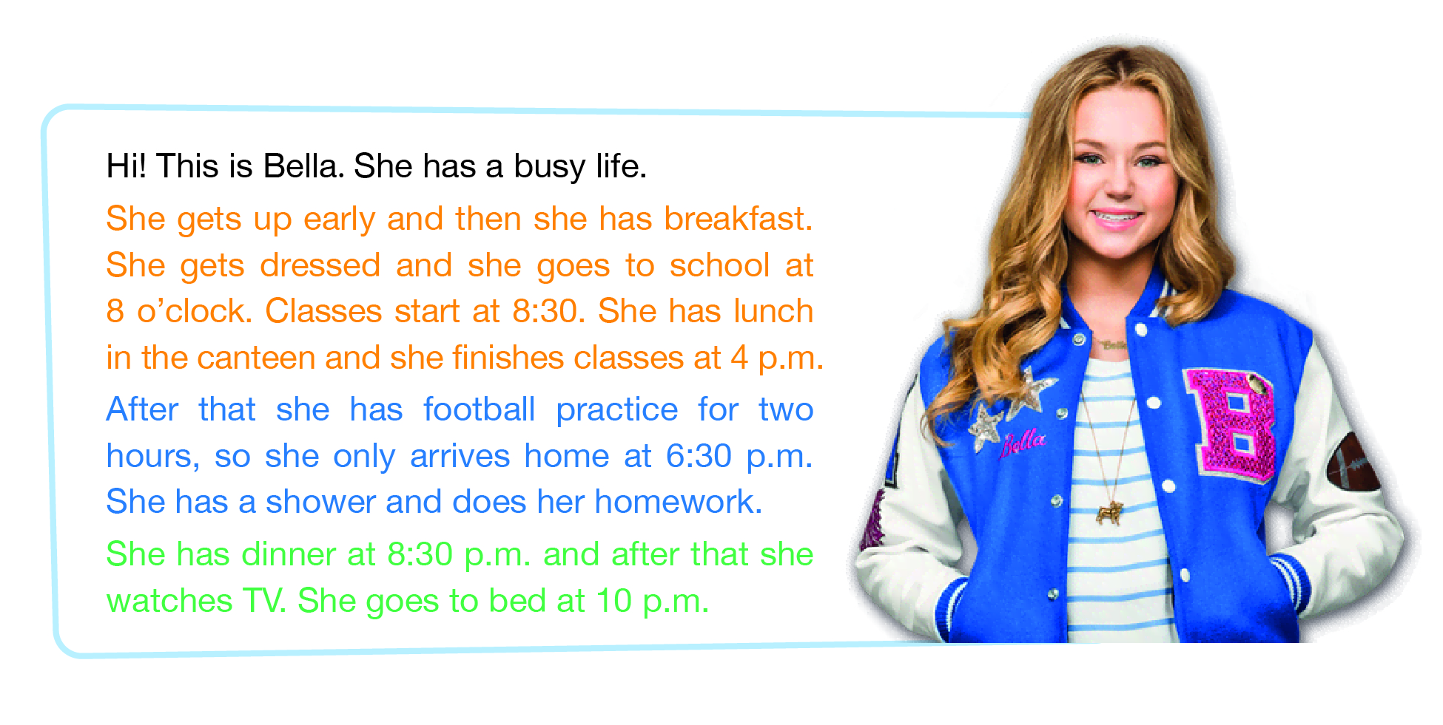
- This is Bella from the series “Bella and the Bulldogs”.
Read the text about her daily routine.


B. Choose someone you like (a friend, a relative, a celebrity...) and imagine his/her daily routine. Describe it to the class.
Use the model from A and the guide below. Write it down before you tell the class. You can stick a photo of this person in the space!

Hi! This is __________________!
_____________________________________________________________________________________________________________________________________________________________________
________________________________________________________________________________________________________________________________________________________________________________________________________________________________


Evening routine
Afternoon
routine
Morning routine

Edições ASA | High Five 6 | 2018

A. Jason and Alicia are talking about their weekends. Read the dialogue.
Jason – So, Alicia, tell me about your typical weekend.
Alicia – Well, on Saturday morning I have swimming practice from 10 a.m. to 11 a.m. I have lunch at 1 p.m. and in the afternoon I do my homework or meet my friends. What about you?
Jason – I usually play football in the morning and in the afternoon I also do my homework or play video games. And on Sundays?
Alicia – Oh, I love Sundays, because I get up late. I stay at home in the morning and in the afternoon I visit my grandparents or go for a walk.
Jason – Me too! I also get up late and I usually visit my grandparents in the afternoon. I hate the evenings... it’s Monday the next day!

B. Complete the table with information about you and your partner.
 | You | Your partner
 | Saturday | Sunday
In the morning  Edições ASA | High Five 5 | 2018 | _____________________  have lunch at _________ | ______________________  ______________________
In the afternoon | _____________________  _____________________ | _______________________  _______________________

C. Replace the underlined expressions in A with the words/expressions from B.
Role-play a dialogue similar to the one in A with your partner.
Edições ASA | High Five 5 | 2018
Edições ASA | High Five 5 | 2018
Edições ASA | High Five 5 | 2018
Edições ASA | High Five 5 | 2018

