- Look at the pictures and circle the correct option to complete the text about the daily routine. (Observa as imagens e rodeia a opção correta para completar o texto sobre a rotina diária.)





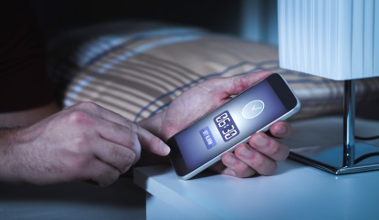

1. My name is Bruno Harper. I always wake up / go to bed at 6:30 a.m.
2. Then I have a shower / work.
3. After that I have breakfast / dinner.
4. I always cook lunch / breakfast at 12:00.
5. In the afternoon I go to work. In the evening, I have cook / dinner with my friends.
6. I go to bed / dressed at 10:30.

B. Read the sentences and complete them with the correct nationality. Use the words from the box. (Lê as frases e completa-as com a nacionalidade correta. Usa as palavras da caixa.)
Canadian English American Brazilian

- My name’s Rita Ora. I’m from England, so I’m __________________________
- He’s The Weeknd and he’s a __________________________ singer. He’s from Canada.
- Gabriel Barbosa is a football player from Brazil. He’s __________________________.
- Zendaya is an actress from the USA, so she’s __________________________.

C. Write the numbers in the pictures. (Escreve os números nas imagens.)

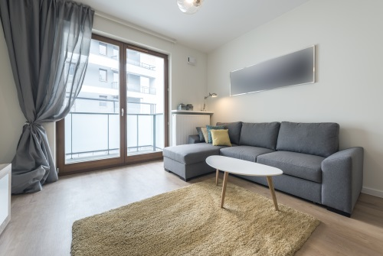


1. castle 2. flat 3. detached house
A
B
C
D. Label the household chores. Use the words/expressions from the box.
(Identifica as tarefas domésticas. Usa as palavras/expressões da caixa.)

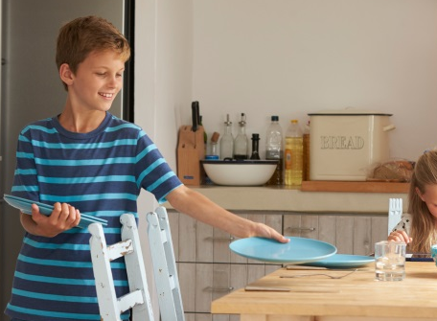

set the table
make the bed
do the washing up
cook

1. ________________________ 2. _________________________
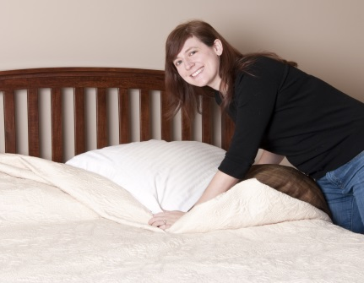


3. _________________________ 4. _______________________


E. Circle the correct form of the verb to be.
Rodeia a forma correta do verbo to be.)

1. Bruno Mars is / are a singer and a songwriter.
2. He am / is from Honolulu, in Hawaii.
3. Eric and Presley is / are two of his best friends.
4. I am / are Bruno’s fan.

F. Match the sentences with the correct form of the verb have got.
(Liga as frases à forma correta do verbo have got.)
have got
- Bruno and his family __________ a very big flat.

- It __________an attic.
has got
- She __________ a terraced house.
- I __________ a cottage.

G. Circle the correct present simple forms. (Rodeia as formas corretas do present simple.)
1. Presley go / goes to the cinema with her brother once a week.
2. Matt and Hanna usually catches / catch the bus at 7:30 a.m.
3. My sister and I sometimes cooks / cook dinner together.
4. Antonio listen / listens to music at night.

H. Circle the correct connector. (Rodeia o conector correto.)
1. Bruno always tidies his bedroom then / when he is at home.
2. He wakes up at 6 o’clock and while / after that he has breakfast.
3. He does the washing up while / then his girlfriend takes the rubbish out.
4. They have dinner and then / when they watch TV.

Answer key
A. (6 x 3% = 18%)
1. wake up | 2. shower | 3. breakfast | 4. lunch | 5. dinner | 6. to bed
B. (4 x 4% = 16%)
1. English | 2. Canadian | 3. Brazilian | 4. American
C. (3 x 2% = 6%)
A. 3. detached house | B. 2. flat | C. 1. castle
D. (4 x 3% = 12%)
1. cook | 2. set the table | 3. do the washing up | 4. make the bed
E. (4 x 3% = 12%)
1. is | 2. is | 3. are | 4. am
F. (4 x 3% = 12%)
1. have got | 2. has got | 3. has got | 4. have got
G. (4 x 3% = 12%)
1. goes | 2. catch | 3. cook | 4. listens
H. (4 x 3% = 12%)
1. when | 2. after that | 3. while | 4. then

