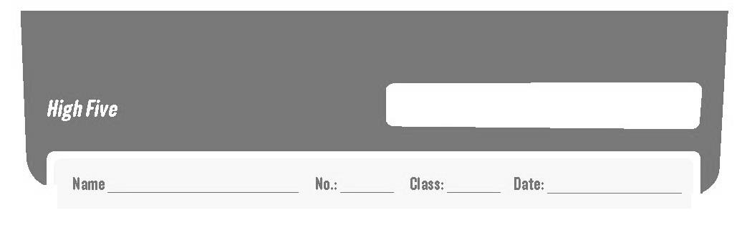
Revision Worksheet A
6


- Complete the text about Alex O’Loughlin’s daily routine. Use the pictures to help to complete the senteces.

Alex O’Loughlin is Steve McGarrett in the TV series Hawaii Five-0. He has
a very busy life, so he usually ⁽¹⁾ _____________________  at 7 o’clock. Then he
⁽²⁾ _______________ and he gets dressed. He always ⁽³⁾ _______________ 
at home. After that he ⁽⁴⁾ _________________ by motorcycle. He stays at the studio
until midday. He sometimes ⁽⁵⁾ __________________  with some friends in a Thai
restaurant. After work he ⁽⁶⁾ _____________________ on foot because it’s next to
the studio. Then he ⁽⁷⁾ _____________________  and has dinner at 8 o’clock. He
always goes to bed at 10.30 pm.

- Read the sentences about household chores. Complete the cross word with the missing words.
²
³
⁴
⁵
¹
⁶
⁷

  - Before I go to school I always… my bed.
  - I usually take the… out.
  - Anna likes to… delicious meals with her mother at the weekend.
  - I hate when I have to… my bedroom.
  - Sophia does the… and her clothes always look great.
  - Ted always helps his father… the car.
  - Before dinner my sister sets the…

- What time is it? Write the times in full.


07.45
02.30
06.00
10.15

  - It’s a quarter past ten.
  - _____________
_____________
  - _____________
_____________
  - _____________
_____________

- Read the sentences and fill in the blanks with the correct question words/ expressions from the box.

how often how what where why what time

  - _______________ do you go to school? – By bike.
  - _______________ do you study? – In my bedroom.
  - _______________ does Maria have dinner? – At 8 p.m.
  - _______________ do you go to the theatre? – Once a month.
  - _______________ do you go to school by bike? – Because my parents haven’t got a car.
  - _______________ do they have for breakfast? – Cereal and milk.

- Complete the sentences with the present simple of the verbs in brackets.

  - Maria never _______________ (sleep) until 7.30.
  - Her father _______________ (catch) the bus to work at 8 a.m.
  - I _______________ (not ride) my bike when it’s cold.
  - How often _______ you __________ (eat) Chinese food? – Twice a month.
  - _______ she __________ (ride) her bike on Sunday? – Yes, she __________.

- Put the words in order to make sentences and write the verbs in the present simple. There is one example.

- usually / tidy / my bedroom / I I usually tidy my bedroom.

- be / they / never / for school / late
_______________________________________________________________

- make / always / his bed / Matt
_______________________________________________________________

- once a week / go / to the swimming pool / we
_______________________________________________________________

- do / the ironing / Paula / twice a week
_______________________________________________________________

- Write the verbs in the present simple or the present continuous.

  - Peter _______________ (take) the rubbish out every day.
  - Look! The teacher _______________ (paint) a very beautiful picture!
  - I ______________ (watch) TV at the moment but I usually _______________ (read) a book before going to bed.
  - Pete and I _______________ (bake) a cake today because it’s our sister’s birthday.

  - They always _______________ (set) the table for dinner.
Good work!

Answer key – Revision worksheet A

A.
- gets up
- has a shower
- has breakfast
- goes to work
- has lunch
- goes to the gym
- goes home

B.
- make
- rubbish
- cook
- tidy
- ironing
- wash
- table

C.
- It’s six o’clock.
- It’s half past two.
- It’s a quarter to eight.

D.
- How
- Where
- What time
- How often
- Why
- What

E.
- sleeps
- catches
- don’t ride
- do; eat
- Does; ride; does

F.
- They are never late for school.
- Matt always makes his bed.
- We go to the swimming pool once a week.
- Paula does the ironing twice a week.

G.
- takes
- is painting
- am watching; read
- are baking
- set

