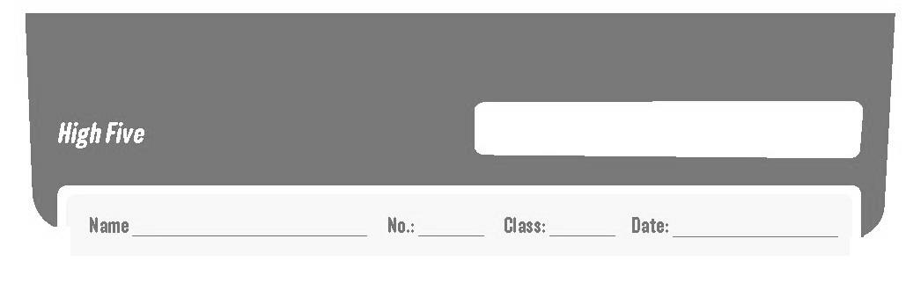
Revision Worksheet B
6


- Complete the text about Alex O’Loughlin’s daily routine. Use the words from the box. The pictures in the text can help you. (Completa o texto com as atividades diárias do Alex O’Loughlin. Usa as palavras da caixa. As imagens no texto podem ajudar-te.)

has breakfast goes to the gym gets up goes home
has lunch goes to work has a shower

Alex O’Loughlin is Steve McGarrett in the TV series Hawaii Five-0. He has
a very busy life, so he usually ⁽¹⁾ _____________________ 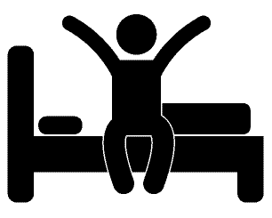 at 7 o’clock. Then he
⁽²⁾ _______________ and he gets dressed. He always ⁽³⁾ _______________ 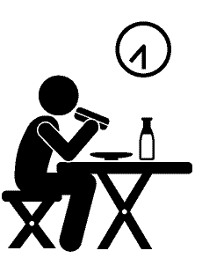
at home. After that he ⁽⁴⁾ _________________ by motorcycle. He stays at the studio
until midday. He sometimes ⁽⁵⁾ __________________  with some friends in a Thai
restaurant. After work he ⁽⁶⁾ _____________________ on foot because it’s next to
the studio. Then he ⁽⁷⁾ _____________________  and has dinner at 8 o’clock. He
always goes to bed at 10.30 pm.

- Look at the pictures and label the household chores. Use the words from the box. (Observa as imagens e legenda as tarefas domésticas. Usa as palavras da caixa.)

tidy the bedroom do the ironing take the rubbish out make the bed
do the washing up wash the car set the table cook


1. ____________ 2. _____________ 2. _____________ 4. ______________

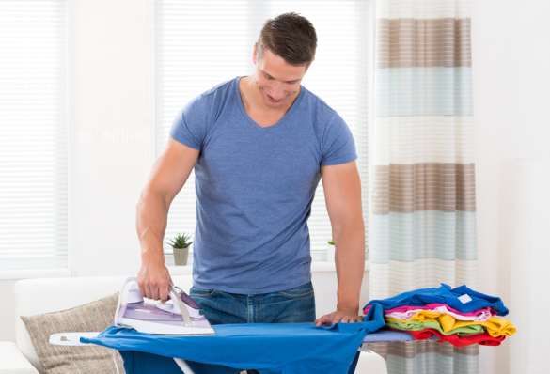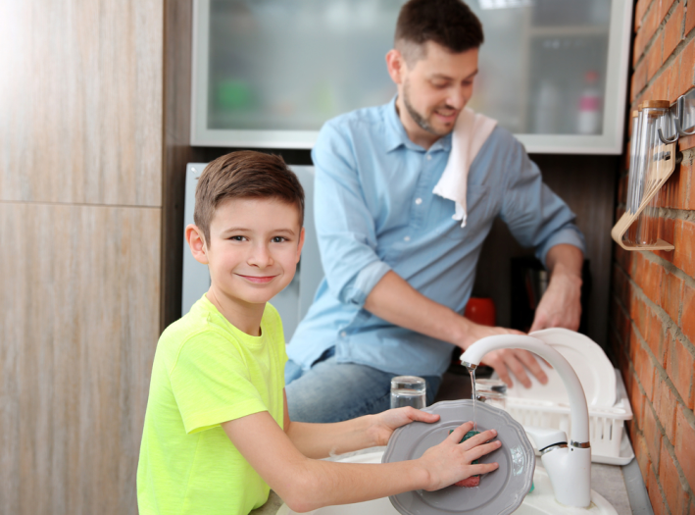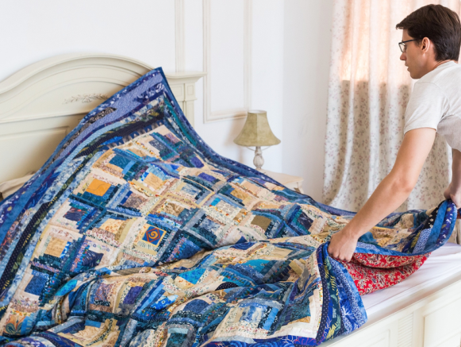
5. ____________ 6. _____________ 7. ______________ 8. ______________
- What time is it? Tick () the correct option. (Que horas são? Assinala a opção correta.)

1.   10.15 | 2.  06.00 | 3.  02.30 | 4.  07.45
a) It’s a quarter past ten.  b) It’s half past ten. | a) It’s five o’clock.  b) It’s six o’clock. | a) It’s half past two.  b) It’s ten past two. | a) It’s a quarter to eight.  b) It’s five to eight.

- Read the sentences and fill in the blanks with the correct question words/ expressions from the box. (Lê as frases e preenche os espaços com as expressões interrogativas da caixa.)
how often how
what where
why what time

  - ____________ do you go to school? – By bike.
  - ____________ do you study? – In my bedroom.
  - ____________ does Maria have dinner? – At 8 p.m.
  - ____________ do you go to the theatre? – Once a month.
  - ____________ do you go to school by bike? – Because my parents haven’t got a car.
  - ____________ do they have for breakfast? – Cereal and milk.

- Circle the correct present simple form. (Rodeia a forma correta do present simple.)

  - Maria never sleeps / sleep until 7.30.
  - Her father catch / catches the bus to work at 8 a.m.
  - I don’t ride / doesn’t ride my bike when it’s cold.
  - How often do / does you eat / eats Chinese food? – Twice a month.
  - Does / Do she rides / ride her bike on Sunday? – Yes, she does / do.

- Order the words and write sentences in the present simple. There is one example. (Ordena as palavras e escreve frases no present simple. Segue o exemplo.)

  - usually / tidy / my bedroom / I – I usually tidy my bedroom.

  - are / they / never / for school / late
_______________________________________________________________

  - makes / always / his bed / Matt
_______________________________________________________________

  - once a week / go / to the swimming pool / we
_______________________________________________________________

  - does the ironing / Paula / twice a week
_______________________________________________________________

- Read the sentences and circle the correct option. (Lê as frases e rodeia a opção correta.)

  - Peter takes / is taking the rubbish out every day.
  - Look! The teacher paints / is painting a very beautiful picture!
  - I am watching / watch TV at the moment but I usually am reading / read a book before going to bed.
  - Pete and I are baking / bake a cake today because it’s our sister’s birthday.

  - They always are setting / set the table for dinner.
Good work!

Answer key – Revision worksheet B

A.
- gets up
- has a shower
- has breakfast
- goes to work
- has lunch
- goes to the gym
- goes home

B.
- tidy the bedroom
- set the table
- cook
- wash the car
- do the ironing
- do the washing up
- take the rubbish out
- make the bed

C.
- a) It’s a quarter past ten.
- b) It’s six o’clock.
- a) It’s half past two.
- a) It’s a quarter to eight.

D.
- How
- Where
- What time
- How often
- Why
- What

E.
- sleeps
- catches
- don’t ride
- do; eat
- Does; ride; does

F.
- They are never late for school.
- Matt always makes his bed.
- We go to the swimming pool once a week.
- Paula does the ironing twice a week.

G.
- takes
- is painting
- am watching; read
- are baking
- set

