Articles: a, an, the and omission of the
Review worksheet
3
Name No.: ______ Class: ________ Date: _____/ _____/ _____
A. Write a or an.
(Escreve a ou an.)
 |  |  |  | 
1. ______ doctor | 2. ______ architect | 3. ______ engineer | 4. ______ cook | 5. ______ firefighter
B. Fill in the gaps with a, an or the.
(Preenche os espaços em branco com a, an ou the.)
1. My mother is ________ vet and my father is ________ swimming teacher.
2. Ricky and Carly live in ________ UK. They think it’s ________ wonderful place to live.
3. ________ apple a day keeps ________ doctor away.
4. Is your brother ________ singer or ________ actor?
5. Josh isn’t ________ waiter, but he sometimes helps his father in ________ restaurant.
C. Complete the sentences with the or ∅.
(Completa as frases com the ou ∅.)
1. ________ Canada is one of the largest countries in ________ world.
2. ________ Joana and Lorenzo are ________ engineers.
3. We have dance lessons on ________ Monday.
4. ________ dance teacher is ________ French. She’s from ________ Paris.
5. ________ Ted’s father works in ________ hospital near my house.
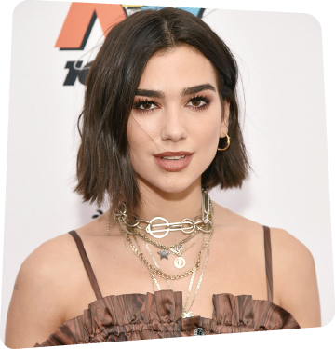
D. Complete the text with a, an, the or ∅.
(Completa o texto com a, an, the ou ∅.)
Dua
Lipa
¹________ Dua Lipa is ²________ English singer. She is also ³________ songwriter and ⁴________ model. She was born in ⁵________ London on 22nd August 1995. Her parents are not from ⁶________ UK. They are ⁷________ Albanian. Her father is ⁸________ singer, too, and her mother works in tourism. She has got ⁹________ younger brother and ¹⁰________ younger sister.
Before becoming famous, Dua Lipa was ¹¹________ waitress at the age of 15, to pay for her music lessons.
Nowadays, she lives in ¹²________ flat, in ¹³________ New York, in ¹⁴________ USA. She loves living in ¹⁵________ America.

