Present simple: verb to be
Review worksheet
6
Name No.: ______ Class: ________ Date: _____/ _____/ _____


A. Circle the correct verb form in each sentence.
(Rodeia em cada frase a forma correta do verbo.)
1. Mariska is / are American, but her parents is / are from Russia.
2. I am / are very busy, so I am not / are not going to the cinema today.
3. Are / Is you from London or from Liverpool?
4. She isn’t / aren’t a firefighter. She ’s / ’m a nurse.
5. Paul and Trisha isn’t / aren’t in New York. They is / are in Orlando.
B. These sentences are wrong. Correct the underlined words. There is one example.
(Estas frases estão erradas. Corrige as palavras sublinhadas. Segue o exemplo.)
Lucy and Millie are Australian.
• Lucy and Millie is Australian.
1. Melinda am the new English teacher.
2. Noah aren’t a student. He’s a baker.
3. Is you twelve years old?
4. We isn’t Brazilian.
5. Harry are my goldfish. I love him very much.
C. Make sentences. Use the verb to be: affirmative (✓), negative (✗) or interrogative (?).
(Constrói frases. Usa o verbo to be: afirmativa, negativa ou interrogativa.)
1. John / British (✓)
2. my parents / at home (✗)
3. what / that girl’s name (?)
4. you / Canadian (?)
5. Sarah / at school (✗)
6. I / from Miami (✓)
D. Complete the text with the correct forms of the verb to be.
(Completa o texto com as formas corretas do verbo to be.)
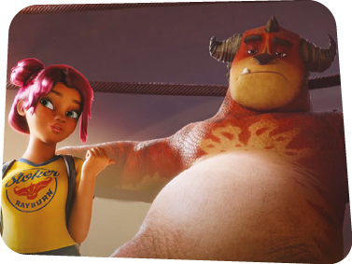
Winnie ¹_____________ a monster wrestling trainer in the film Rumble. She ²_____________ a young girl with a dream: training a monster, Steve, to win the championship. At first
it ³___________ (not) easy to train him. He ⁴___________ stubborn and feels tired all the time, but she doesn’t give up.
Winnie
Steve
Steve often tells Winnie he ⁵__________ afraid of Tentacular, because he ⁶_____________ strong and he always wins the competition. “Really, Steve? ⁷_____________ you a winner or a loser? You ⁸____________ both fighters, of course,” Winnie says.

