Present simple: verb have got
Review worksheet
7
Name No.: ______ Class: ________ Date: _____/ _____/ _____
A. Complete the sentences with the verb forms from the boxes.
(Completa as frases com as formas verbais das caixas.)
has got

1. Molly _______________ two brothers and one baby sister.
2. Walter and I _______________ a new pair of boots.
3. Richard and Lenny _______________ brown hair and blue eyes.
have got

4. I _______________ short blonde hair.
5. John _______________ a nice family.
6. My hamster _______________ a very modern cage.
B. Write the sentences in the negative (short form).
(Escreve as frases na negativa – forma abreviada.)
Serena hasn't got blue gloves.
• Serena has got blue gloves.
1. Matt and Vivian have got black hair.
2. Marcel has got a new watch.
3. Suzy has got lovely earrings.
4. Her dog has got a modern kennel.
5. I have got a moustache.
6. Fatima and you have got a twin brother.
C. Look at the picture. Write questions and answers with the verb have got. There is one example.
(Observa a imagem. Escreve perguntas e respostas com o verbo have got. Segue o exemplo.)
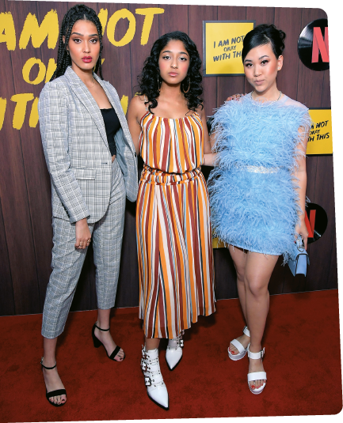
• Maitreyi / long hair
Yes
she has
Ramona
Young
Lee
Rodriguez
Maitreyi
Ramakrishnan
Has Maitreyi got curly hair
“ ?” “_______, .”
1. Lee and Ramona / white boots
“ ?” “_______, .”
2. Lee / a short skirt
“ ?” “_______, .”
3. they / a modern look
“ ?” “_______, .”
4. Maitreyi / a long dress
“ ?” “_______, .”
5. the three girls / a bag in their hand
“ ?” “_______, .”

