Past simple: verb to be
Review worksheet
11
Name No.: ______ Class: ________ Date: _____/ _____/ _____
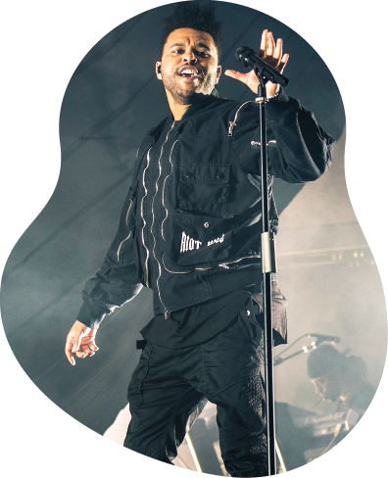
A. Read the sentences and tick (✓) the correct option.
(Lê as frases e escolhe a opção correta.)
1. The Weeknd ______ in Dublin last month.
a) was b) were

2. The Weeknd and his band ______ in a show with 20,000 fans.
a) was b) were

3. His Irish fans ______ very happy to see him.
a) was b) were

4. They ______ anxious to sing "In your eyes" with him at the end of the concert.
a) was b) were

B. Fill in the gaps with the past simple of the verb to be.
(Completa os espaços com o past simple do verbo to be.)
The
Weeknd
1. The Weeknd ______ in my hometown last week.
2. My friends and I ______ at the concert.
3. My parents ______ at the concert, too.
4. The singer ______ very nice to the fans.
5. My friends Joe and Paul ______ with the artist backstage.
6. They ______ excited and nervous about meeting him.
C. Rewrite the sentences in the affirmative, negative or interrogative.
(Escreve as frases na afirmativa, negativa ou na interrogativa.)
1. You were at home yesterday.
Neg.: Int.:
2. Ted wasn’t with his schoolmates this morning.
Neg.: Int.:
3. Were Minnie and Mark at the gym?
Neg.: Int.:
4. Bruno’s dog was in the park.
Neg.: Int.:

