Personal pronouns: subject/object
Review worksheet
1
Name No.: ______ Class: ________ Date: _____/ _____/ _____

A. Look at the words in the box. Circle the personal pronouns. There is one example.
(Observa as palavras da caixa. Rodeia os pronomes pessoais. Segue o exemplo.)
we | you | his | they | mine | its | ours | is | I | she | us | it | he

B. Complete the table with the personal pronouns – subject and object.
(Completa a tabela com os pronomes pessoais – função de sujeito e de complemento.)
Subject | Singular |  | Object | Singular
Subject | ¹___________  you  he  she  ²___________ |  | Object | me  ⁵___________  ⁶___________  her  it
Subject | Plural |  | Object | 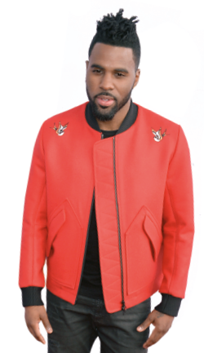  Plural
Subject | we  ³___________  ⁴___________ |  | Object | ⁷___________  you  ⁸___________
C. Fill in the blanks with the correct personal pronouns.
(Preenche os espaços com os pronomes pessoais corretos.)
1. Jason Derulo is a great singer. ________ is my favourite artist.
2. “And you? Do ________ like his songs, too?”
“Yes, ________ do.”
Jason
Derulo
3. He’s got a lot of fans. ________ are from all over the world.
4. My mother is a fan too. ________ loves his music.
5. My sister and I like hip-hop, but ________ prefer listening to The Weeknd and Drake.
D. Complete the sentences with the correct personal pronouns – object. There is one example.
(Completa as frases com os pronomes pessoais – função de complemento – corretos. Segue o exemplo.)
it
• I love watching America’s Got Talent. Do you like ________, too?
1. It’s the Jason Derulo concert tonight. We’re going to see ________ for the first time.
2. Our grandmother is also a fan. Let’s invite ________ to go with ________.
3. “Have you got the tickets?” “Yes, I’ve got ________ in my bag.”
4. Lisa, I’m watching a new dance show. Do you want to watch it with ________?
5. I know you’re going to the JD concert. Can I go with ________?

