Personal pronouns
Possessive determiners (Unit 1)
Apoio ao estudo
1
Name No.: ______ Class: ________ Date: _____/ _____/ _____

Os personal pronouns (subject) desempenham a função de sujeito e usam-se para substituir os nomes ou outros grupos nominais (ex.: Jacques is 12 years old and he is French.).
Os possessive determiners indicam posse e surgem antes de um nome ou adjetivo (ex.: My friend Pedro is Portuguese, but his cousin is Canadian.).
Para estudares os personal pronouns e os possessive determiners podes fazer uma tabela no teu caderno diário em que associes cada um dos pronomes ao respetivo determinante (ex.: I → my).
Personal pronouns | I | you | he | she | it | we | you | they
Possessive determiners | my | your | his | her | its | our | your | their
Bom estudo!
STUDY TIPS
A. Complete the sentences with the correct personal pronouns.
he
• Victor is 12 years old and __________ is from Scotland.
1. Mary is in year 7 and __________ loves riding her bike.
2. Janine and Sue are from Melbourne, so __________ are Australian.
3. Mel and I aren’t English. __________ are Welsh.
4. That cat is grey and orange. __________ is very beautiful.

B. Circle the correct possessive determiners.
1. Lucas is Portuguese, but his / her mother is British.
2. Nelly and Jodie love listening to his / their favourite singer’s songs.
3. We live in Ireland, but our / my family isn’t Irish. They’re Italian.
4. Spain is a beautiful country and your / its capital, Madrid, is a wonderful city to visit.
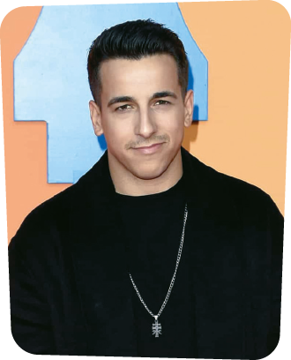
C. Fill in the gaps with personal pronouns (subject) and with possessive determiners.
Fernando Daniel is a Portuguese singer and 1_________ is from Estarreja, a town near Aveiro. 2__________ birthday is on 11th May and one of the best presents he can get is having 3_________ family with him on that day. 4_________ has got two older sisters and 5________ are very proud of 6_________ brother!
Fernando is the winner of the talent show contest “The Voice Portugal” (2016). 7__________ favourite artists are James Arthur, Ed Sheeran, Shawn Mendes and Adele. 8__________ are an inspiration.

