Prepositions of place (Unit 2)
Apoio ao estudo
10
Name No.: ______ Class: ________ Date: _____/ _____/ _____

As prepositions of place (preposições de lugar) indicam o lugar onde algo se situa. Deves saber muito bem o seu significado para que as possas aplicar corretamente.
 |  |  |  |  |  |  | 
on  (em cima de) | in  (dentro de) | under  (debaixo de) | in front of  (à frente de) | behind  (atrás de) | between  (entre) | opposite  (no lado oposto) | next to  (ao lado de)
Bom estudo!
STUDY TIPS
A. Match the two columns to make correct sentences. Write the letters a-d.
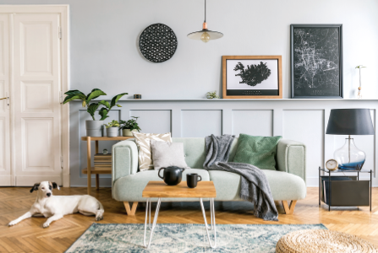
1. There’s a dog _____________ the sofa.
a) on b) next to

2. The coffee table is _____________ the sofa.
a) between b) in front of

3. There’s a rug _____________ the coffee table.
a) under b) opposite

4. The sofa is _____________ the lamp and the plant.
a) between b) behind

B. Look at the upside-down living room and make sentences with the correct prepositions of place.
• three bottles / the box
There are three bottles in the box.
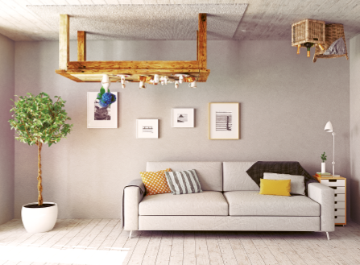
1. a sofa / the table

2. a lamp / the small vase

3. four pictures / the wall

4. a plant / the vase

5. four cushions / the sofa

