Past continuous (Unit 4)
Apoio ao estudo
16
Name No.: ______ Class: ________ Date: _____/ _____/ _____
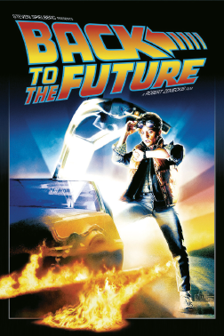

Usamos o past continuous para nos referirmos a:
− ações em curso num determinado momento passado;
− ações a decorrer em simultâneo no passado;
− uma ação em curso no passado interrompida por outra também no passado.
Presta atenção à construção do past continuous:
− afirmativa: was/were + -ing form do verbo principal (ex.: I was visiting an exhibition.);
− negativa: was not (wasn’t)/were not (weren’t) + -ing form do verbo principal (ex.: They weren’t shopping.);
− interrogativa: Was/Were + sujeito + -ing form do verbo principal (ex.: Were you walking along the streets?);
− nas respostas curtas utiliza-se was/were ou wasn’t/weren’t (ex.: "Were you walking in the street?" "Yes, I was."/"No, I wasn’t.").
Bom estudo!
STUDY TIPS
A. Complete the text with the past continuous of the verbs in brackets.
Back to the future was a very popular film in the past. The main character, Marty McFly, 1__________________ (try) to go back to his real life after going on a crazy trip to 1950. Marty 2__________________ (do) some research on his family history while he 3__________________ (travel) around the city.
He didn’t feel very comfortable with his story, so Doc Brown, the scientist 4__________________ (fix) his timeline car to end that problem. Marty and his family 5__________________ (have) a lot of fun together when he had to get back to reality.
B. What were they doing? Fill in the gaps with the past continuous of the verbs from the box.
take | walk | not watch | drive | read

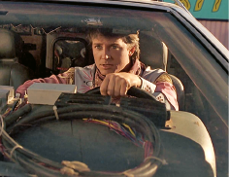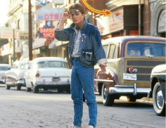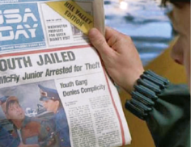
1
2
3
4
1. Marty __________________ around the city.
2. He __________________ along the street.
3. People __________________ photos of the skyscrapers.
4. Marty’s son __________________ the news on TV. He __________________ the newspaper.

