Past simple and past continuous (Unit 4)
Apoio ao estudo
17
Name No.: ______ Class: ________ Date: _____/ _____/ _____

Recorda o seguinte:
- O past simple usa-se para descrever:
  - ações concluídas no passado (ex.: Maggie and Liam went to Paris last year.);
  - ações habituais no passado (ex.: When I lived in Braga, I ran in the city park.);
  - e com as time expressions:
when, yesterday, last week/month/year, … ago, …
- O past continuous usa-se para descrever:
  - ações em curso num determinado momento passado (ex.: David was running at that moment.);
  - ações a decorrer em simultâneo no passado (ex.: While Ruth and Jill were walking the dog, Jim was relaxing at the park.;
  - uma ação em curso no passado interrompida por outra também no passado (ex.: We were visiting the museum when the police arrived.);
  - e com as time expressions:
while, as, at that time, at that moment…
Bom estudo!
STUDY TIPS
A. Past simple or past continuous? Tick (✓) the correct option to complete the sentences.

1. While Otto ________ along the street, he fell down.
a) was walking b) walked

2. Yesterday, Gru ________ the Minions about his childhood.
a) told b) was telling

3. Belle Bottom ________ her motorbike when the traffic ________.
a) rode… was stopping b) was riding… stopped

B. Fill in the gaps with the past simple or the past continuous of the verbs in brackets. Then match the sentences with the corresponding pictures. Write the numbers 1-4.
1. Gru ____________ (speak) with the criminals while they ____________ (wait) in the waiting room.
2. While Belle Bottom ____________ (look) for Gru, the girls ____________ (be) scared.
3. While Otto ____________ (jump) to catch the medal, the duck ____________ (fly) near him.
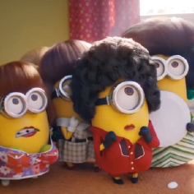
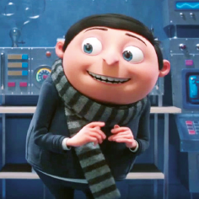
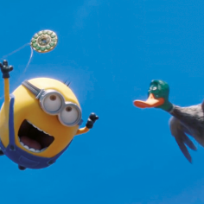
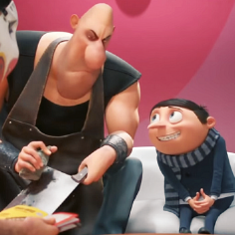
4. Gru ____________ (feel) happy when he ____________ (become) a villain.

