Possessive pronouns (Unit 1)
Apoio ao estudo
4
Name No.: ______ Class: ________ Date: _____/ _____/ _____

A question word Whose significa “De quem” e utiliza-se em perguntas quando queremos saber a quem pertence algo (ex.: "Whose bag is this?" "It’s mine.").
Os possessive pronouns indicam sempre posse e substituem os nomes. Deves memorizá-los para os aplicares corretamente.
Personal pronouns | I | you | he | she | it | we | you | they
Possessive pronouns | mine | yours | his | hers | its | ours | yours | theirs
Nota:
Quando queres indicar que algo pertence a alguém também podes utilizar o possessive case:
- se o primeiro nome for singular ou plural irregular, acrescentas ’s (ex.: Matt’s cat/The children’s cars).
- se o primeiro nome for plural e terminar em -s, acrescentas apenas o apóstrofo (ex.: The girls’ hats).
Bom estudo!
STUDY TIPS

A. Read and circle the correct possessive pronouns.
1. Can I borrow your jacket? Theirs / Mine is in the classroom.
2. “Is this Matt’s cap?” “No, it isn’t hers / his. It’s Jane’s.”
3. “Whose T-shirt is that?” “It’s Maria’s. It’s hers / mine.”
4. John and Ricky have got two hamsters at home, but the pets aren’t ours / theirs. They’re Nina’s.
4. We like your new car. It’s more modern than ours / his.
B. Look at the pictures and complete with the correct possessive pronouns.
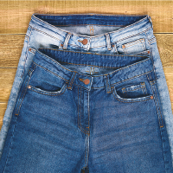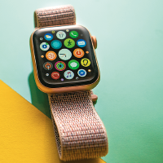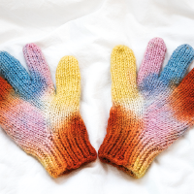
yours
Jack
we
Rita
they
you
I
• “Which smart watch is the prettiest?” “The prettiest one is ____________.”
1. “Whose jeans are these?” “They are ____________.”
2. “Whose mobile is that?” “It’s ____________.”
3. “Whose bikes are the ones in the photo?” “They’re ____________.”
4. My trainers are nice, but I prefer ____________.”
5. These gloves are so colourful. Don't you love them? They’re ____________!

