Present simple (Unit 1)
Worksheet
1B6
Name No.: ______ Class: ________ Date: _____/ _____/ _____
A. Rewrite the verbs from the box in the 3rd person singular in the correct column.
go | study | play | watch | like | cry | kiss | walk | fly

Verb + -s | Verb + -es | Verb + -ies
likes | goes | flies


B. Circle the correct present simple form to complete the text.
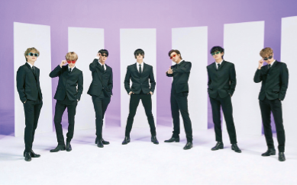
This is Suga, a member of the famous band BTS. On Saturdays,
he ¹ get up / gets up early and ² haves / has a shower. Then, he
³ go / goes to a dance class at 9 a.m. He ⁴ meets / meet his colleagues
from the band before the class, but they ⁵ not have / don’t have
lunch together. Suga ⁶ enjoys / enjoies spending time with
his family, so he ⁷ doesn’t forget / don’t forget a good meal
with his parents on Saturdays.
Suga ⁸ write / writes songs every day, even at the weekends
and he ⁹ does / do that in the evening when everything
¹⁰ get / gets quieter!

This is Suga, a member of the famous band BTS. On Saturdays,
he 1________________ (get up) early and 2________________ (have)
a shower. Then, he 3________________ (go) to a dance class.
He 4________________ (meet) his colleagues from the band before
the class, but they 5________________ (not have) lunch together.
Suga 6________________ (enjoy) spending time with his family, so he
7________________ (not forget) a good meal with his parents on Saturdays.
Suga 8____________ (write) songs every day, even at the weekends and he 9____________ (do)
that in the evening when everything 10________________ (get) quieter!
C. Tick (✓) the correct sentences about an interview to the band.
BTS
1.
a) J-Hope wear new shoes for every concert. | b) J-Hope wears new shoes for every concert.
2.
a) They don’t take their phones to concerts. | b) They doesn’t take their phones to concerts.
3.
a) Jin doesn’t like to wake up early. | b) Jin doesn’t likes to wake up early.
4.
a) Your friends go to your concerts? | b) Do your friends go to your concerts?
5.
a) What time do they leave home? | b) What time they leave home?
6.
a) Do Suga enjoy playing video games? | b) Does Suga enjoy playing video games?

