Past simple: regular verbs (Unit 3)
Worksheet
11A
Name No.: ______ Class: ________ Date: _____/ _____/ _____
A. Find the past simple form of the verbs below
in the word search (→↑). Write it next to
the corresponding infinitive form.
G | B | G | P | R | M | D | F | M | T | C | W | K | E | R
O | X | K | W | D | O | S | H | D | I | G | Q | K | U | D
P | L | A | N | N | E | D | V | A | I | L | Z | K | V | N
C | P | E | U | D | N | W | S | N | V | K | P | D | K | S
J | Y | Y | O | X | D | V | D | C | B | G | U | A | Q | Q
Y | C | W | W | A | T | C | H | E | D | R | G | Y | W | Y
S | G | L | C | A | N | B | V | D | C | X | F | H | E | K
M | T | G | H | X | W | M | G | S | L | I | L | R | I | S
R | M | X | T | N | O | S | T | O | P | P | E | D | X | Z
S | A | L | I | P | R | G | S | T | U | D | I | E | D | K
T | R | I | Z | M | K | A | Y | B | I | P | I | K | I | I
A | H | V | C | X | E | B | Z | P | W | U | S | H | B | E
Y | F | E | N | Q | D | W | Q | G | Z | U | S | Z | H | Q
E | G | D | U | X | D | E | O | E | U | E | X | L | U | W
D | W | V | D | H | B | D | Y | C | B | D | S | Y | X | R

1. watch  _______________ | 5. stay  _______________
2. study  _______________ | 6. live  _______________
3. stop  _______________ | 7. dance  _______________
4. plan  _______________ | 8. work  _______________
B. Complete a short biography of the Portuguese footballer, Eusébio, using the past simple of the regular verbs in brackets.
A football
legend!
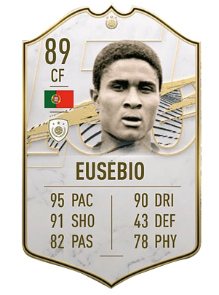
Eusébio da Silva Ferreira, also known as “The Black Panther”, was born in 1942 in
Mozambique. He 1____________ (attend) school there, but he 2___________ (skip)
classes just to play football! He 3_____________ (not arrive) classes on time as
he 4___________ (kick) every object that 5____________ (look) like a ball on his way
to school! He 6_____________ (move) to Lisbon in 1960. He 7_____________ (start)
his career and 8_____________ (turn) into one of the greatest footballers
of all time. He 9_____________ (play) for Benfica most of his career
until he badly 10_____________ (injure) his knee in 1974. After his recovery,
he 11_____________ (not return) to Benfica. He 12_____________ (not stop) playing
until 1979, when he 13____________ (retire). He 14_____________ (score) a total of
896 goals! He always 15_____________ (try) really hard to be a good professional
and a caring human being. He 16_____________ (die) in 2014, in Lisbon.
C. Write questions and short answers about Eusébio’s life.
Yes, he did
Did Eusébio like football as a child
• Eusébio / like / football as a child ? .
1. he / live / in Mozambique ? .
2. when / he / arrive / in Portugal ? .
3. where / he / play / most of his career ? .
4. he / continue / playing after 1979 ? .
5. how many / goals / he / score ? .
6. he / die / in Mozambique ? .

