Past simple: regular verbs (Unit 3)
Worksheet
11B
Name No.: ______ Class: ________ Date: _____/ _____/ _____

A. Circle the past simple form of the verbs from the box in the word search (→↑).
G | B | G | P | R | M | D | F | M | T | C | W | K | E | R
O | X | K | W | D | O | S | H | D | I | G | Q | K | U | D
P | L | A | N | N | E | D | V | A | I | L | Z | K | V | N
C | P | E | U | D | N | W | S | N | V | K | P | D | K | S
J | Y | Y | O | X | D | V | D | C | B | G | U | A | Q | Q
Y | C | W | W | A | T | C | H | E | D | R | G | Y | W | Y
S | G | L | C | A | N | B | V | D | C | X | F | H | E | K
M | T | G | H | X | W | M | G | S | L | I | L | R | I | S
R | M | X | T | N | O | S | T | O | P | P | E | D | X | Z
S | A | L | I | P | R | G | S | T | U | D | I | E | D | K
T | R | I | Z | M | K | A | Y | B | I | P | I | K | I | I
A | H | V | C | X | E | B | Z | P | W | U | S | H | B | E
Y | F | E | N | Q | D | W | Q | G | Z | U | S | Z | H | Q
E | G | D | U | X | D | E | O | E | U | E | X | L | U | W
D | W | V | D | H | B | D | Y | C | B | D | S | Y | X | R

watch  study  stop  plan | stay  live  dance  work
B. Circle the correct past simple form of the verbs to complete a short biography of the Portuguese footballer, Eusébio.
A football
legend!
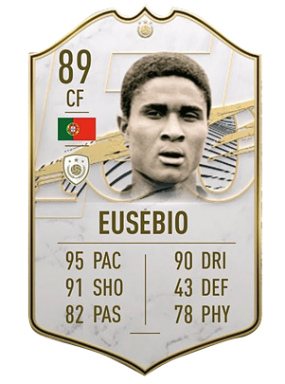
Eusébio da Silva Ferreira, also known as “The Black Panther”, was born in 1942 in
Mozambique. He ¹ attend / attended school there, but he ² skiped / skipped
classes just to play football! He ³ didnt’t arrive / not arrive classes on time
as he ⁴ kick / kicked every object that ⁵ looked / look like a ball on his
way to school! He ⁶ move / moved to Lisbon in 1960. He ⁷ starts / started
his career and ⁸ turned / turn into one of the greatest footballers of all time.
He ⁹ plaied / played for Benfica most of his career until he ¹⁰ injure / injured his knee
in 1974. After his recovery, he ¹¹ didn’t return / didn’t returned to Benfica.
He ¹² not stopped / didn’t stop playing until 1979, when he ¹³ retires / retired.
He ¹⁴ scored / score a total of 896 goals! He always ¹⁵ tries / tried really hard to be
a good professional and a caring human being. He ¹⁶ die / died in 2014, in Lisbon.
C. Complete the questions and circle the correct short answers about Eusébio’s life.
like
Did
• “___________ Eusébio ___________ football as a child?” “Yes, he did./ No, he didn’t.”
1. “___________ he ___________ (live) in Mozambique?” “Yes, he did. / No, he didn’t.”
2. “When ___________ he ___________ (arrive) in Portugal?” “In 1960. / In 1979.”
3. “Where __________ he ___________ (play) most of his career?” “In Mozambique. / In Benfica.”
4. “___________ he ___________ (continue) playing after 1979?” “Yes, he did. / No, he didn’t.”
5. “How many goals ___________ he ___________ (score)?” “896 goals. / 2014 goals.”
6. “___________ he ___________ (die) in Mozambique?” “Yes, he did. / No, he didn’t.”

