Past simple: irregular verbs (Unit 3)
Worksheet
12A
Name No.: ______ Class: ________ Date: _____/ _____/ _____
A. Complete the sentences and the crossword puzzle with the past simple form of the irregular verbs from the box.
 |  |  |  |  |  |  | 
 |  |  |  |  |  | 
 |  |  |  |  |  | 
 | 
 | 
 |  |  |  |  | 
 | W | E | N | T

went
go | have | buy | do | send | swim | see | catch

1. Mrs Preston _____________ to a museum.
2. She _____________ in the river.
3. She _____________ new clothes and accessories.
4. She _____________ a taxi to school.
5. She _____________ some shopping at the supermarket.
6. She _____________ a sandwich for lunch.
7. She _____________ an old student.
8. She _____________ her students text messages.
B. Mrs Preston, the English teacher, lost her memory for two hours during a school trip. No one could find her! The pictures below show what she had in her pocket. Label them with some sentences from exercise A to find out what she did during those two hours!
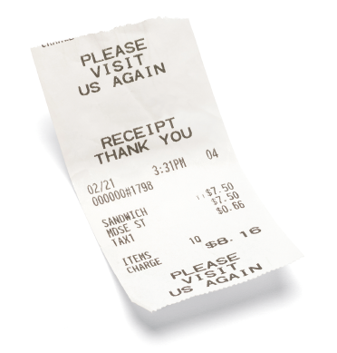 | 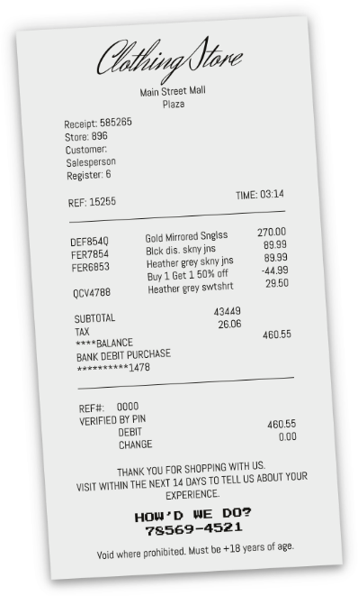 | 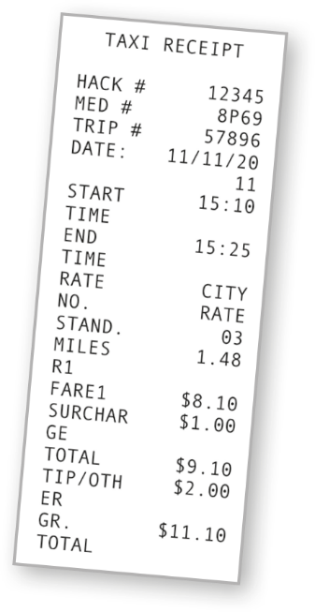
1. | 2. | 3.
C. Rewrite the sentences in the correct past simple form (negative and interrogative).
1. Mrs Preston saw an old student. Neg.: ______________________ Int.:
2. She ate a giant ice cream. Neg.: _______________________ Int.:
3. She did some shopping. Neg.: _______________________ Int.:
4. She went to a museum. Neg.: _______________________ Int.:
5. She ran in the park. Neg.: ________________________ Int.:

