Past simple: irregular verbs (Unit 3)
Worksheet
12B
Name No.: ______ Class: ________ Date: _____/ _____/ _____
A. Complete the sentences with the past simple form of the irregular verbs in brackets. Then write the past simple verb forms in the crossword puzzle.
went
 |  |  |  |  |  |  | 
 |  |  |  |  |  | 
 |  |  |  |  |  | 
 | 
 | 
 |  |  |  |  | 
 | W | E | N | T

1. Mrs Preston ___________ (go) to a museum.
2. She ___________ (swim) in the river.
3. She ___________ (buy) ten new dresses.
4. She ___________ (catch) a taxi to school.
5. She ___________ (do) some shopping at the supermarket.
6. She ___________ (have) a sandwich for lunch.
7. She ___________ (see) an old student.
8. She ___________ (send) her students text messages.
B. Mrs Preston, the English teacher, lost her memory for two hours during a school trip. No one could find her! The pictures below show what she had in her pockets. Which sentences tell us what she did during those two hours?
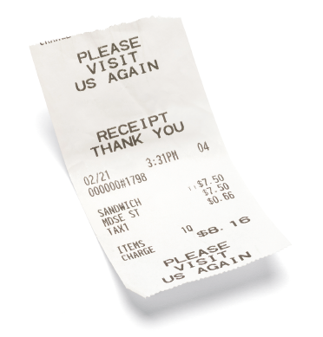 | 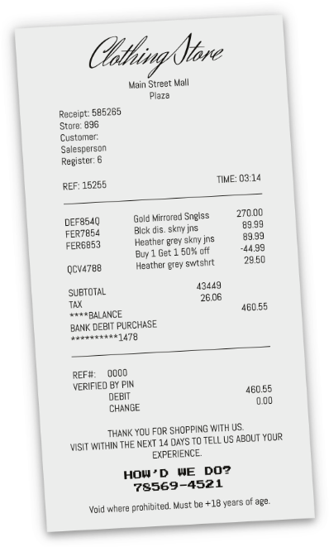 | 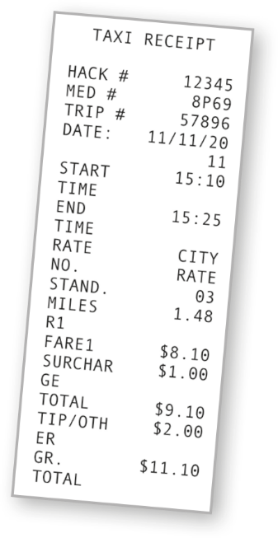

1. a) She saw an old student. |  | 2. a) She swam in the river. |  | 3. a) She caught a taxi.
b) She had a sandwich for  lunch. |  | b) She bought new  clothes. |  | b) She ran in the park.
C. Tick (✓) the correct sentences.
1. a) Mrs Preston didn’t saw an old student. b) Mrs Preston didn’t see an old student.

2. a) She didn’t eat a giant ice cream. b) She didn’t ate a giant ice cream.

3. a) Did she do any shopping? b) Did she any shopping?

4. a) Did she went to a museum? b) Did she go to a museum?

