Past continuous (Unit 4)
Worksheet
13A
Name No.: ______ Class: ________ Date: _____/ _____/ _____
A. Look at the scenes from the film Tom & Jerry and complete the sentences with the past continuous of the verbs in brackets.
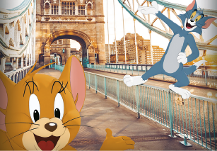 | 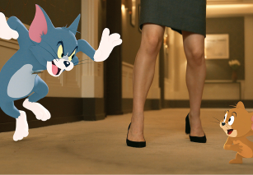 | 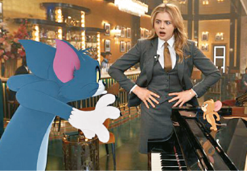
• Tom and Jerry ____________  (have) fun in Tower Bridge.  were having | 1. Tom ______________ (chase)  Jerry; Jerry ___________ (run)  away from Tom. | 2. Tom _______________ (play)  the piano while Kayla  ____________ (stare) at him.
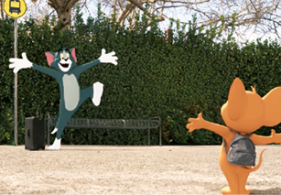 |  | 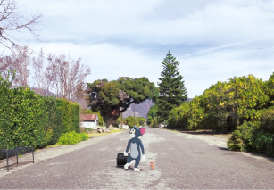
3. Tom ______________ (wait)  for Jerry at the bus stop. | 4. They ___________________  (skateboard) in the road and  they ________________ (try)  to escape the New York traffic. | 5. They ______________ (walk)  in the middle of the road.
B. Read part of the film synopsis and fill in the gaps with the past continuous of the verbs from the box.
Tom and Jerry 1_______________ a tough time being homeless. They
2_______________ with their owners anymore, so they 3______________
about being friends and having a fresh start! Jerry 4______________ to
live in a comfortable place: a hotel in Manhattan, NYC, where everyone
5_____________ the “wedding of the century”. Kayla, a hotel staff member,
6_____________ the wedding and hired Tom to get rid of Jerry, starting
their never-ending fight again. But Kayla 7______________ everything
that was about to come… you have to watch to guess what it was!
not live
have
prepare
not expect
hope
think
organise
C. Ask and answer, according to the text in exercise B.
1. ____________ Tom and Jerry ____________ (live) in the UK? No, they ____________.
2. ____________ Tom and Jerry ____________ (try) to be friends? ____________, ___________.
3. ____________ Tom ____________ (stay) with Jerry at the hotel? ___________, ___________.
4. ____________ Kayla ___________ (help) to prepare the wedding? __________, ___________.

