Past continuous (Unit 4)
Worksheet
13B
Name No.: ______ Class: ________ Date: _____/ _____/ _____

A. Look at the scenes from the film Tom & Jerry and circle the correct past continuous form of the verbs to complete the sentences.
 | 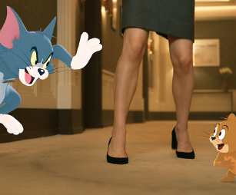 | 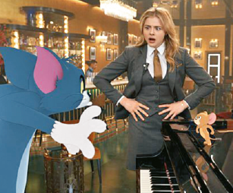
1. Tom and Jerry  were having / was having  fun in Tower Bridge. | 2. Tom was chase / was chasing  Jerry; Jerry  was running / were running  away from Tom. | 3. Tom was play / was playing  the piano while Kayla  were stare / was staring  at him.
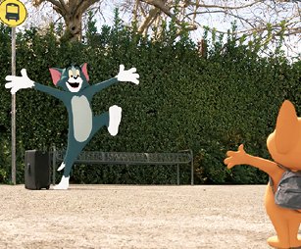 |  | 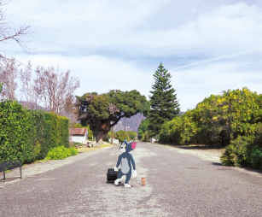
4. Tom was waiting / was wait  for Jerry at the bus stop. | 5. They skateboard / were  skateboarding in the road. | 6. They walk / were walking  in the middle of the road.
B. Tick (✓) the correct sentence in the negative.
1. a) Tom and Jerry weren’t having fun at the Eiffel Tower.

b) Tom and Jerry not having fun at the Eiffel Tower.

2. a) Tom wasn’t not waiting for Kayla at the bus stop.

b) Tom wasn’t waiting for Kayla at the bus stop.

3. a) They didn’t were walking in the middle of the park.

b) They weren’t walking in the middle of the park.

C. Complete the questions and the short answers.
he was
running
Was
• “________ Tom ___________ (run) after Jerry?” “Yes, ____________.”
1. “________ Jerry ___________ (play) the guitar?” “No, ____________.”
2. “________ Tom and Jerry __________ (drive) in New York?” “No, ________________.”
3. “________ Kayla _______ (look) angrily at Tom while he was on the piano?” “Yes, _________.”

