The imperative (Unit 4)
Worksheet
16A
Name No.: ______ Class: ________ Date: _____/ _____/ _____

A. Here are some basic rules of parkour. Circle the correct imperative to complete them.

1. Walk / Run first, then run!
2. Plan / Swim before you jump!
3. Respect / Harm the environment!
4. Forget / Wear comfortable clothes!
5. Enjoy / Know your limits!
6. Don’t leave / Not leave trash around.
7. Don’t do / Do something you’re not sure you can.
8. Don’t try / Try to do it in crowded areas.
9. Don’t be / Not be overconfident!
10. Not practise / Don’t practise it when you’re injured!
B. Carla is a parkour fan. She needs to know all the city signs to do it safely.
Choose a verb from the box and complete the sentences to label the signs. Use the imperative.
leave | pay | be | not walk | not circulate

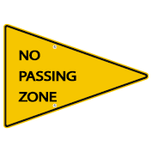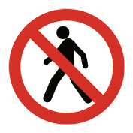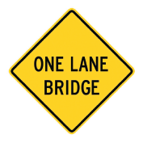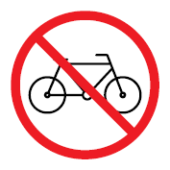
1
2
3
4
5
1. _________________________ in this area.
2. _________________________ careful! Road under construction!
3. _________________________! Pedestrians aren’t allowed!
4. _________________________ attention! Narrow bridge ahead!
5. Please, _________________________ your bikes at home!
C. Make affirmative and negative sentences in the imperative.
Don't cross the road with the red light.
• cross the road / the red light (✗)
1. park / here (✗)
2. jump / without looking (✗)
3. go / over the obstacles (✓)
4. run / get some speed (✓)
5. cross / busy streets (✗)
6. be / aware / traffic (✓)

