The imperative (Unit 4)
Worksheet
16B
Name No.: ______ Class: ________ Date: _____/ _____/ _____

A. Here are some basic rules of parkour. Circle the correct verb form in the imperative to complete the rules.

1. Walk / Don’t walk first, then run!
2. Plan / Don’t plan before you jump!
3. Respect / Don’t respect the environment!
4. Don’t wear / Wear comfortable clothes!
5. Don’t know / Know your limits!
6. Don’t leave / Not leave trash around.
7. Don’t do / Do something you’re not sure you can.
8. Don’t try / Try to do it in crowded areas.
9. Don’t be / Not be overconfident!
10. Not practise / Don’t practise it when you’re injured!
B. Carla is a parkour fan. She needs to know most city signs to do it safely.
Choose a verb form from the box and complete the sentences to label the signs.
leave | pay | be | don’t walk | don’t circulate

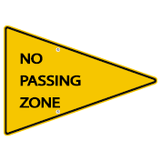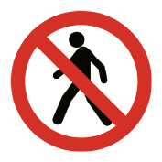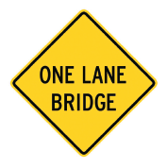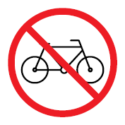
1
2
3
4
5
1. _________________________ in this area.
2. _________________________ careful! Road under construction!
3. _________________________! Pedestrians aren’t allowed!
4. _________________________ attention! Narrow bridge ahead!
5. Please, _________________________ your bikes at home!
C. Make affirmative and negative sentences in the imperative.
Don't cross
• ______________________ (cross) the road with the red light. (✗).
1. ______________________ (park) here. (✗)
2. ______________________ (jump) without looking. (✗)
3. ______________________ (go) over the obstacles. (✓)
4. ______________________ (run) to get some speed. (✓)
5. ______________________ (cross) busy streets. (✗)
6. ______________________ (be) aware of the traffic. (✓)

