Prepositions of movement (Unit 4)
Worksheet
17A
Name No.: ______ Class: ________ Date: _____/ _____/ _____
A. Fill in the blanks to complete Simon’s cat’s movements. Use the prepositions of movement from the box.
over | into | towards | onto | down | across

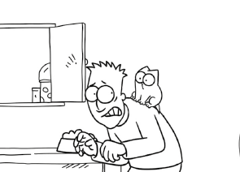
1. He is climbing ______________
Simon’s back.
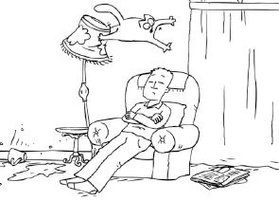
2. He is flying _________________
Simon’s head.
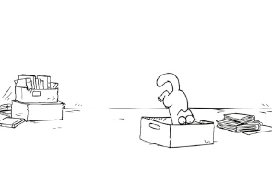
3. He is jumping ______________
the box.
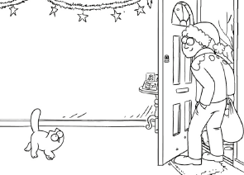
4. He’s walking _______________
Simon.
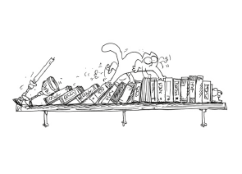
5. He is running ______________
the bookshelf.
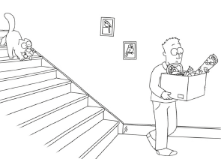
6. He is coming _______________
the stairs.
B. Read the text and complete it with the correct preposition of movement. The pictures next to each gap will help you.

There’s a party today at Simon’s house. His cat secretly invited ALL his friends.
Here’s the secret note he sent them with his house directions:
Come 1_______________ the train station and turn left. Turn right into Park Road
and go 2_______________ the little bridge. Walk 3_______________ the supermarket.
From there you’ll see a tunnel. Go 4_______________ that tunnel and walk
5_______________ the park. Turn right 6_______________ Chester Road. My block
of apartments is next to the pet shop. Go 7_______________ the stairs to the
2nd floor. My door is on the left! See you at the party...
Cat’s greetings

