Prepositions of movement (Unit 4)
Worksheet
17B
Name No.: ______ Class: ________ Date: _____/ _____/ _____

A. Circle the correct preposition of movement to complete Simon’s cat’s movements.
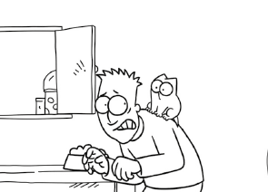
1. He is climbing onto / down Simon’s back.
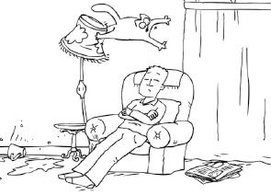
2. He is flying towards / over Simon’s head.
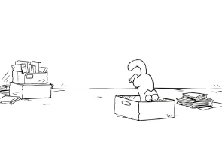
3. He is jumping into / out of the box.
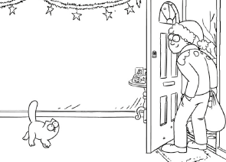
4. He’s walking
through / towards Simon.
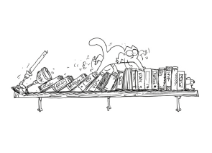
5. He is running across / down the bookshelf.
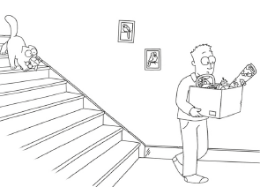
6. He is coming down / over the stairs.
B. Read the text and complete it with a preposition of movement from the box. The pictures next to each gap will help you.
towards | across | over | through | into | up | out of

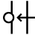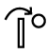
There’s a party today at Simon’s house. His cat secretly invited ALL his friends.
Here’s the secret note he sent them with his house directions:
Come 1_______________ the train station and turn left. Turn right into Park Road
and go 2_______________ the little bridge. Walk 3_______________ the supermarket.
From there you’ll see a tunnel. Go 4_______________ that tunnel and walk
5_______________ the park. Turn right 6_______________ Chester Road. My block
of apartments is next to the pet shop. Go 7_______________ the stairs to the
2nd floor. My door is on the left! See you at the party...
Cat’s greetings

