Future forms (Unit 5)
Worksheet
18A
Name No.: ______ Class: ________ Date: _____/ _____/ _____
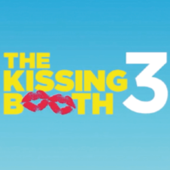
A. Match the columns to make correct pairs. Write the letters a-e.
1. You will like the film The Kissing Booth. a) I will be on holiday.

2. I won’t see you next week. b) I can’t draw or paint.

3. I definitely won’t become an artist. c) I hate the traffic noise.

4. We’ve got a lot of time. d) It’s excellent!

5. I definitely won’t live in the city. e) We won’t be late!

B. What are they going to do? Ask and answer.
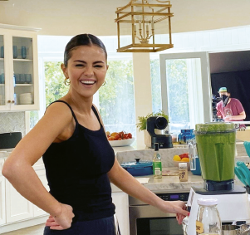  • | 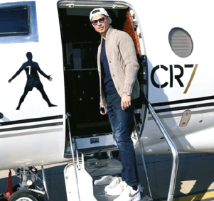  1 | 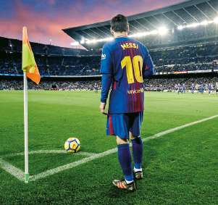  2
• Selena / have a shower / have breakfast
"Is Selena going to have a shower?" "No, she isn't. She is going to have breakfast."

1. Ronaldo / exercise / travel
“ ?”
“____________, ___________________. .”
2. Messi / rest / play a match
“ ?”
“____________, ___________________. .”

C. Circle the correct future form to make correct sentences.

1. Will you be / Are you being a famous footballer in the future?
2. That’s Ariana Grande! She is going to take / will take a selfie!
3. I’m meeting / will meet my teacher on Sunday. We have work to do!
4. I don’t know where John is! I will send / am sending him a message.
5. I promise I won’t leave / am going to leave you alone at the concert.
6. Next weekend we are going to ride / will ride our bikes.
Ariana
Grande
7. I hate football, so I probably won’t go / am probably going to the match.
8. “Are you going / Will you go to the dentist tomorrow?” “Yes, I am.”

