Future forms (Unit 5)
Worksheet
18B
Name No.: ______ Class: ________ Date: _____/ _____/ _____
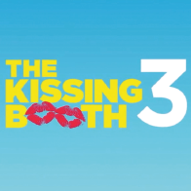
A. Match the two columns. Write the letters a-e.
1. You will like the film The Kissing Booth. a) I will be on holiday next week.

2. I won’t see you next week. b) I can’t draw or paint as an artist.

3. I definitely won’t become an artist. c) I hate the traffic noise in the city.

4. We’ve got a lot of time. d) It’s an excellent film!

5. I definitely won’t live in the city. e) We won’t be late! The match is only in 1 hour.

B. What are they going to do? Ask and answer.
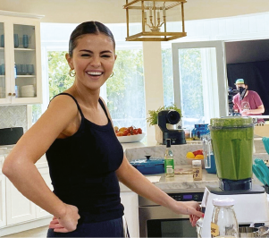  • | 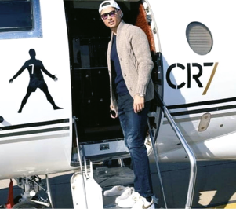  1 | 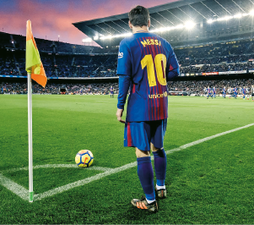  2
• Selena / have a shower / have breakfast
is going to have breakfast
she isn't
going to have a shower
Is
“______ Selena __________________________?” “No, __________. She .”
1. Ronaldo / exercise / travel
“________ Ronaldo ?”
“No, ___________________. He .”
2. Messi / rest / play a match
“________ Messi ?”
“No, ___________________. .”
C. Tick (✓) the correct sentences.
1. a) Will you be a famous footballer in the future?

b) Are you being a famous footballer in the future?


2. a) That’s Ariana Grande! She is going to take a selfie!
Ariana
Grande

b) That’s Ariana Grande! She will take a selfie!

3. a) I’m meeting my teacher on Sunday. We have work to do!

b) I will meet my teacher on Sunday. We have work to do!

4. a) I promise I am going to leave you alone at the concert.

b) I promise I won’t leave you alone at the concert.

5. a) “Will you go to the dentist tomorrow?” “Yes, I am.”

b) “Are you going to the dentist tomorrow?” “Yes, I am.”

