Adverbs of frequency (Unit 1)
Worksheet
2A6
Name No.: ______ Class: ________ Date: _____/ _____/ _____
A. Complete the sentences with the correct adverb of frequency from the box.
sometimes | never | usually | always | hardly ever | often


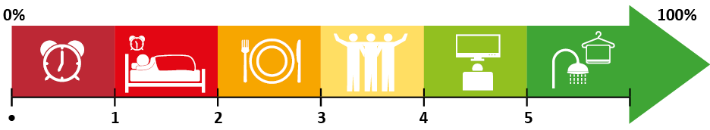
Tom
Holland
•. I _____________ get up before 7 a.m.  never | 3. I _____________ meet my friends.
1. I _____________ go to bed late. | 4. I _____________ watch TV.
2. _____________ have lunch at school. | 5. I _____________ have a shower.
B. Rewrite the sentences. Put the adverbs of frequency in the correct place.
1. Tom and his friends chat after work. (often)
2. Tom does a lot of sports. (usually)
3. He is impatient. (hardly ever)
4. I’m happy to see him as Spider-Man. (always)
C. Answer the questions. Use the adverbs of frequency from exercise A. Write complete sentences.
I sometimes read a book.
• How often do you read a book?

1. How often do you do your homework?

2. How often does your mother go shopping?

3. How often does Helen go to the cinema?

4. How often do Ted’s parents drive to work?

5. How often is Mike late for football practice?

D. Write sentences that are true for YOU. Use adverbs of frequency.
I am often at home at the weekend.
• I / be / at home / at the weekend
1. We / speak / Portuguese / in the English class
2. My friends and I / watch Marvel films
3. The weather / be / nice / in Portugal
4. I / play video games / after school
5. I / go swimming

