Adverbs of frequency (Unit 1)
Worksheet
2B6
Name No.: ______ Class: ________ Date: _____/ _____/ _____

A. Circle the correct adverb of frequency to complete the sentences.
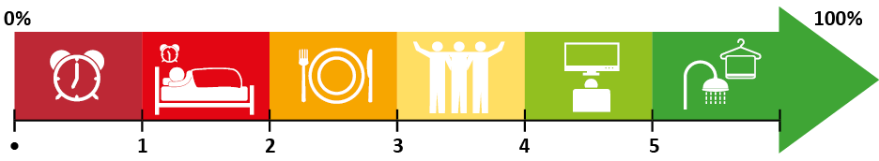
•. I never / often get up before 7 a.m. | 3. I often / sometimes meet my friends.
1. I hardly ever / always go to bed late. | 4. I always / usually watch TV.
2. I never / sometimes have lunch at school. | 5. I always / hardly ever have a shower.
B. Answer the questions. Use the adverbs of frequency from exercise A.
sometimes
• How often do you read a book? I _____________ read a book.

1. How often do you do your homework? I _____________ do my homework.

2. How often does your mother go shopping? My mother ___________ goes shopping.

3. How often does Helen go to the cinema? Helen _____________ goes to the cinema.

4. How often do Ted’s parents drive to work? Ted’s parents ___________ drive to work.

5. How often is Mike late for football practice? Mike is _____________ late for football practice.

C. Complete the sentences so that they are true for YOU. Use adverbs of frequency.
often
• I am ________________ at home at the weekend.

1. We ________________ speak Portuguese in the English class.
Tom
Holland
2. My friends and I ________________ watch Marvel films.
3. The weather is ________________ nice in Portugal.
4. I ________________ play video games after school.
5. I ________________ go swimming.
D. Rewrite the sentences. Put the adverbs of frequency in the correct place.
Tom Holland's films are always great.
• Tom Holland’s films are great. (always)
He sometimes plays superheroes.
• He plays superheroes. (sometimes)
1. Tom and his friends chat after work. (often)
2. Tom does a lot of sports. (usually)
3. He is impatient. (hardly ever)
4. I’m happy to see him as Spider-Man. (always)

