Indefinite pronouns (Unit 5)
Worksheet
21A
Name No.: ______ Class: ________ Date: _____/ _____/ _____

A. Circle the correct indefinite pronoun in the sentences.
1. “I think there’s someone / anyone at the door!” “You’re right! I’ll see who it is.”
2. “Can no one / anyone help me fix this?” “Sure! Let me have a look!”
3. Nobody / Everybody came to my party and I was very sad.
4. “Where did everyone / somebody go?” “They all went to the swimming pool.”
5. Does nobody / anybody have a pen I can borrow?

B. Complete Alice’s email. Use the pronouns from the box.
nothing | something | everything | anything

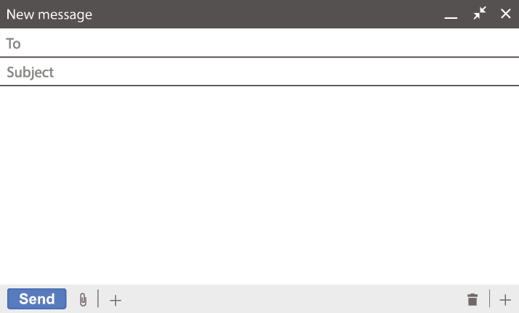
dennis@gmail.com
Fantastic vacations
Hi, Dennis!

Greetings from Brazil! We’re having a lot of fun here. 1__________________ is
fantastic: the people, the food, the weather… Jackson is lazy, you know, so he’s doing 2__________________ special, but I’m enjoying every moment. There
isn’t 3__________________ bothering me. I will send you some photos and later
I will buy 4__________________ to take home as a souvenir!
See you in two days!

Alice
C. Fill in the gaps with the correct indefinite pronoun: somewhere, everywhere, anywhere or nowhere.
1. They said Neymar is _________________ on this beach. Let’s find him!
2. “Where are you going on holiday?” “_________________! We’re staying home this summer.”
3. I looked _________________ for my surfing equipment but I can’t find it _________________.
D. Complete the speech bubbles with the correct indefinite pronoun.
1. Can _________________  help me with my luggage,  please? | 2. There is __________ that  makes me happier than a  good day sunbathing! | 1. We looked ___________  for our sunglasses, but we  couldn’t find them!
 |  | 

