Indefinite pronouns (Unit 5)
Worksheet
21B
Name No.: ______ Class: ________ Date: _____/ _____/ _____

A. Circle the correct indefinite pronoun in the sentences.
1. “I think there’s someone / anyone at the door!” “You’re right! I’ll see who it is.”
2. “Can no one / anyone help me fix this?” “Sure! Let me have a look!”
3. Nobody / Everybody came to my party and I was very sad.
4. “Where did everyone / somebody go?” “They all went to the swimming pool.”
5. Does nobody / anybody have a pen I can borrow?

B. Circle the correct pronouns to complete Alice’s email.
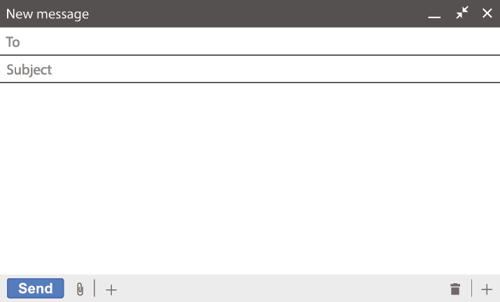
dennis@gmail.com
Fantastic vacations
Hi, Dennis!

Greetings from Brazil! We’re having a lot of fun here. ¹ Everything / Nothing is
fantastic: the people, the food, the weather… Jackson is lazy, you know, so he’s
doing ² something / nothing special, but I’m enjoying every moment. There isn’t
³ anything / nothing bothering me. I will send you some photos and later I will
buy ⁴ something / anything to take home as a souvenir!
See you in two days!

Alice
C. Which sentence is correct? Only one is right! Tick (✓) it!
1. They said Neymar is somewhere on this beach. Let’s find him!

2. “Where are you going on holiday?” “Everywhere! We’re staying home this summer.”

3. I looked nowhere for my surfing equipment but I can’t find it everywhere.

D. Complete the speech bubbles with the correct indefinite pronoun: someone, everywhere or nothing.
1. Can _________________  help me with my luggage,  please? | 2. There is __________ that  makes me happier than a  good day sunbathing! | 1. We looked ___________  for our sunglasses, but  we couldn’t find them!
 |  | 

