Present continuous (Unit 2)
Worksheet
3A6
Name No.: ______ Class: ________ Date: _____/ _____/ _____
A. Read the sentences and tick (✓) the correct one.
1. a) I’m waiting for my friends. b) I waiting for my friends.

2. a) My friends and I aren’t swimming. b) My friends and I aren’t swimming.

3. a) My sister is surf the net. b) My sister is surfing the net.

4. a) Caroline is write a message. b) Caroline is writing a message.

5. a) Lina isn’t helping her parents at home. b) Lina not is helping her parents at home.


B. What are her friends saying? Complete the sentences
with the verbs from the box in the present continuous.
What are
you doing?
play | not have | take | chat | not do | sleep | drink | watch

  1 | 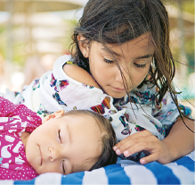  2 |   3 |   4
1. I ___________________________ lunch right now, but I ___________________________ juice.
2. I ___________________________ care of my sister. She ___________________________.
3. I ___________________________ TV at the moment. Doug and I ___________________________ too.
4. Jack and I _________________________ our homework. We _________________________ video games.
C. Look at the pictures. Write questions and answers using the present continuous.
  1 |   2 |   3
they / run / celebrate | Aurea / sing / visit London | Bruno Mars / cook / dance
1. ____________ they ? No, they . They .
2. ? ____________, . .
3. ? ____________, . .

