Present simple and present continuous (Unit 2)
Worksheet
4A6
Name No.: ______ Class: ________ Date: _____/ _____/ _____
A. Read the sentences and tick (✓) PS (present simple) or PC (present continuous).
PS PC
1. Look! The waiter is bringing our pizza now.

2. We usually make the bed before we leave home.

3. I’m not watching TV at the moment.

4. Jackie is tidying her bedroom today.

5. My friends don’t cook meals, but I cook very well!

B. Complete the texts with the present simple or present continuous of the verbs in brackets.
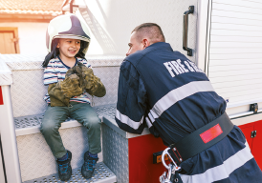
What do they do on a usual Friday afternoon? • What are they doing this Friday afternoon?
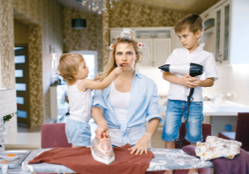
wears
Helen
House
Bob Brave
Bob Brave usually ______________ (wear) a uniform and
1_______________ (help) people in danger. This Friday afternoon
he 2_______________ (not do) that. He 3_______________ (swim)
in the pool. He always 4_______________ (stay) at the fire
station, but today he 5_______________ (not work)!
Helen House always 6_______________ (clean) the house,
7_______________ (wash) the car or 8_______________ (look)
after her children. She 9_______________ (not have) free
time. But this Friday she 10_______________ (enjoy) her free
time. She and her friends 11_______________ (shop) in the city!
C. Fill in the gaps using the verbs in brackets in the present simple or present continuous.
1. Look at this photo! Diogo Piçarra’s cat _________________ (play) with him! How cute!

2. Katy _________________ (not set) the table every day. She _________________ (set)
the table twice a week.
Diogo
Piçarra
3. Peter _________________ (ride) his bike to school every morning.
4. Hurry up! Matt and Liz _________________ (wait) for us. I really
_________________ (not want) to be late!
5. “Where _________________ (your mother/buy) your clothes?”
“She usually _________________ (buy) them at that new shop in town.”
6. “_________________ (you/cut) the grass now?”
“No, I _________________. I _________________ (sweep) the floor!”
7. “_______________ (they/come) home before 5 p.m. every day?” “Yes, they __________________.”
8. “What _________________ (Bill and Peter/do) at the moment?”
“They _________________ (not play) football, they _________________ (listen) to music.”

