Plural of nouns (Unit 2)
Worksheet
5A6
Name No.: ______ Class: ________ Date: _____/ _____/ _____
A. Read these riddles. Then write the plural form of the coloured nouns in the correct column.
When you walk into a living room  You might see a coffee table  You also see this item  You can turn on and watch cable  Answer: television | This is something in your kitchen  An apple, an egg and a potato it does hold  The reason you put them in this  Is because it helps keep them cold  Answer: fridge
I’m something in your kitchen  Although I am not a cup  You can find me in the cupboard  Used to cut all your food up  Answer: knife | In every person’s bathroom  This is a thing that will be seen  For it is used by all the family  To keep your teeth white and clean  Answer: toothbrush

1. Noun + -s | 2. Noun + -es | 3. Noun + -ies | 4. Nouns + -ves | 5. Irregular nouns
rooms

B. Look at the pictures. Tick (✓) the correct sentences to label them.
  Will Smith  1 | 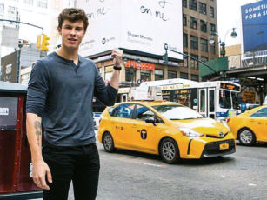  Shawn Mendes  2 |   Jacob Elordi  3
a) Will loves his childrens. | a) There are two taxis here. | a) Jacob takes great photoes.
b) Will loves his children. | b) There are two taxi here. | b) Jacob takes great photos.
C. Rewrite the sentences and change the underlined words into the plural form. Make other necessary changes.
1. Look at the chimney!
2. The woman in the red dress is my aunt.
3. The house has got a balcony.
4. There is a black tree leaf in the garden.
5. That block of flats has got a studio and a yellow roof.

