Plural of nouns (Unit 2)
Worksheet
5B6
Name No.: ______ Class: ________ Date: _____/ _____/ _____
A. Tick (✓) the correct plural forms box from the coloured nouns in the riddles. Then write the plural form of the coloured nouns in the correct column.
1. I’m something in your kitchen  Although I am not a cup  You can find me in the cupboard  Used to cut all your food up  Answer: knife  cups  cupboards  knives  a)  cups  cupboardes  knifes  b) | 2. In every person’s bathroom  This is a thing that will be seen  For it is used by all the family  To keep your teeth white and clean  Answer: toothbrush  persons; bathrooms;  things; families; tooths;  toothbrushes  a)  people; bathrooms;  things; families; teeth;  toothbrushes  b)
B. Put the plural forms of the coloured nouns from exercise A in the correct column.
1. Noun + -s | 2. Noun + -es | 3. Noun + -ies | 4. Nouns + -ves | 5. Irregular nouns
C. Look at the pictures. Choose a sentence from the box to label them. Write the letters a-c.
a) There are two taxis here. | b) Jacob takes great photos. | c) Will loves his children.

  Will Smith  1 | 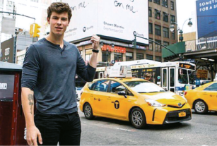  Shawn Mendes  2 |   Jacob Elordi  3
D. Tick (✓) the correct sentence in the plural form.
1. Look at the chimney!
a) Look at the chimneys! | b) Look at the chimneies!
2. The woman in the red dress is my aunt.
a) The womans in the red dresses is my aunts. | b) The women in the red dresses are my aunts.
3. The house has got a balcony.
a) The house has got two balconies. | b) The houses have got two balconies.
4. There is a black tree leaf in the garden.
a) There are black tree leafs in the garden. | b) There are black tree leaves in the gardens.

