Personal pronouns: subject/object (Unit 2)
Worksheet
6A6
Name No.: ______ Class: ________ Date: _____/ _____/ _____

A. Find the missing object pronouns in the word cloud and write them on the table.
Subject | I | you | he | she
Object | me | ¹  __________ | ²  __________ | ³  __________
Subject | it | we | you | they
Object | it | ⁴  __________ | ⁵  __________ | ⁶  __________

B. Circle the correct option to complete the sentences.
1. Can you give me / I your book, please?
2. This is Gary’s mobile. Can you give it to you / him?
3. Tom sets the table every day. He / Him is very helpful.
4. My dogs are great. I really like it / them.
5. We cut the grass on Saturday. Do you want to help we / us?
6. My sister and I share a bedroom. Us / We clean her / it together.
C. Fill in the blanks with the correct personal pronoun subject or object.
1. My father washes the dishes. _______________________ also cooks meals.
2. Amy lives in my street. I see _______________________ every day after school.
3. Are Amy and you at the park? I can meet _______________________ there.
4. Matilde and Robert live next door. _______________________ are very friendly neighbours.
5. That’s my favourite actor! Do you know _______________________?

D. Complete the text with the correct personal pronouns (subject or object).
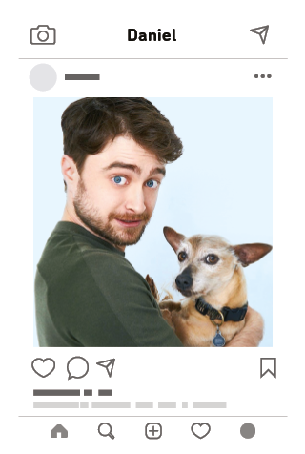
What a boring Saturday! I’m so bored! My mother says it’s cleaning
day, so my sisters and I help 1__________ with the chores. 2__________
are against this idea, but we have to accept 3__________ ! There’s no
other option! My brother Tom never does anything. 4__________ says
he has to study! Good excuse! My sisters Paula and Beth dust the
furniture and I sometimes help 5__________ ! Our Dad also washes
the car on Saturdays and my sister Lydia always helps 6__________ !
It’s a boring family cleaning day… well, not for everyone because
my brother doesn’t do it with 7__________ ! How lucky!
The only thing that cheered me up?? A photo of Daniel Radcliffe
with his dog ! Check it out! Aren’t 8__________ funny?

